Handouts of:

THE EPISODES OF OCEANIC OPENING AND THEIR SPACE-TIME
RELATIONS WITH POST-OROGENIC EXTENSION AND CALC-ALKALINE VOLCANISM OF THE WEST-MEDITERRANEAN-TYRRHENIAN REGION

Handouts:
- The images with comment:
- (A): Oceanic openings of West-Mediterranean-Tyrrhenian seafloor. Pg 1
- (B). - The orogen of Alpine age (OAA) of the west Mediterranean Tyrrhenian seafloor. Pg.2
- (C): Tyrrhenian bathyal volcanism linked to oceanic opening. Pg 3
- (D): Age histogram of volcanic rocks of the Provence-Sardinia-Tyrrhenian-Italy region. Pg 4
- (E): The time-space distribution of igneous rocks of the Provence-Sardinia-Tyrrhenian-Italy region. Pg 5
- References. Pg 6
- The two Abstracts presented at the joint Meeting of Societa’ Geologica Italiana and Societa’ Italiana di Mineralogia e Petrologia, Milan, 10-12 September 2014. Pages 7 - 9

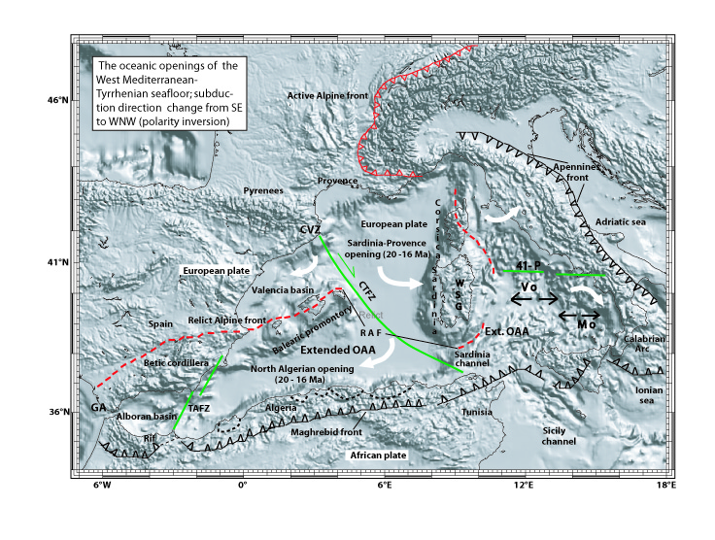Image (A). – Relief-shaded image of the west Mediterranean-Tyrrhenian seafloor and the continental margins of the European and African plates; Plotmap cartographic software (Ligi and Bortoluzzi, 1989). Abbreviations: CTFZ = Catalan -Tunisian fracture zone; CVZ = Catalan volcanic zone; GA = Gibraltar arc; RAF = Relict Alpine Front; TASZ = Trans-Alboran fracture zone; WSG = west Sardinia graben, target of intense volcanism. 41-P = 41° parallel fracture zone. Comment: the image shows (a) the Recent convergence fronts of the Maghreb-Apennines belt and the Alpine orogen, (b) the pre-Oligocene front of subduction of the European plate beneath the extended, submerged orogen of Alpine age (OAA), and (c) the bathyal openings of Sardinia-Provence, north Algeria, Vavilov (V o) and Marsili (M o). The white arrows suggest the counter-clockwise rotation of Corsica-Sardinia and north Apennines, and the clockwise rotation of the Algeria margin and south Apennines and their association to asymmetric basin formation. The CTFZ is a major transcurrent structure which dates back to the plate interactions of Hercynian age (Rehault et al., 1984) and separates the west segment of European plate and extended OAA from that to the east. Extension and magmatism occurred in both the OAA and the European continental margin The fracture zone along the 41° parallel is circa astride thinned continental and oceanic crust flooring the north and south Tyrrhenian Sea, respectively.

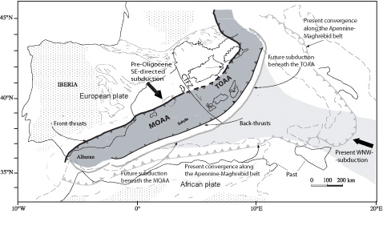
Image (B). - The orogen of Alpine age (OAA) of the west Mediterranean Tyrrhenian seafloor shortly before the start of extension and magmatism in the early Oligocene (33/32 Ma; modified from Gueguen et al., 1998). Abbreviations: west Mediterranean orogen = MOAA; Tyrrhenian orogen = TOAA. Comment: The submerged orogen extending from Alpine Corsica to the Betic cordillera was recognized as the westernmost branch of the western Alps related to the closure of the Mesozoic Alpine Tethys (Sartori et al., 2004; Martin, 2006). It has has been linked to SE-directed subduction of European plate between late Cretaceous and the start of Oligocene. Eventual collision with the African plate led to the double-verging growth of front- and back-thrusts. Along the back-thrusts will initiate the WNW-directed subduction of African lithosphere.
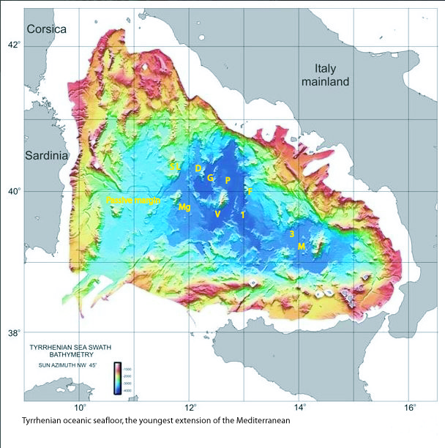

Image (C). - Relief-shaded multibeam map (between 200 and 3600 meters) showing bathyal volcanism linked to Tyrrhenian oceanic opening. Abbreviations: (1) = DSDP borehole 373, deep-seated volcano by the eastern rim of Vavilov bathyal plain; (3) = ODP borehole 650, deep-seated volcano by the western rim of Marsili bathyal plain (Kastens et al., 1988); (V) and (M) = the plains and the large axial volcanoes of, respectively, Vavilov and Marsili; (F) = Flavio Gioia smt.; (D) = De Marchi smt.; (G) = Gortani ridge and ODP borehole 655; (P) = serpentinized peridotite flooring the ODP borehole 651, along Vavilov smt. axis; (SL) = Selli lineament (NNE-SSW oriented); (Mg) = Magnaghi volcano. Comment: Hyperextension and volcanism of sites 373 and 650 were penecontemporaneous with volcanic gap of the continental margins (see the Abstracts and Images D and E). The Flavio Gioia and De Marchi of crystalline-metamorphic nature probably indicate seafloor outcrop of Alpine-age orogen which borders the rapidly foundered peridotite core complex (4120 meters below sea level). The Selli lineament and Magnaghi volcano show the deep edge of the Hercynian passive margin (Sardinia offshore, former foreland of the OAA). In fact, the basalt volcanism of Magnaghi showing alkaline nature and Pliocene age (3.0 – 2.7 Ma; K/Ar dating) may call to mind the Pliocene alkaline basalts of Sardinia (Image, E).

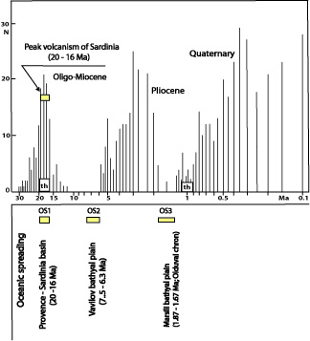

Image (D). – Histogram of age data vs number of ages of volcanic rocks of the Provence-Sardinia-Tyrrhenian-Italy region. Oligo - Miocene (33/32 to 12 Ma), Pliocene (5.4 to 1.8 Ma) and Quaternary (1.2 Ma to Recent) see the abstracts and image (E). Abbreviations: OS1, OS2, OS3 = oceanic spreading and hyperextension showing 20 – 16, 7.5 – 6.3, 1.87 – 1.67 Ma, respectively. Comment: Above WNW directed subduction beneath Tyrrhenian Sea, the OS2 and OS3 hyperextension and localized effusion of MORB-type basalts were penecontemporaneous with the absence or scarcity of volcanism in the passive and active margins of the bathyal plains. In the margins of the Provence-Sardinia bathyal plain, on the contrary, was present 20-16 Ma old (Burdigalian) volcanism of calcalkaline (CA) nature. Also the north-Algerian (West Mediterranean) oceanic spreading has been accompanied by widespread, 20-16 Ma old, peri-bathyal magmatism. Such clearly diverse space-time aspects may indicate that, unlike the Tyrrhenian, the Provence-Sardinia oceanic opening did not occur above subduction. It is here considered that WNW subduction beneath the Tyrrhenian Orogen of Alpine Age was commenced at 16/15 Ma (Late Burdigalian-Early Langhian). In this view, most CA volcanics distributed around the continental margins of Provence-Sardinia and north Algeria bathyal plains reflect source area metasomatic modifications which were likely linked to orogenic accretion of Hercynian and early-Alpine age (Savelli, 2005).
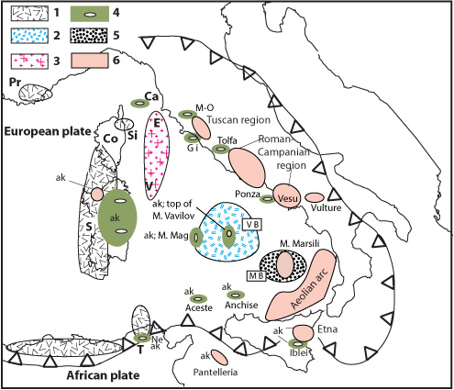

Image (E). - Schematic distribution of volcanism and magmatism of the Provence-Sardinia-Tyrrhenian-Italy region. Abbreviations: 1 = calc-alkaline volcanism between 33/32 and 12 Ma (it is present also in the Nefza area, Tunisia); 2 = oceanic spreading of Vavilov bathyal plain (7.5 - 6.3 Ma; Late Tortonian-Early Messinian); 3 = granitoids emplaced in thinned continental crust of north Tyrrhenian Sea (8 - 6 Ma; penecontemporaneous with south Tyrrhenian bathyal spreading); 4 = Pliocene volcanism (5.4 - 1.8 Ma); 5 = oceanic spreading of Marsili bathyal plain (1.87 - 1.67 Ma; Olduvai chron); 6 = Quaternary volcanism (1.2 Ma to Recent). ak = volcanism exhibiting alkaline character, and Pliocene and Quaternary age. Ca = Capraia island, Co = Corsica, E = Elba island, Gi = Giglio island (granitoids), M-O = Montecatini Val/Cecina - Orciatico, M. Mag = Mount Magnaghi, M B = Marsili Bathyal plain, Ne = Nefza area, Pr = Provence, S = Sardinia, Si = Sisco; T = Tunisia, V = Vercelli seamount, V B = Vavilov Bathyal plain, Vesu = Vesuvius - Campi Flegrei. Comment: Unknown is the chemistry of the pillow basalts documented by submersible dives upslope the flanks of M. Vavilov. Early volcanism of Late Tortonian-Early Messinian age occurred in Capraia island, too. The granitoid plutonism extending from the submerged Vercelli seamount and Etruschi ridge to the subaerial outcrops of Montecristo and Elba islands (north Tyrrhenian Sea; Savelli, 2002) accompanied moderate extension (high-angle faulting) of continental lithosphere (Moeller et al., 2013). Strong igneous activity and moderate extensional tectonics (e.g. pure shear, Wernicke model) contrast with the hyperextension and localized volcanism of the Tyrrhenian bathyal plain. Moving from north to south, the emplacement of granitoids and MORB-type basalts probably reflects increasing strength of lithosphere extension. The diverse stretching rates of the Tyrrhenian seem to mirror the diverse nature of the foreland which subducts beneath the Apennine/Tyrrhenian Sea system: the less subductable continental lithosphere of Adria passes to the oceanic, cold lithosphere flooring the Ionian Sea.

Acknowledgements. I thank the GSA executive for the opportunity of uploading. Handouts are dedicated to the memory of Mario Fornaseri, Fabrizio Innocenti and Raimondo Selli. They would never have been possible without Maria Pia.

References

Gueguen, E., Doglioni, C. &. Fernandez M., (1998). On the post-25 Ma geodynamic evolution of the Western Mediterranean. Tectonophysics, 298, 259-269. Doi:10.1016/S0040-1951(98)00189-9

Kastens, K. et alii ODP Leg 107 in the Tyrrhenian Sea: Insigths into passive margin and back-arc basin evolution, Geological Society of America Bulletin, 100, 1140-1156 (1988); doi:10.1130/0016-7606(1988)100<1140:OLITTS>2.3.CO;2

Ligi, M. & Bortoluzzi, G. Plotmap: geophysical and geological applications of good standard quality cartographic software. Computers and Geosciences, 15, 519–585 (1989). doi:10.1016/0098-3004(89)90023-X

Martin, A. K., (2006). Oppositely directed pairs of propagating rifts in back-arc basins: Double saloon door seafloor spreading during subduction rollback, Tectonics, 25, TC3008; doi:10.1029/2005TC001885.

Moeller, S. et alii, (2013). Early-stage rifting of the northern Tyrrhenian Sea Basin: Results from a combined wide-angle and multichannel seismic study. Geochemistry, Geophysics, Geosystems, 14/8, 3032-3052. DOI:10.1002/ggge.20180

Rehault J.P., Boillot G. & Mauffret A., (1984). The western Mediterranean basin geological evolution, Marine Geology, 55, 447-477; doi:10.1016/0025-3227(84)90081-1

Sartori, R., et alii, (2004). Crustal features along a W–E Tyrrhenian transect from Sardinia to Campania margins (Central Mediterranean). Tectonophysics, 383, 171– 192;
doi:10.1016/j.tecto.2004.02.008

Savelli C. (1988), Late Oligocene to Recent episodes of magmatism in and around the Tyrrhenian sea: implications for the processes of opening in a young inter-arc basin of intra-orogenic (Mediterranean) type, Tectonophysics, 146, 163–181. doi:10.1016/0040-1951(88)90089-3

Savelli C., (2002). Time-space distribution of magmatic activity in the western Mediterranean and peripheral orogens during the past 30 Ma (a stimulus to geodynamic considerations), J. of Geodynamics, 34, 99-126. DOI:10.1016/S0264-3707(02)00026-1

Savelli C., (2005). Post-Eocene calcalkaline activity and basin opening in the western and central Mediterranean region: implications for magma source metasomatism linked to Hercynian orogeny. Boll. Soc. Geol. It., Special Volume n. 4, 119-125.

First Abstract:
Rend. Online Soc. Geol. It., Suppl. n. 1 al Vol. 31 (2014) CONGRESSO SGI-SIMP 2014
© Società Geologica Italiana, Roma 2014

Thematic Session T1 - Holes in the Bottom of the Sea: discoveries and challenges in marine geology – page 28
Space-time aspects of the oceanic opening of Tyrrhenian Sea:
1 - The Bathyal Plain of Vavilov
Savelli C.
CNR, ISMAR, Geologia Marina.

Corresponding email: carlo.savelli@bo.ismar.cnr.it

Keywords: oceanic opening, hyperextension and extension, volcanism and spreading axes.

DSDP and ODP drilling results unveil fundamental aspects of the oceanic lithosphere emplacement in the geological medley of Tyrrhenian seafloor. Above the subducting Adria and Ionian micro-plates, four distinct episodes of extension tectonics and volcanism formed bathyal zone within a disrupted submerged Orogen of Alpine Age (OAA). The episodes 1 and 3 exhibit strong extensional deformation (Savelli, 1988; Tectonophysics, 146). In the the LateTortonian/EarlyMessinian (LT-EM), hyperextension and volcanism induce the opening of the Vavilov bathyal plain. The lowstanding basalts drilled at DSDP373 (eastern edge of the plain) show MOR-type nature and a range of six whole-rock K/Ar datings between 7.5 and 6.3+/- 0.8 Ma (LT-EM). As long as refining Ar/Ar data is not available, the K/Ar range may be taken as sufficient approximation of eruption time. The LT-EM age indicates that ocean opening precedes the salinity crisis (late Messinian; 5.96 - 5.33 Ma). The absence of evaporite deposits in the Vavilov deep-plain ought to reflect a shallow waterdepth. In fact, a high-stand of seafloor probably impeded inflow of Atlantic water in sufficient amount to form evaporites at the time of desiccation. LT-EM hyperextension and low-angle detachment faulting are associated to localized, non axial MORB volcanism. Concomitantly, simple-shear deformation strongly stretches and thinns the wide submerged area of the Hercynian Sardinia margin (former foreland of local OAA) in the absence of volcanism. Strong extension produced probable denudation of the low-standing peridotite of ODP651, too. Always during episode 1, weak extension of the north Tyrrhenian goes with acidic intrusive activity showing age of 8-6 Ma. Moving from S to N, the submerged granitoids of Vercelli seamount and Etruschi ridge precede the intrusions of the islands of Montecristo and Elba. In the Pliocene (5.33 – 1.87 Ma), weak extension linked to high-angle normal faults forms spreading ridges. Uprise of 4.3 Ma old, MORB-type lavas (ODP655) produces the modest elevation of Gortani ridge, NW of DSDP373. Afterwards, MORB volcanism migrates from the Gortani to ESE towards the hinge zone. In the axial zone of Vavilov basin, a major magnetic lineation shows N-S trending positive and negative anomalies. The N positive is likely associated with the ODP651 peridotite and the negative magnetic field with the Vavilov spreading axis to the S. If this anomaly belongs to Matuyama chron the axial volcano is < 2.4 Ma old. 3.0 and 2.6 Ma basalt flows showing MOR and calc-alkaline nature occur above the ODP651 peridotite, and below Plio-Quaternary sediment. Crest elevation and magma input of Vavilov volcano are larger than at the Gortani spreading ridge to NNW. Episodes 3 and 4 are described in the next abstract. In the episode 4 (<1 Ma), weak horizontal deformation and high-angle normal faulting are linked to ascent and emplacement of alkaline basalt melts in the crest of Vavilov volcano.

Second Abstract
Rend. Online Soc. Geol. It., Suppl. n. 1 al Vol. 31 (2014) CONGRESSO SGI-SIMP 2014
© Società Geologica Italiana, Roma 2014

Thematic Session T1 - Holes in the Bottom of the Sea: discoveries and challenges in marine geology – page 29

Space-time aspects of the oceanic opening of Tyrrhenian Sea:
2 - The Bathyal Plain of Marsili
Savelli C.
CNR, ISMAR, Geologia Marina.

Keywords: oceanic opening, hyperextension and extension, volcanism and spreading axes.

The previous abstract describes the episodes 1 (late Tortonian-early Messinian; LT-EM) and 2 (Pliocene) of the Tyrrhenian oceanic spreading above subducting lithosphere. During the episode 3 (late Pliocene), hyperextension and low-standing volcanism force the opening of the bathyal plain of Marsili. In a round-shaped magnetic anomaly of the plain western edge, ODP 650 drilled deep seated basalts which show age of 1.87-1.67 Ma and MOR-like or transitional nature. In the fourth episode (<1 Ma), voluminous volcanism and weak extension form the high-standing axial seamount Marsili. This is the last of the “sui generis” magma-rich spreading ridges of the Tyrrhenian. With time, in the bathyal plains of Vavilov and Marsili the MORB volcanism of the spreading axes migrates ESE, from Gortani (4.3 Ma) to Vavilov (< 2.4 Ma) and Marsili (< 1Ma to Recent). In the course of the migration towards hinge zone magma uprise increased beneath the spreading axis and finally formed the young super-inflated Marsili seamount. Above WNW-directed subduction, the strong extensional episodes 3 and 1 (late Pliocene and LT-EM) saw emplacement of low-lying basalts of MORB composition linked to round-shaped magnetic anomaly. Concomitantly, volcanism is absent in the peri-bathyal passive and active margins. In the West Mediterranean, on the contrary, peri-oceanic volcanism of calcalkaline (CA) nature accompanies the opening of the Provence-Sardinia and north-Algeria oceanic basins (Burdigalian; 20-16 Ma). Such clearly diverse space-time aspects may indicate that, unlike the Tyrrhenian, the oceanic opening of the W Mediterranean did not occur above subduction. It is here considered that WNW subduction beneath the Tyrrhenian Orogen of Alpine Age (OAA) was commenced at 16/15 Ma (late Burdigalian-Langhian). In the absence of subduction,extension, oceanic spreading, and CA volcanism of Oligo-Burdigalian age took place in Hercynian lithosphere (Provence-Sardinia foreland of the Tyrrhenian OAA), and in the OAA bordering north Algeria basin, too. The CA volcanics distributed around the Provence-Sardinia and north Algeria oceanic basins reflect source area metasomatic modifications likely linked to ancient, Hercynian, and early-Alpine episodes of orogenic accretion. If the lost emission centres of allochthonous volcanoclastics of the Apennines of Oligo-Burdigalian age were sited in the Tyrrhenian OAA also this area was affected by CA volcanism and extension in the absence of subduction. In conclusion, these spacetime aspects indicate that the CA volcanism is not linked only to subduction.
http://www.geoscienze2014.it/documenti/SGI-SIMP%202014_Abstract%20book.pdf

