Sand on the northwest shore of Mendenhall Lake, near Juneau, Alaska, is mapped (USGS) as glacial moraine: single particles of silt, sand and gravel fractured and ground from tonalite bedrock, transported and deposited by the Mendenhall Glacier before its retreat, circa 1940. However, a decade of observations and more than 10 thousand detailed micro-photos show this is not likely.
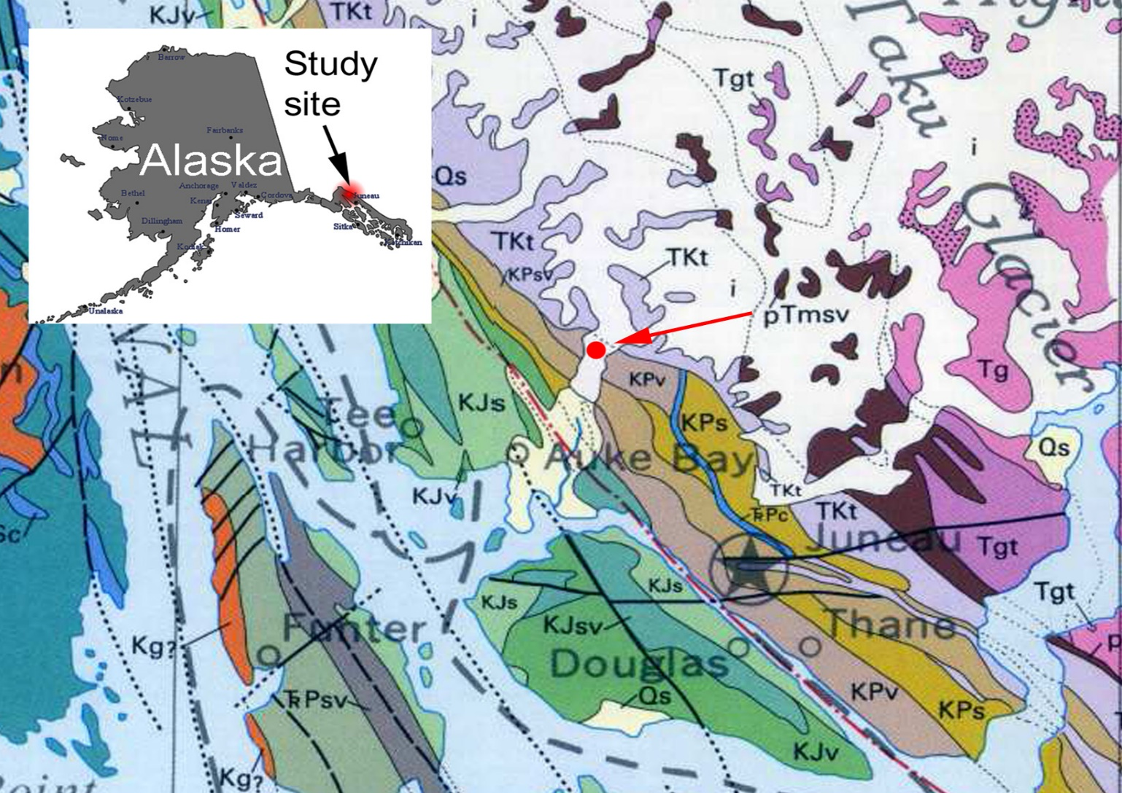
The study site is on the northwest shore of Mendenhall Lake about 20 km northwest of Juneau, Alaska. Bedrock in the vicinity of the study site is phyllite. The sand on the beach is presumed to be glacial moraine derived from the tonalite (TKt) immediately upslope of the lake.
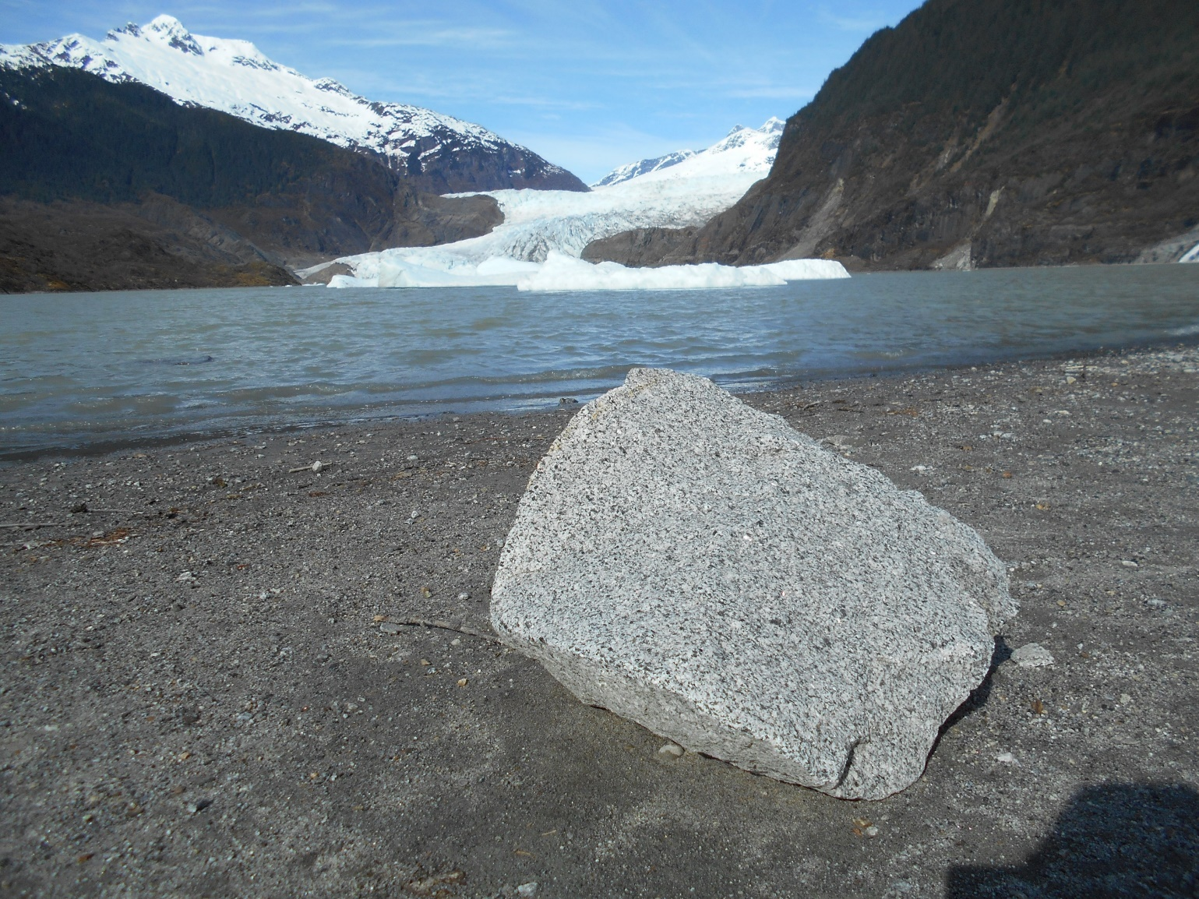
Above is Mendenhall Lake, the Mendenhall Glacier and tonalite rafted onto the beach from an iceberg during a period of higher water. The silica sand here is believed to be derived primarily from such crystalline igneous rock.
Below: tonalite shows cleavage and fractures:

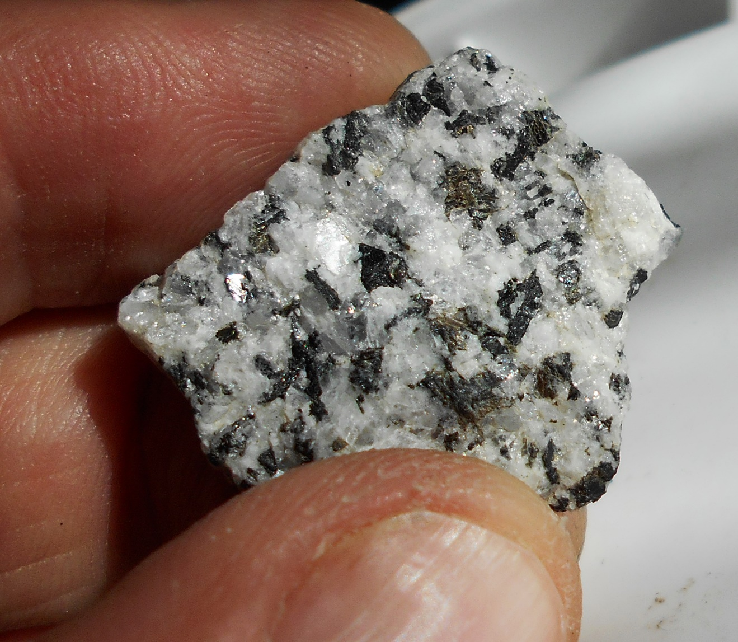
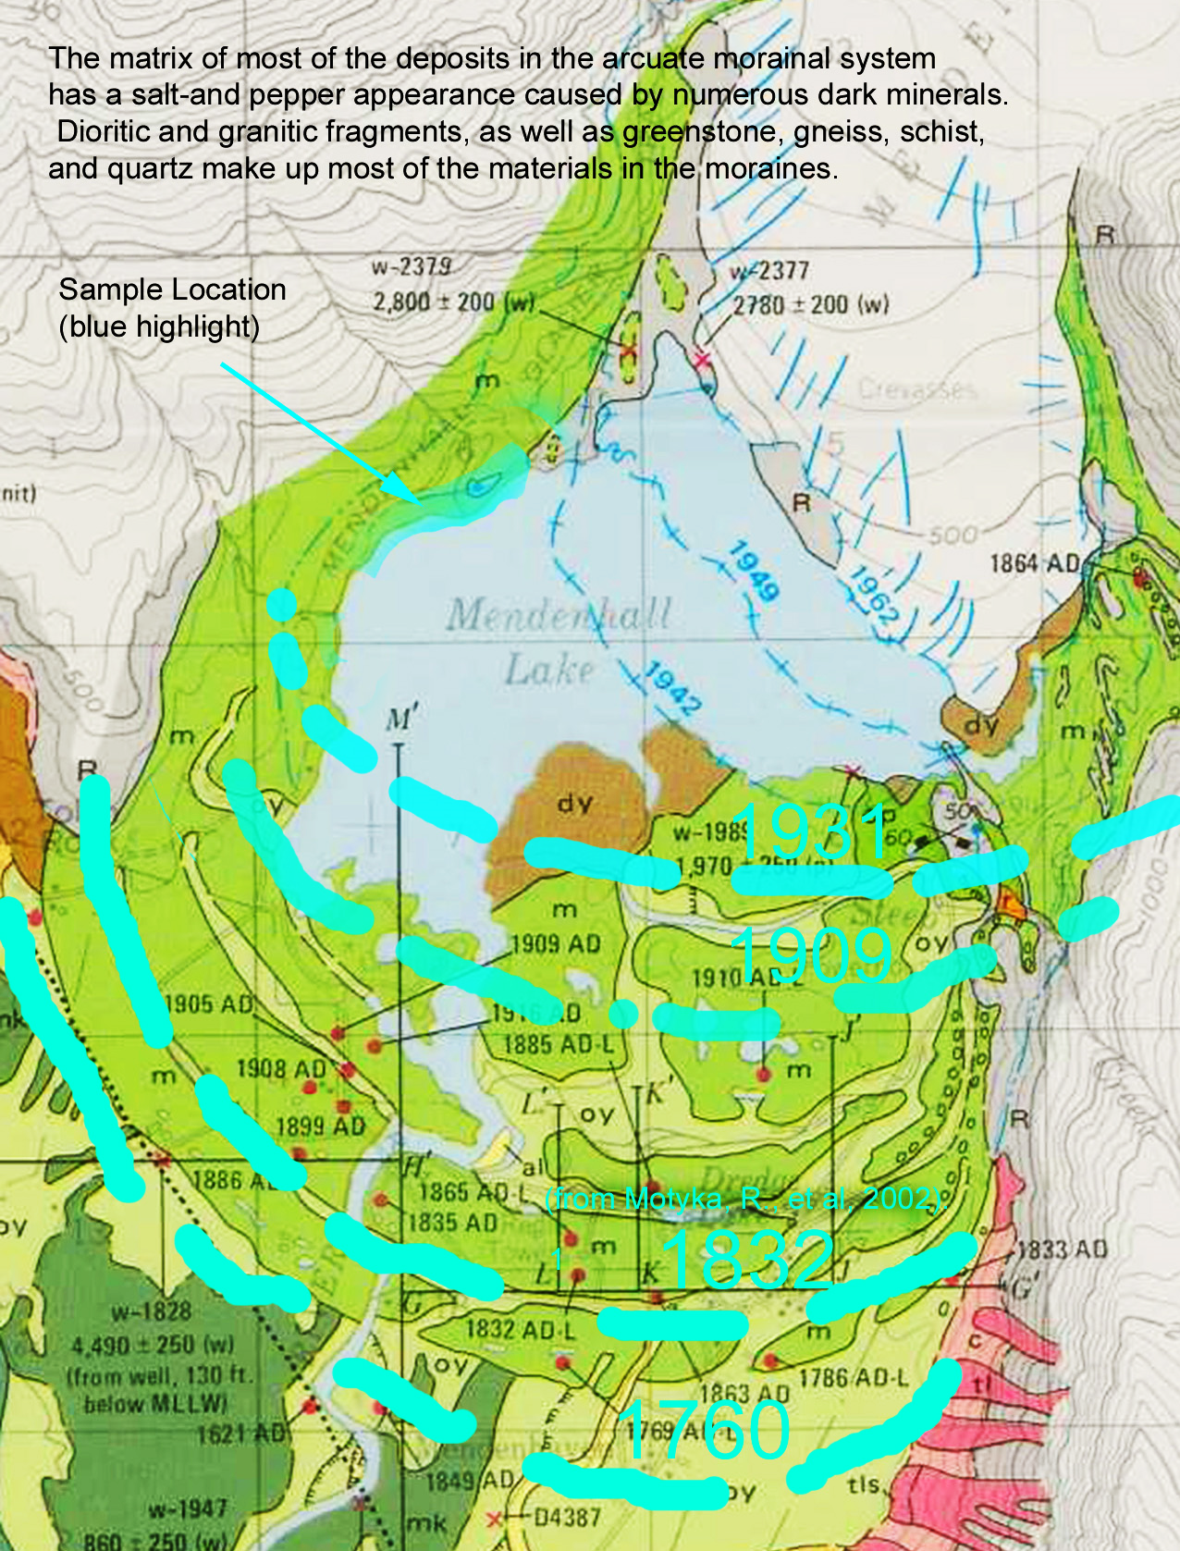
Above: About 10 thousand years ago the Mendenhall Glacier retreated and a forest grew in the valley. Then about 3 thousand years ago the glacier re advanced and covered this forest and the study site. Circa 1760 the glacier began to retreat. Glacial retreat exposed Mendenhall Lake in 1931 and the study site was uncovered in about 1940.
Sand at study site is a mass of molded and interconnected Particles
The sand consists not of individual particles but a mass of interconnected silicate and magnetite grains which appear to be molded together except where spaces between them are filled with a dark, glassy, transparent matrix. Grains are arranged and connected in ways unlikely to have occurred by chance or to have survived crushing and grinding glacio-fluvial transport. This sand appears to have formed in place.
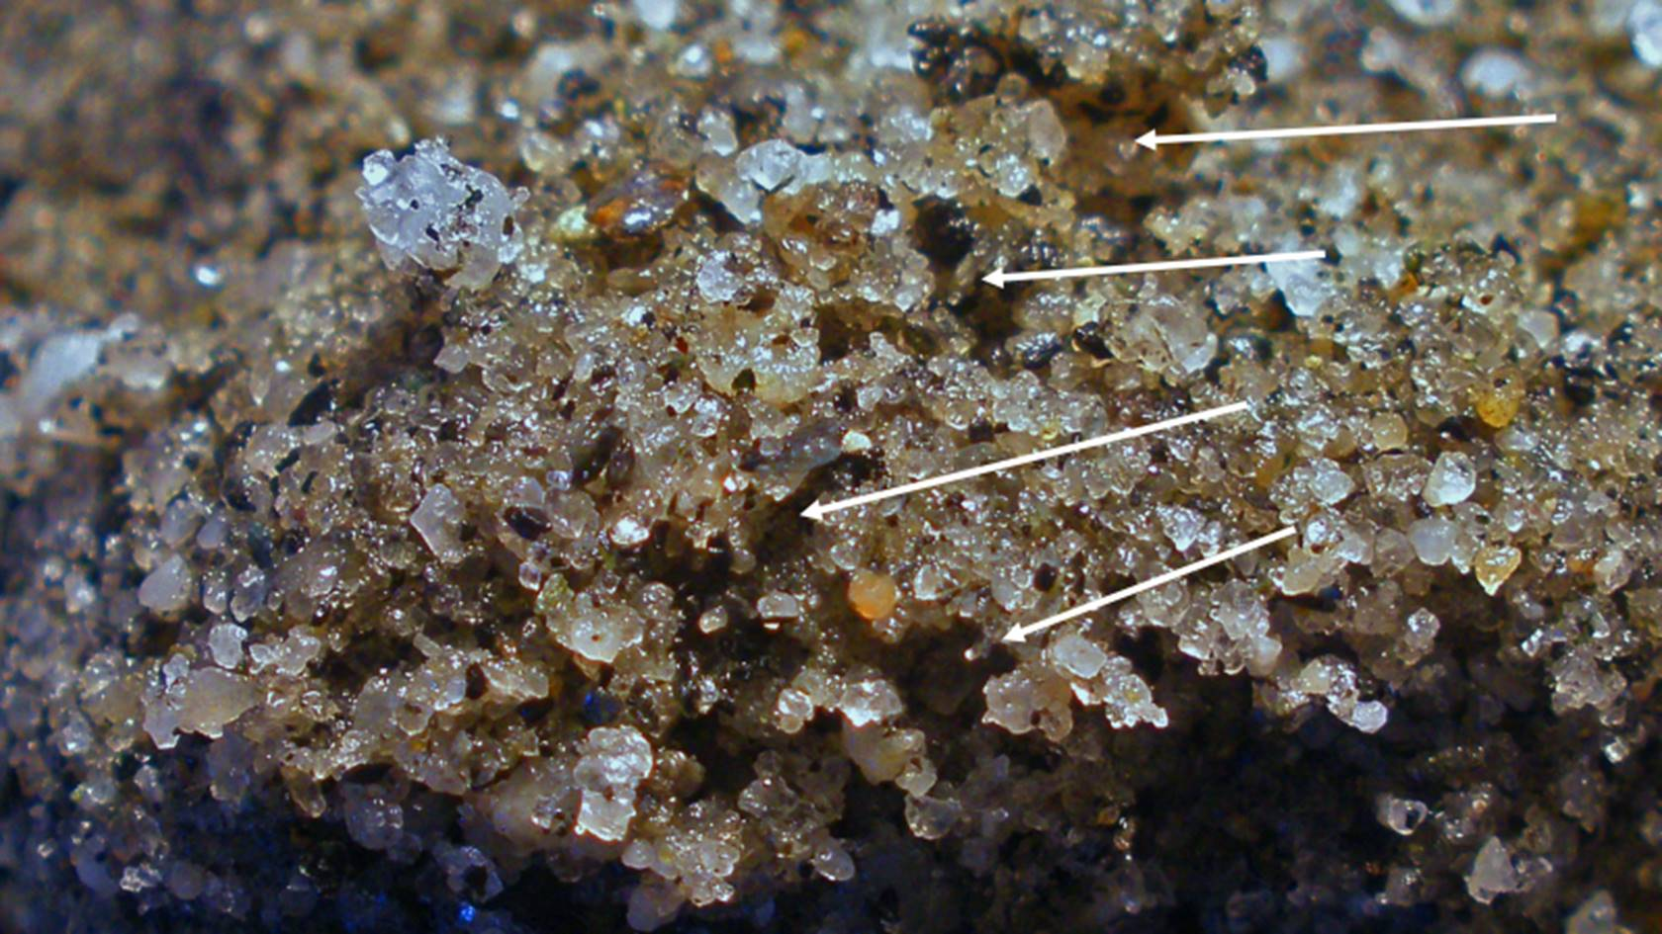
Adjacent grains fit together perfectly except where the spaces are filled with a dark silicate matrix (arrows). In addition, this mass of grains is organized into columns or shafts of grains as indicated by red arrows below.
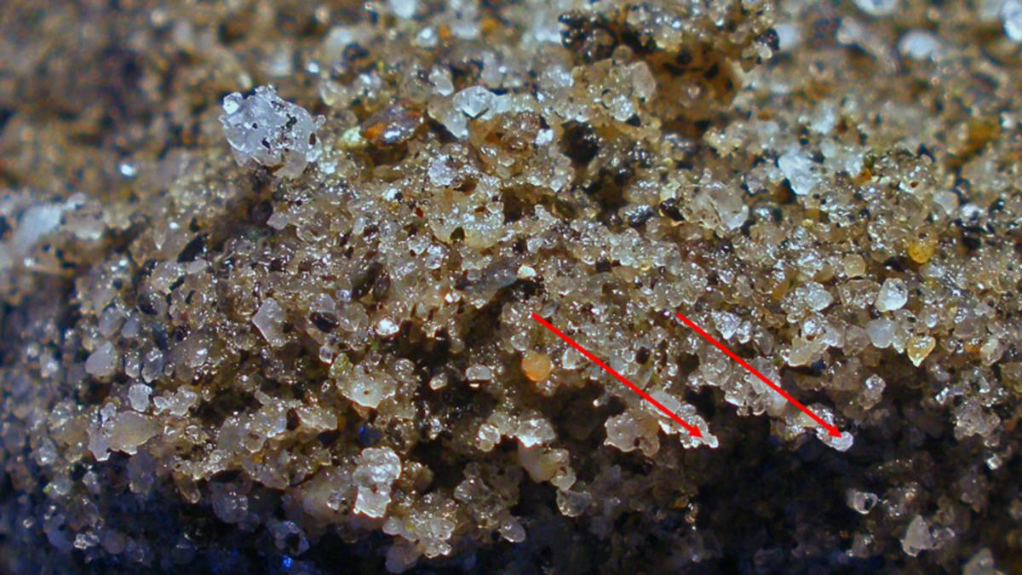
Below is a micro photo of one of these “shafts:”
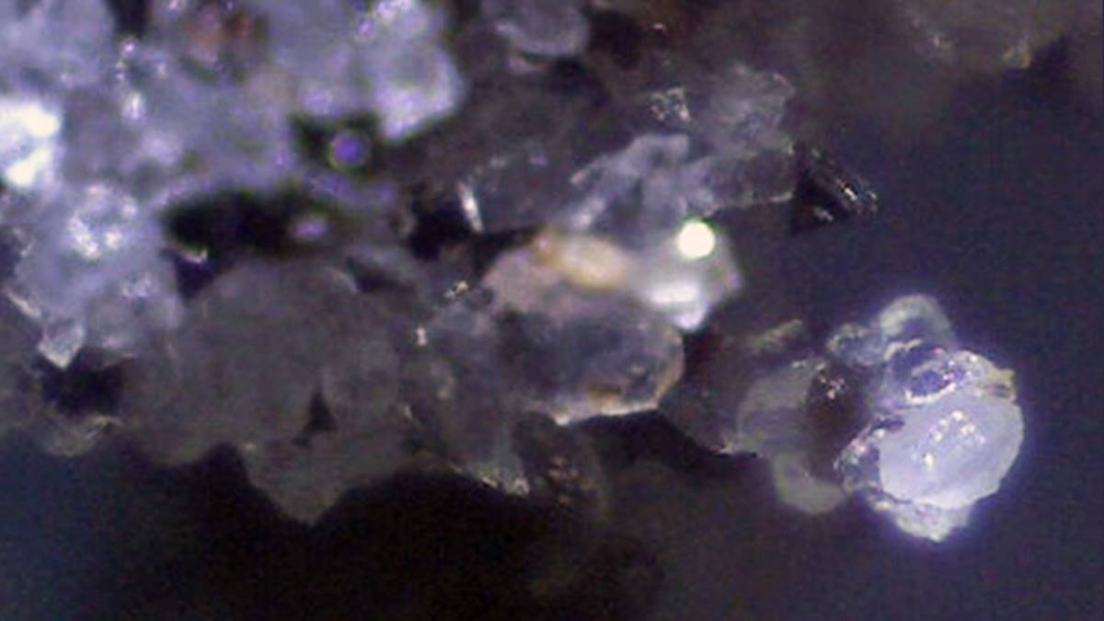
What are the odds that these grains were all ground out of tonalite bedrock about 2 km uphill, transported and polished by a glacial rock polisher and then assembled like this as the grains settled out of suspension? Remember that we’re supposed to be able to draw conclusions from simple observations. I observe that these grains are highly polished, and fit together perfectly into what looks like an organic structure.
1. Grain, surfaces, and structures could not have been formed by grinding but can easily be made in a biological mold.
2. Particles conform to each other perfectly and could not have been deposited by water and assembled by chance.
Silica is being deposited rocks to encapsulate moss
Silica is being deposited on the rocks around the lake, trapping the moss and other organic materials growing on them. Below, moss appears to be growing through the corner of the tonalite cobble:
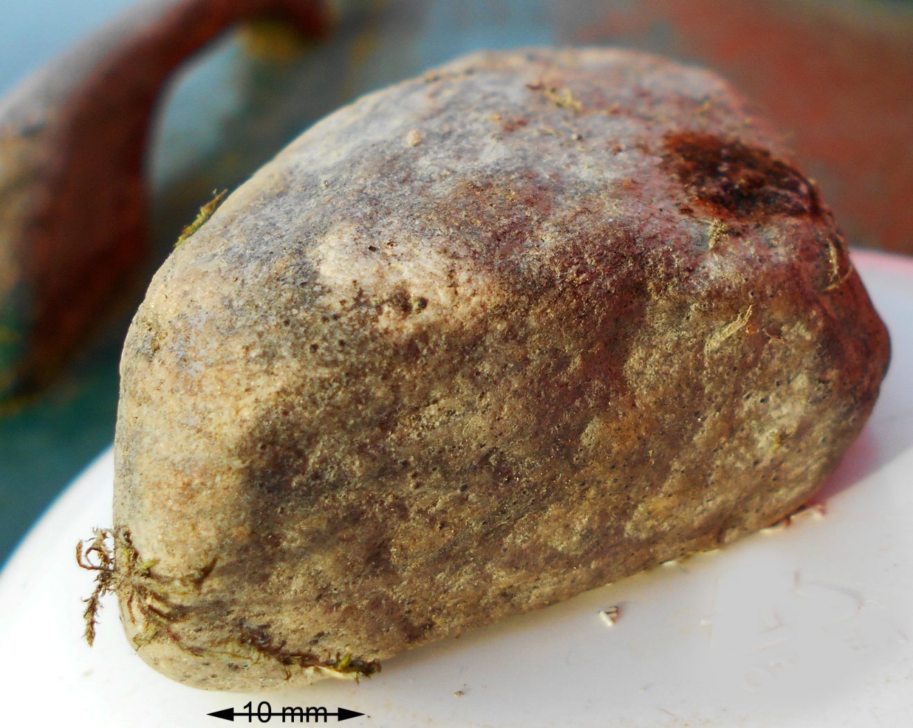

Detail below shows silica is being deposited over the moss, trapping it in the surface.
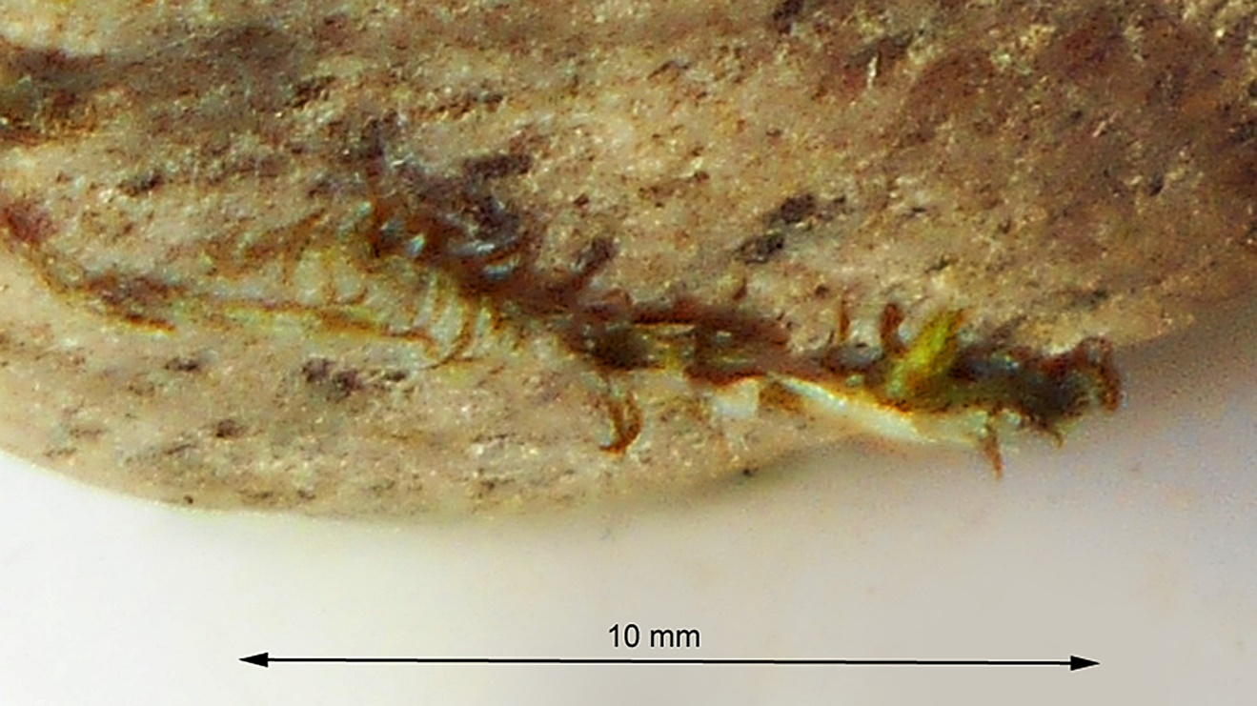

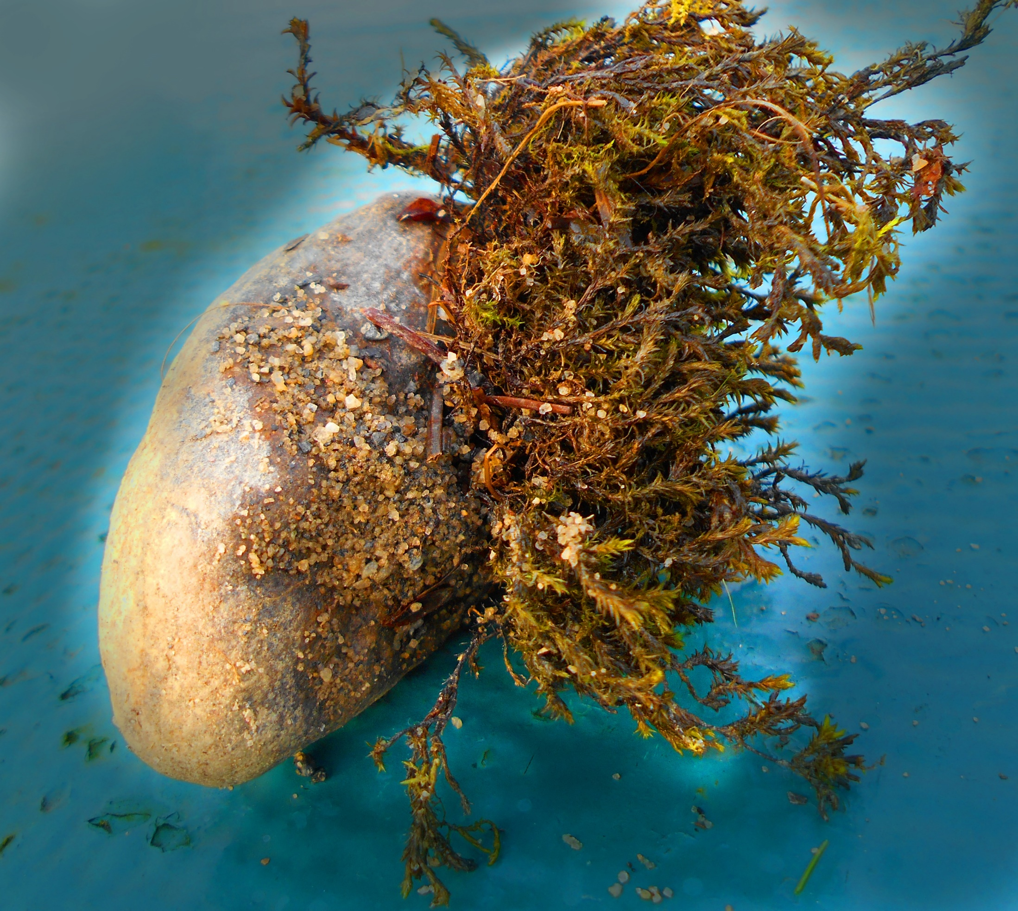
Above: Transparent and colorless silica is being deposited on the surface of this cobble. The moss is “common water moss,” Fontinalis antipyetrica, This cobble was buried in the sand and gravel beach (light colored bare area), so the clear silica deposition was on the exposed surface, underneath the moss, which has here been pushed back for the sake of the photo.
Below is a detail from the photo above. The clear silica seems to be put down in a grid-like pattern. Black arrow indicates where the silica is overgrowing a flattened stem. Note the other organic artifacts in the clear silica.
White arrows indicate milky silica grains which appear to be forming in moss ( see below: Silica and Magnetite Deposition in Moss). How does one make these shapes and surfaces and then place them so precisely in the moss? How far has it travelled from where it formed?
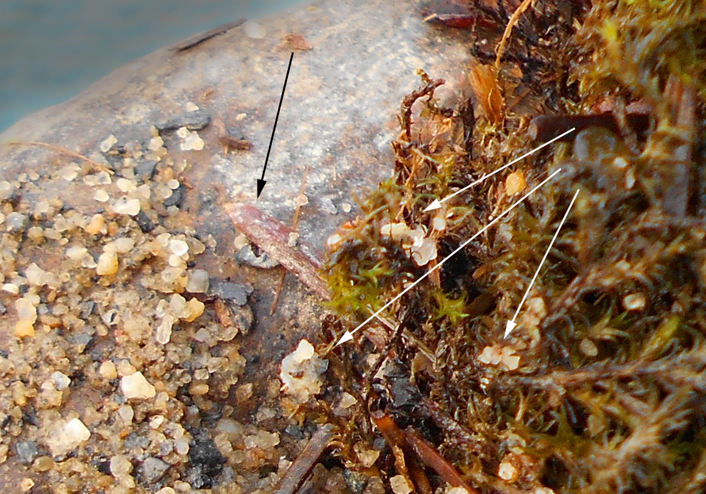
Gravel Sized particles appear to be formed from silica deposition
Below: This gravel particle is about 1.5 cm and has a silica encrusted organic stem protruding from its surface, bottom right. It would be identified as tonalite, quartz diorite, a crystalline igneous rock. However, organic structures that look like “roots or stems” appear on the surface.
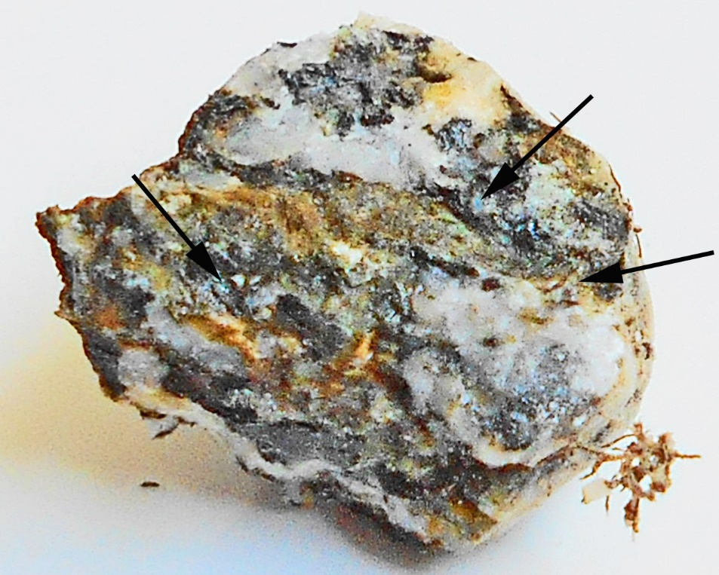
Below: When broken open organic structures, these structures are found throughout (arrows).
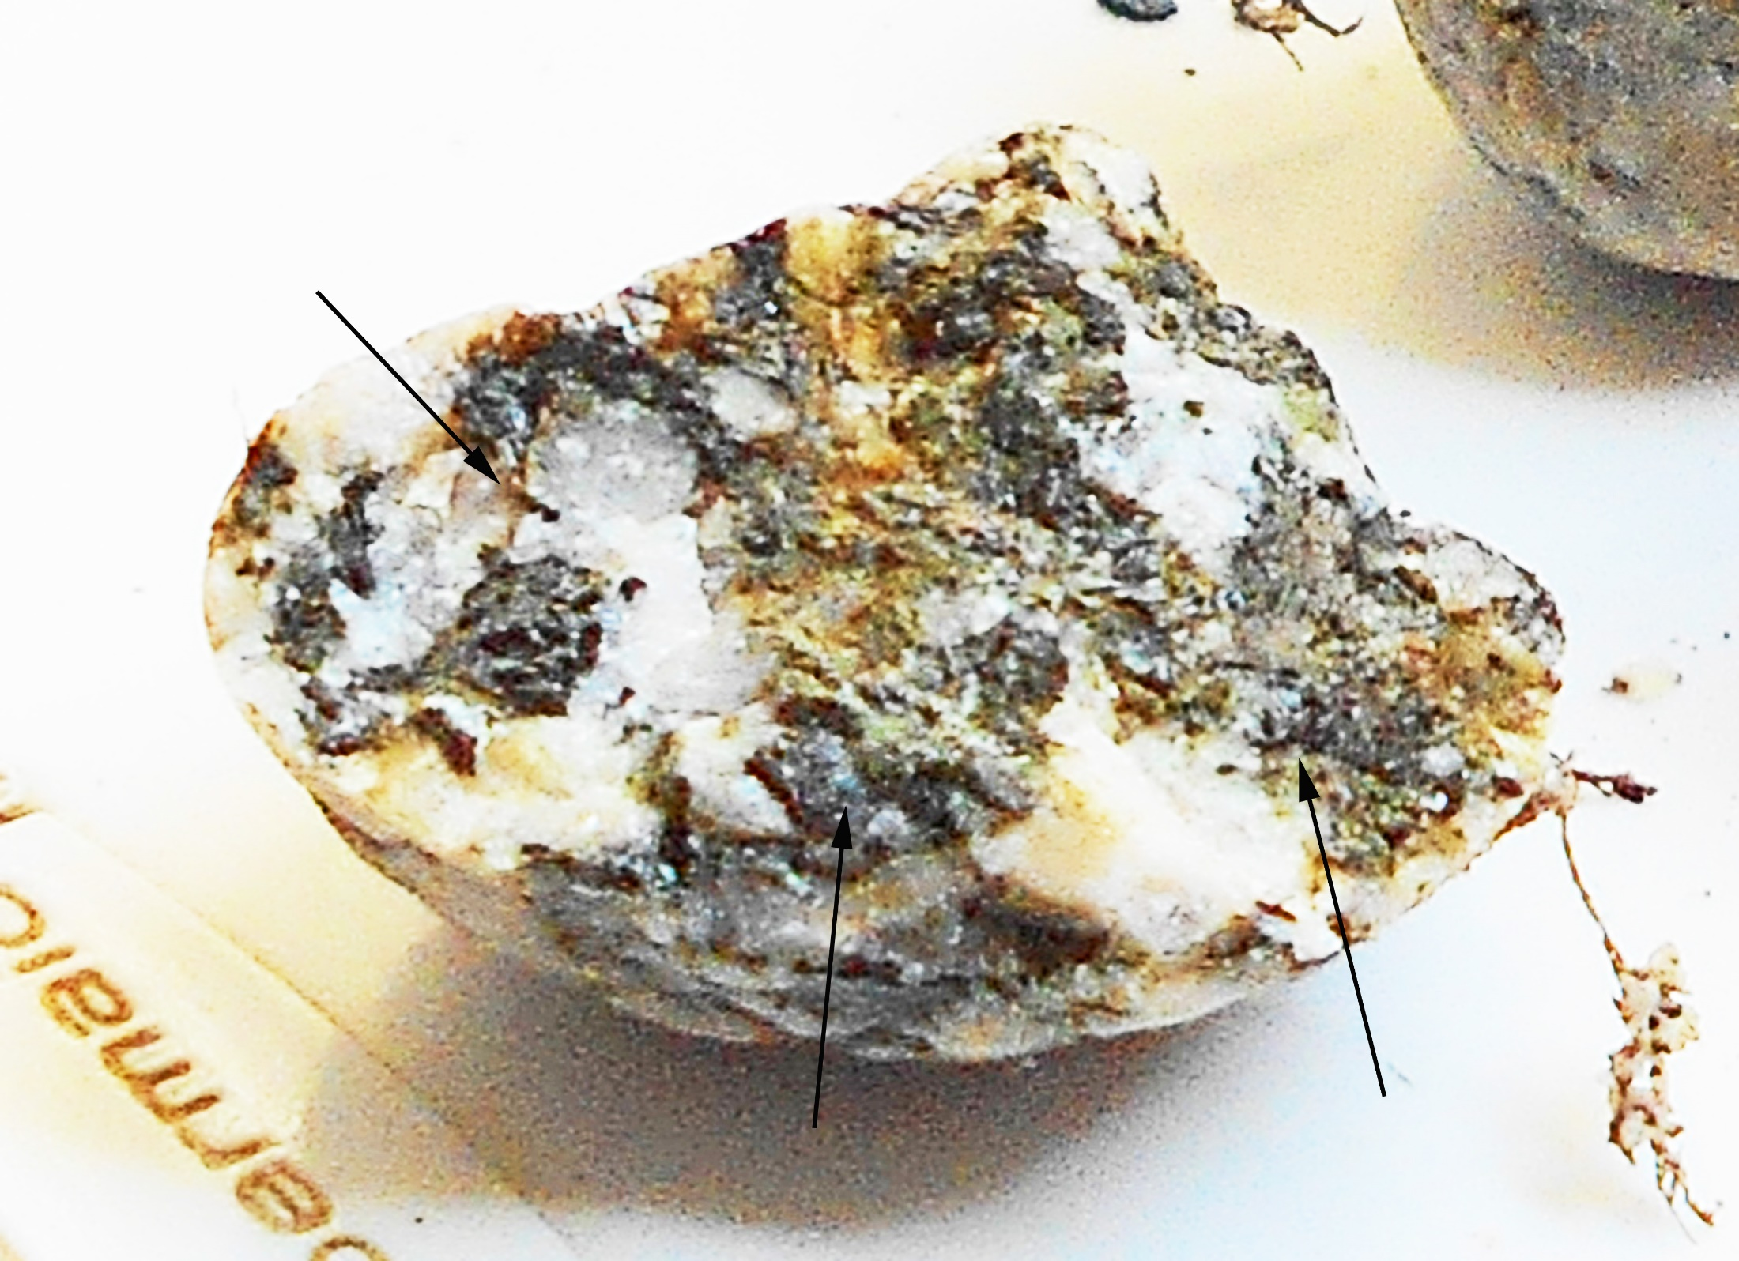
Below: Microscopic examination (frame is 5mm wide) of this freshly broken surface reveals organic material and mineralized organic material. Notice that there are transparent silica sand grains inside this gravel sized pebble.
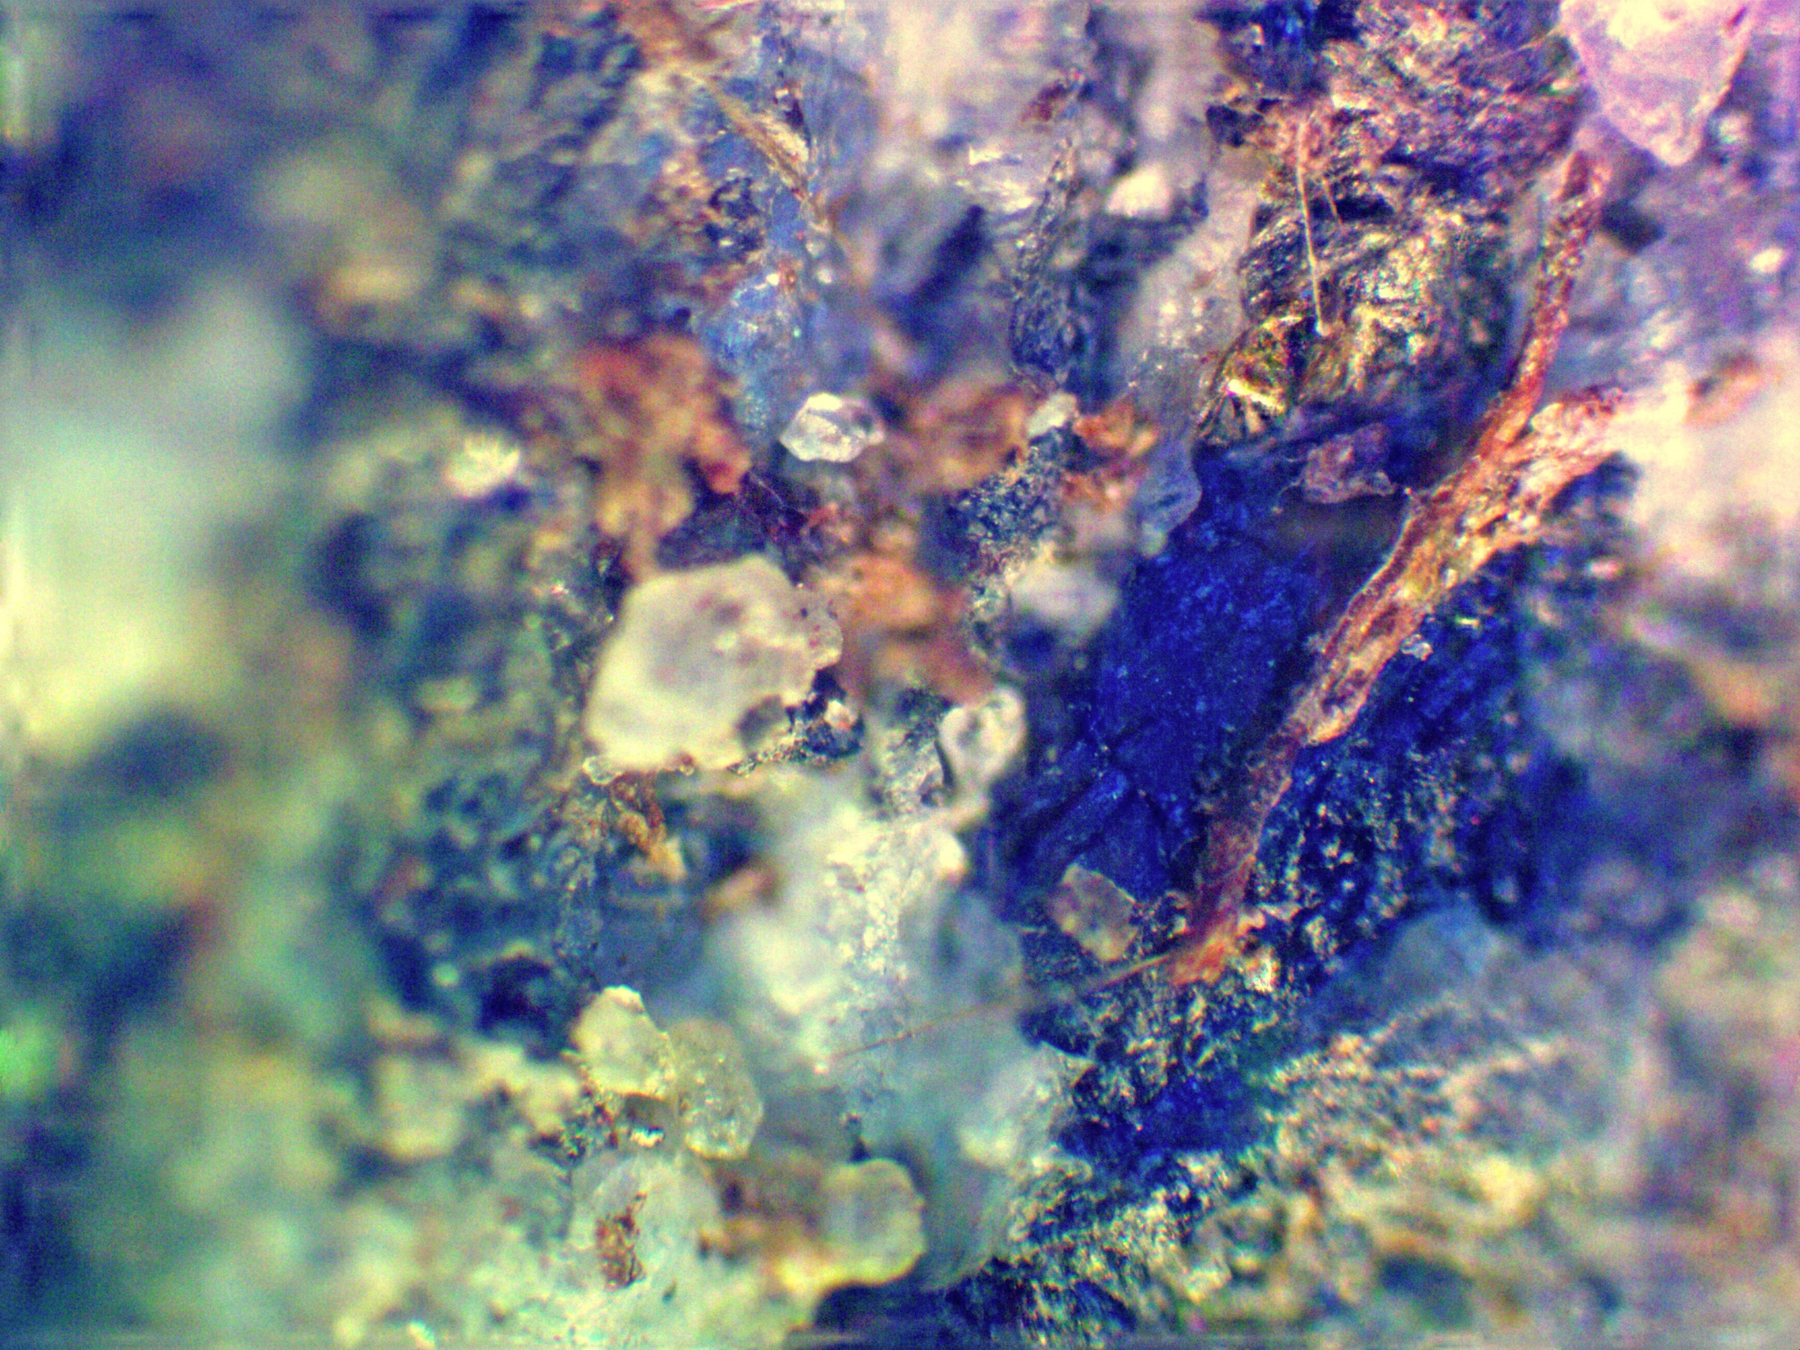
Below: another microscopic view of this gravel sized particle. Here everything appears to be completely mineralized.
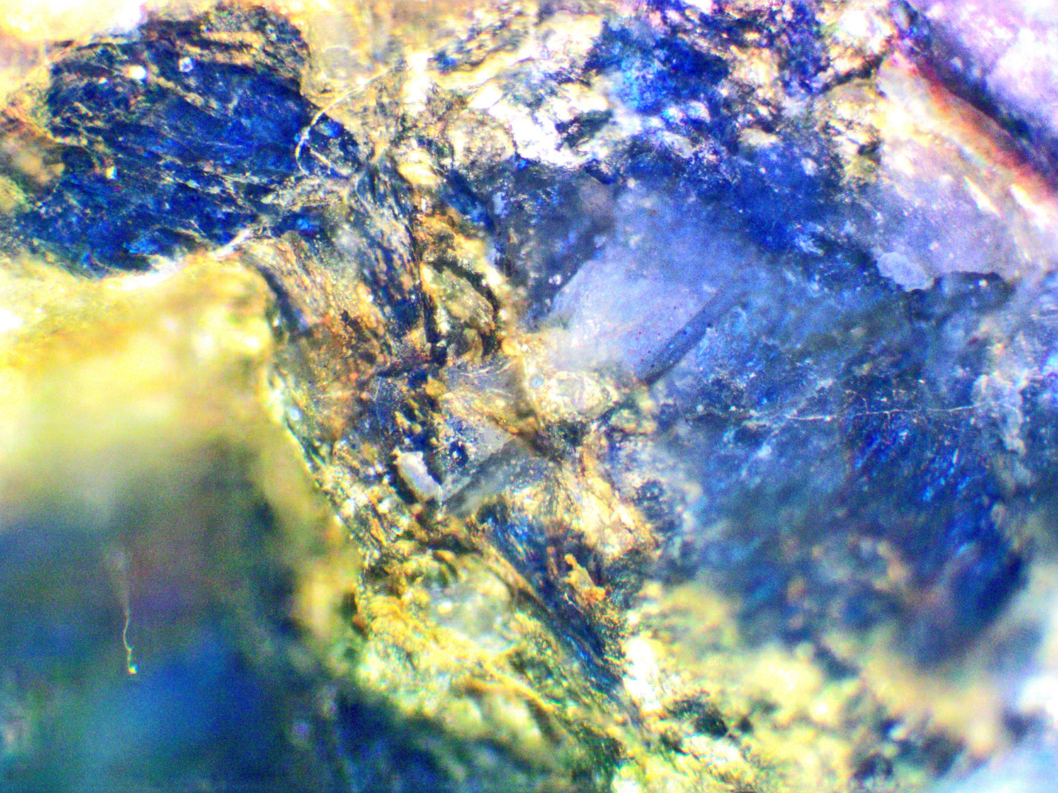

Silica and magnetite are replacing fungus in moss and wood
- Digital photography was used to show what appears to be opal in samples of wood, sand and gravel.
With Adobe “Photoshop” photo processing program, brightness in photos was decreased until only the brightest parts of the image were visible. The result was to reveal bright rainbow colored spots and streaks, which were interpreted to be opal replacing fungus.
Below: This is interstadial wood, wood that grew near the site about 2700 years ago before the most recent advance of the Mendenhall Glacier. Silica is replacing fungus.
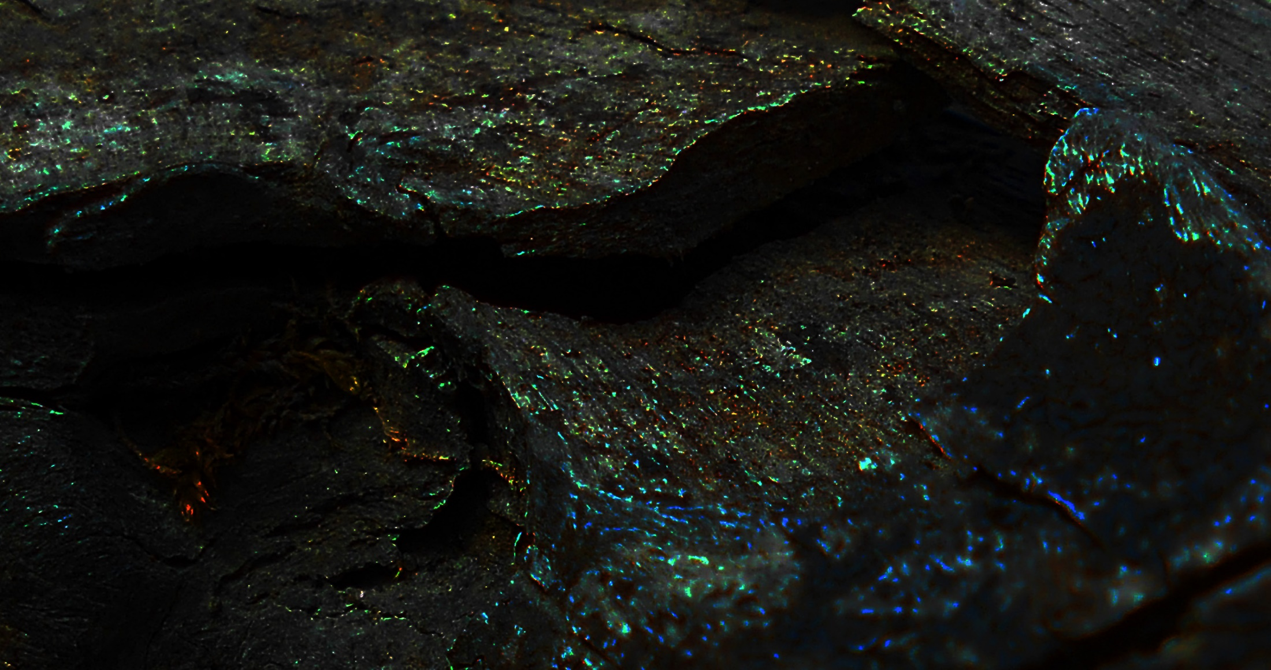
Sand and gravel from the study site also show opal deposition in the peat (below). Sand grains here all seem to be joined together in some kind of silica frosting, and in some places the grains are not well defined:
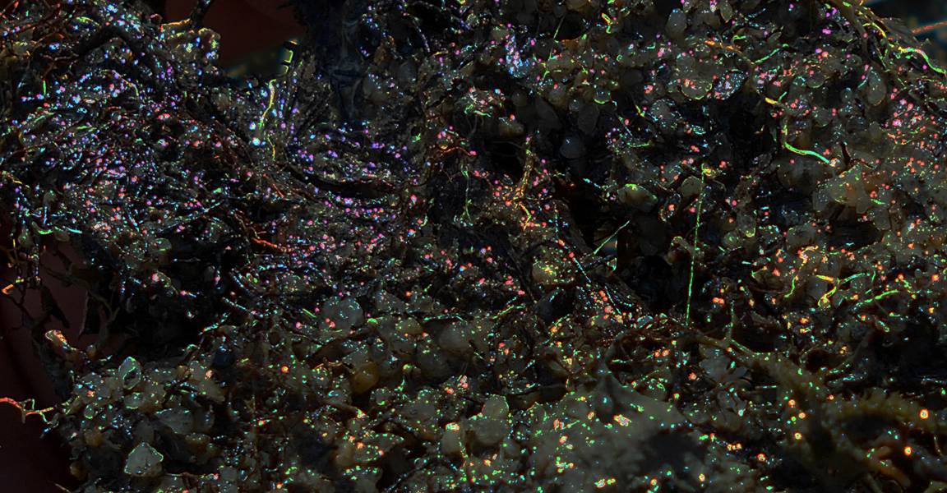
- Fungus is replaced by magnetite in moss and woody organic material
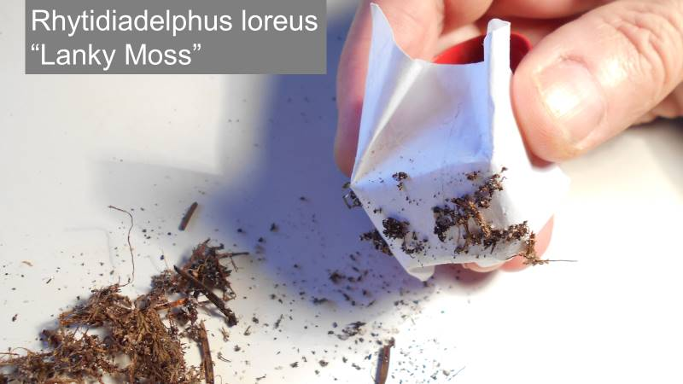
Above: this is magnetic organic material, primarily stems of “lanky moss,” Rhytidiadelphus Loreus. This moss forms an approximately 10 cm thick layer on the surface of the sand beach at the Mendenhall Lake study site. The stem segment below is magnetic though it shows no obvious mineral content. The magnetite is probably in what appears to be fungus (arrow).
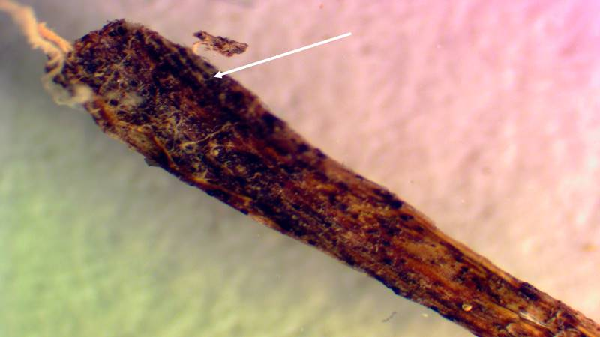
Silica sand is being deposited in the growing moss leaves
Below, a silica grain appears to be forming in the currently growing apical end of a “common water moss” plant (Fontinalis antipyretica).
b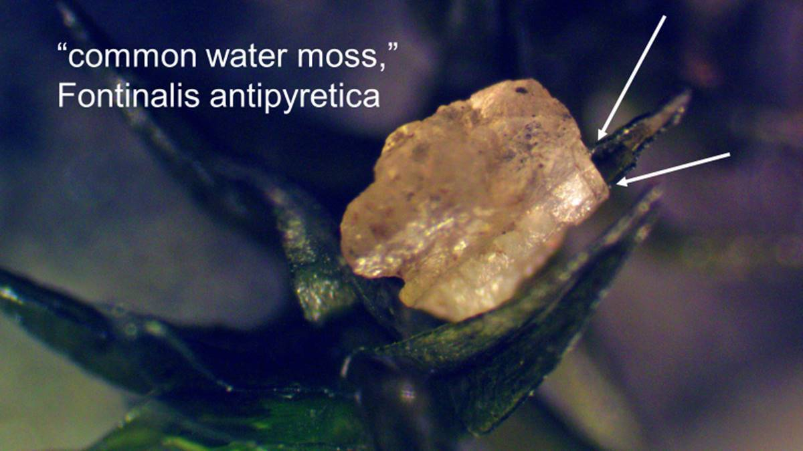
The arrows indicate fungus growing in the edges of the moss leaf behind this grain.
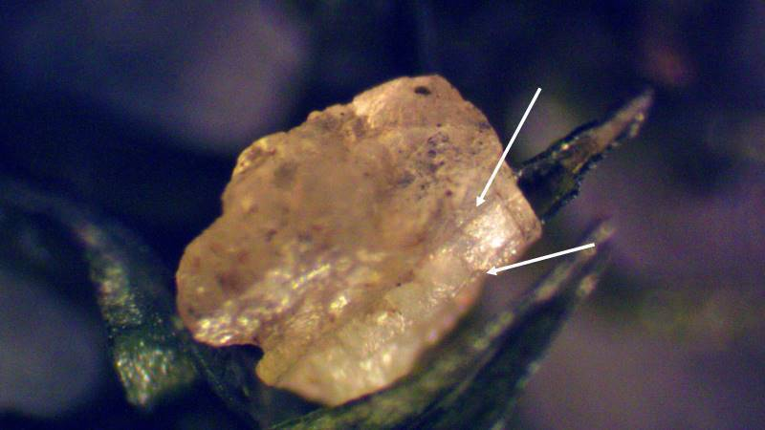
Above: the arrows here indicate where the fungus enters and transits the length of the grain, showing as ridges on the grain surface.
The surface does not look worn. In upper right a dark circular structure “sits” in a pit with an orange peel surface that looks fresh and clean. It’s hard to imagine how you could make that surface out of a quartz crystal by sending it through a glacial cement mixer. Much easier to imagine it’s a freshly exposed molded surface.
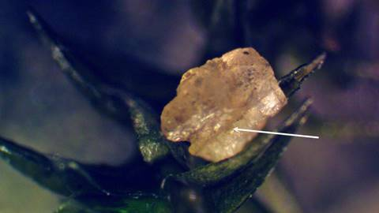
Above: the surface of the notch in the lower left is not fractured or worn.
Below: It is a molded surface. A moss leaf fits perfectly into this notch. This grain formed right where we see it and it formed recently.
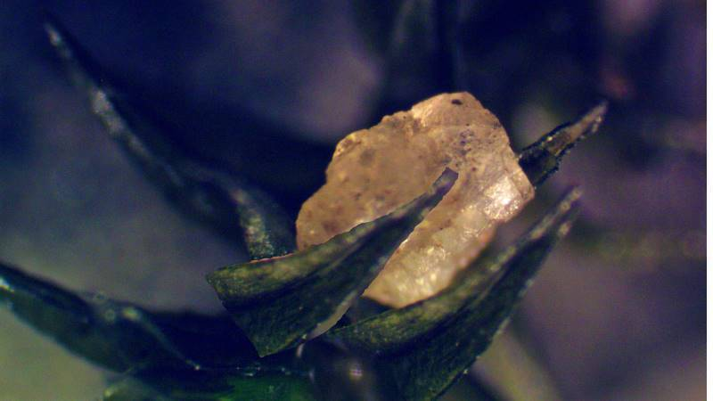
Below is another grain that appears to have formed in the currently growing part of the moss:
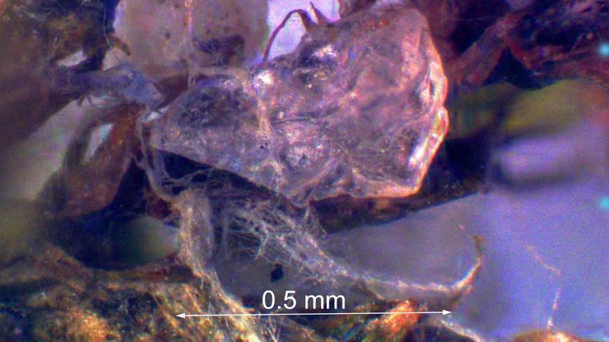
the remains of moss leaves are easy to see inside this grain.
C14 Age of Organic Materials encapsulated in Silica and Magnetite is 1950
Organic material can get inside a silica grain two ways: 1) the organic material can grow into the grain or 2) the grain can form around the organic material. Assuming the sand at Mendenhall Lake is forming around the organic material, a radiocarbon date of organic material associated with magnetic sand grains could then be used to determine when those magnetic grains formed.
A root growing approximately 100 mm below the surface of the sand beach was pulled out of the sand. Clumps of roots and attached sand occurring at intervals along the length of the root were stripped away and dried. The dried material was then crumbled into fine particles to separate the sand grains. A magnet was then used to lift out magnetic particles, and this magnetic material was then submitted to a testing laboratory to determine the C14 date of the included organic material.
Below: The large grain is about 1mm and was collected with a magnet. The dark blue materials are presumed to be magnetite. 1950 is the C14 radiocarbon date of the organic material.
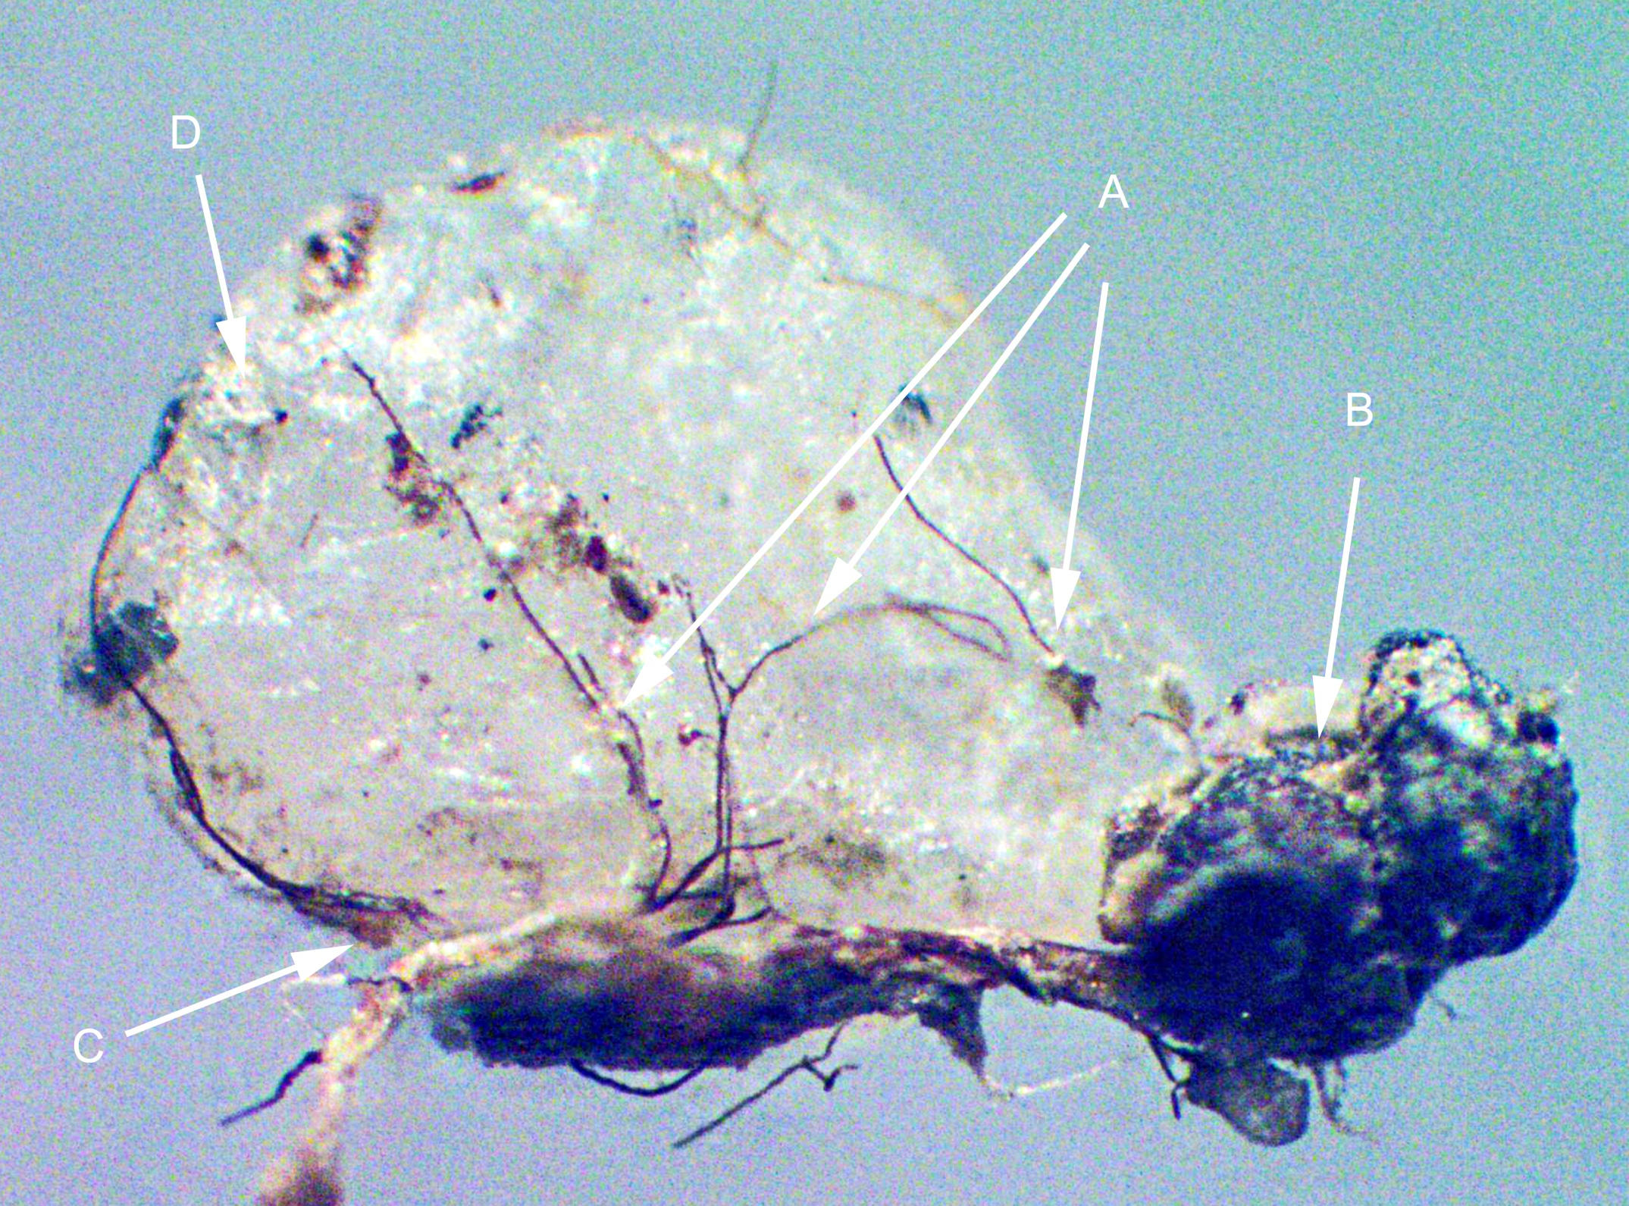
The silica surface is smooth and shiny, but uneven, showing many little opalescent patches that look like pores (A) the organic material goes into, and out of, the grain. Inside it is silica, outside it is organic. B) This is a magnetic particle, so this darker bluish material must be the magnetite. However, it doesn’t look like either massive or crystalline magnetite and it does have lots of stems and other organic structures running through it. C) This is a moss leaf. The material that extends upward and to the left of the tip of the leaf is likely to be fungus, and it fits into a groove along the edge of the silica grain D) A small tubular structure projects from the surface, but it is organic at the tip. How could anything this fine survive a glacial rock tumbler? How could the delicate joint between the silica grain and the magnetite have withstood the forces that supposedly formed them?
The “ground up bedrock” theory would suggest this grain was broken from the bedrock in a fractured state. Travel under the glacier would have smoothed the surface… then some time later the moss and roots would have to invade the grain. In this case they would have done that since 1950. How they would grow through a sand grain in such diversity and abundance is a great mystery.
Then after somehow getting inside, the organic material would have to be replaced by minerals. It’s a complicated and silly story compared to the one where the organic material is there first, and the minerals are deposited in them later.
The Lanky Moss Experiment
Sandy portions of the beach at the Mendenhall Lake study site have a thick layer of moss growing on the surface. This is “lanky moss,” Rhytidiadelphus Loreus. The “Lanky Moss Experiment” confirms the hypothesis that near-surface sand on the shore of Mendenhall Lake formed in place:
- If all the sand on the beach surface is petrified organic material, and if the process is current and ongoing, then sand under moss must have formed under it recently.
- If the process is ongoing and current, then there should be a zone between the actively growing moss and the tightly packed sand where newly and partially formed grains are common.
So, I decided to look for that zone of newly deposited silica and magnetite working from the top down. I removed a plug of moss and sand from the surface and lay it on its side, mossy surface to the left, and started taking photos.
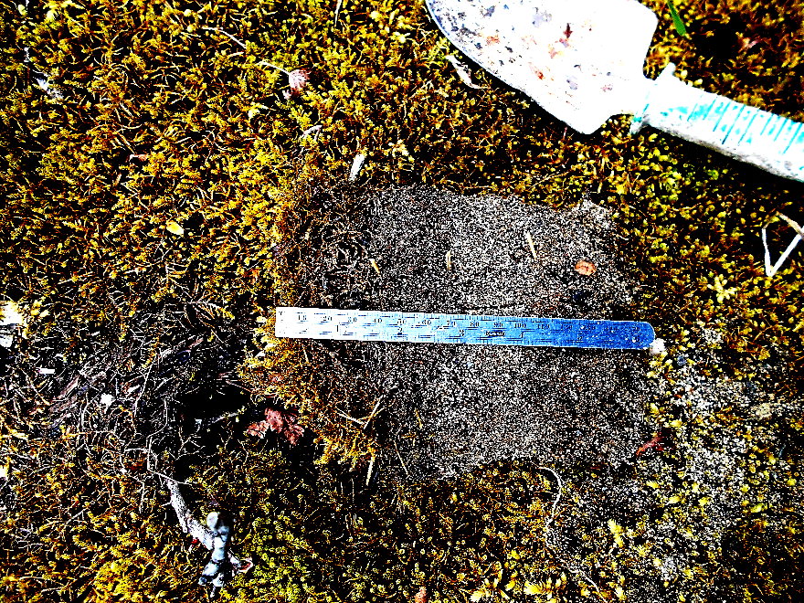

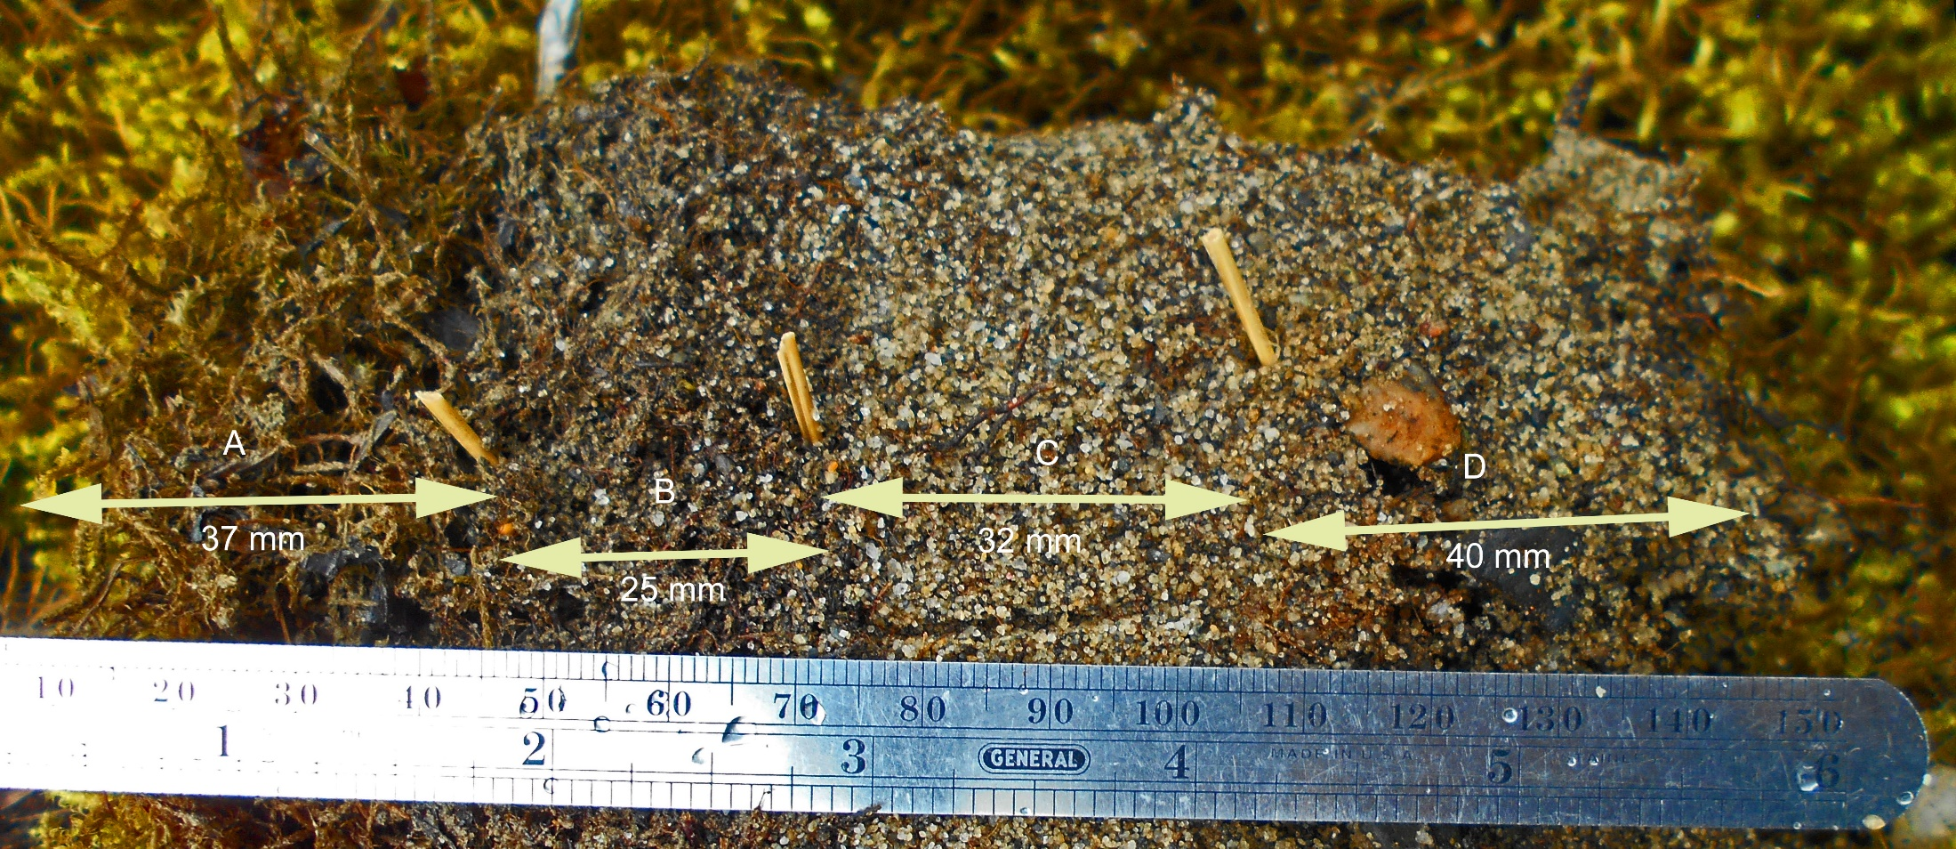
Results: Silica grains were found forming at all levels in the moss. The most obvious and abundant examples of sand with included organics were found in the region between layers B and C.
Above: From the surface downward, four layers are evident based on color, grain size, texture, and predominance of organics.
A. Currently growing moss: Silica or sand not readily visible.
B. Dark grey brown: Silica sand is present, but material is predominantly organic. Loosely compacted organics with many voids: moss, leaves, needles, fungus, some roots.
C. Light gray primarily silica sand: Largest particles about 1 mm, there are no spaces here, tight layer of sand, roots, fungus… decomposing remains of moss, fungus, roots and other organics.
D. Dark grey brown… very much the same color as layer 2, Silica sand predominates but not as tight. Grains somewhat larger than C, maybe to 2mm, and some small gravel particles… 5 mm+.
Below: Moss leaves in layer A, the growing region, show what appears to be small silica grains forming on the surface and what may be fungus growing within. The tiny spots or brightly colored light are likely to be silica, opal, deposited in pores.
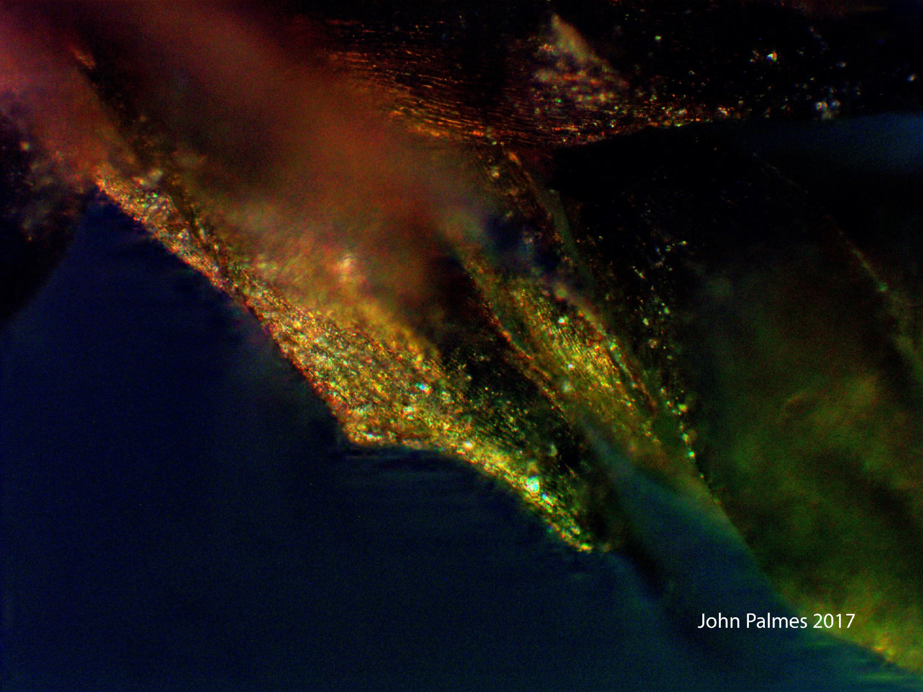
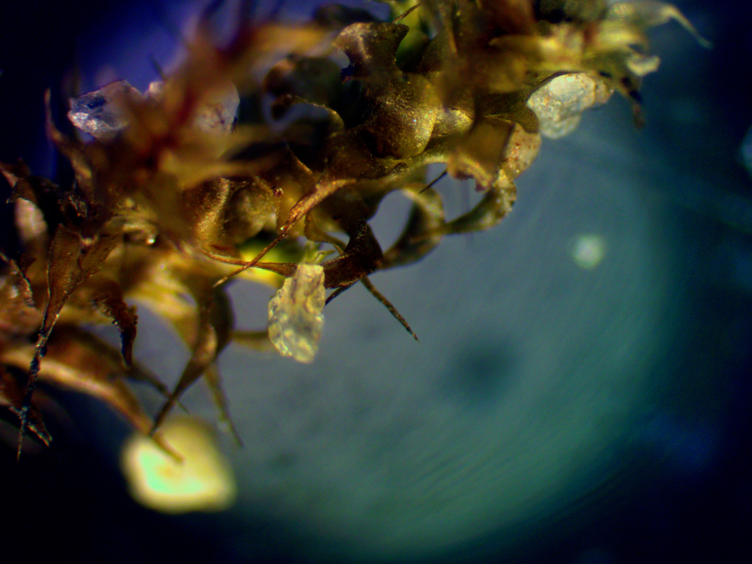
Above: the growing parts of moss plants (zone A) show occasional grains of silica forming on their leaves and stems. The silica has organic fungus/rootlike organic material growing into and through it. This grain appears to have chlorophyll inside.
Below: There appears to be fungus on the surface and its shape suggests it is from the tip of a moss leaf.
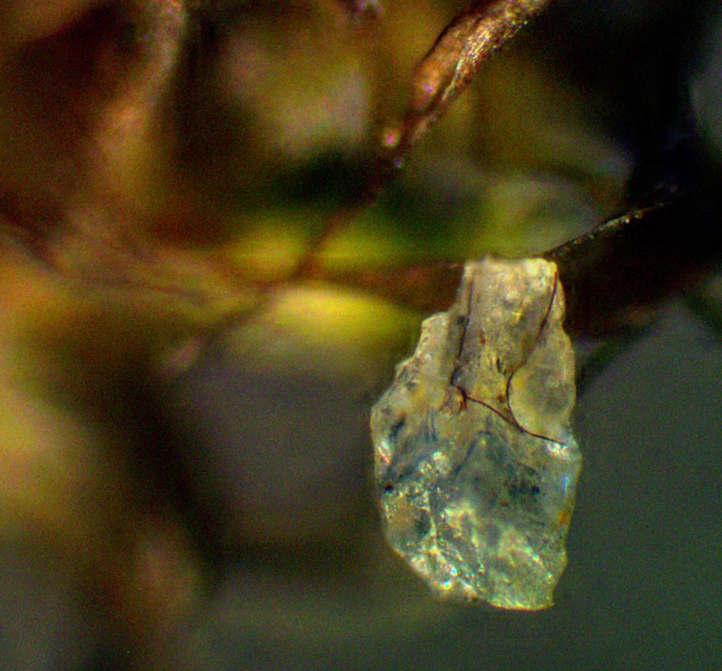

Below: This grain is typical of material found along moss stems in layer B
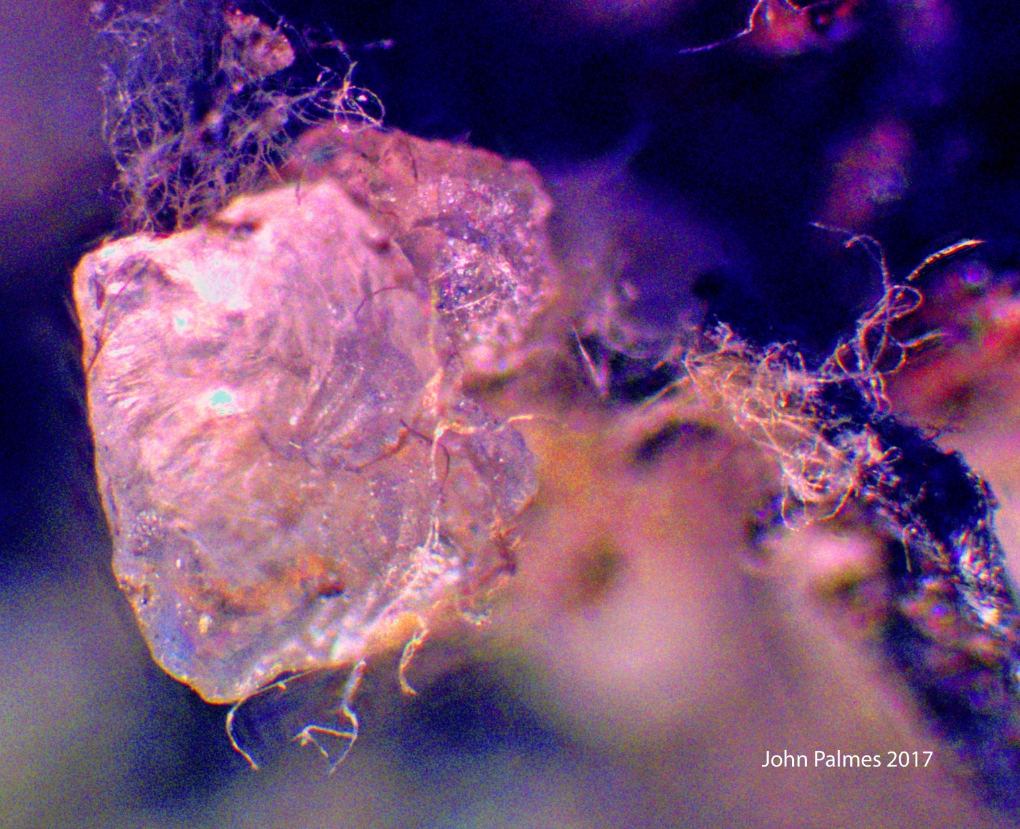
This sand is not ground up bedrock, it has never travelled anywhere. It is a deposit but not a sediment.
Below: Grains forming along the stem of a moss plant in zone B.

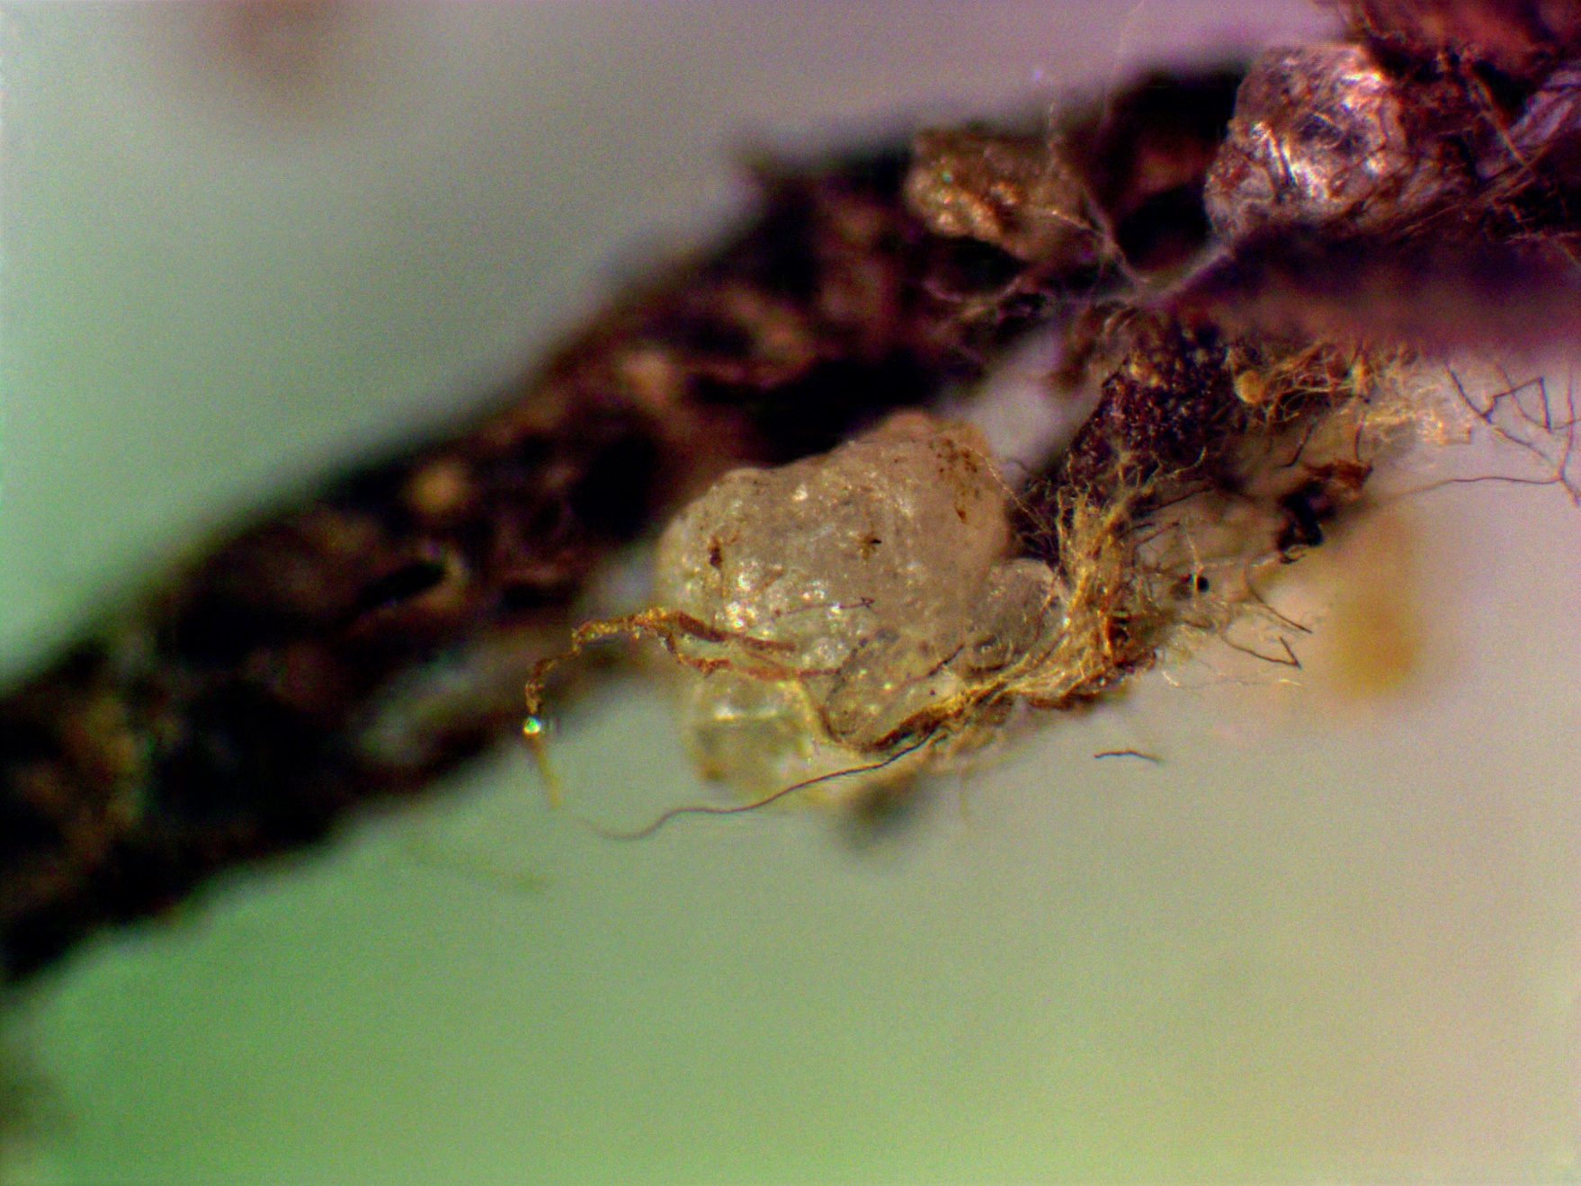
Below: Layer D has very little organic matter left in it and tends to break up into “clumps” of grains. There are also small gravel sized particles about the same size as these clumps (single arrow on left)
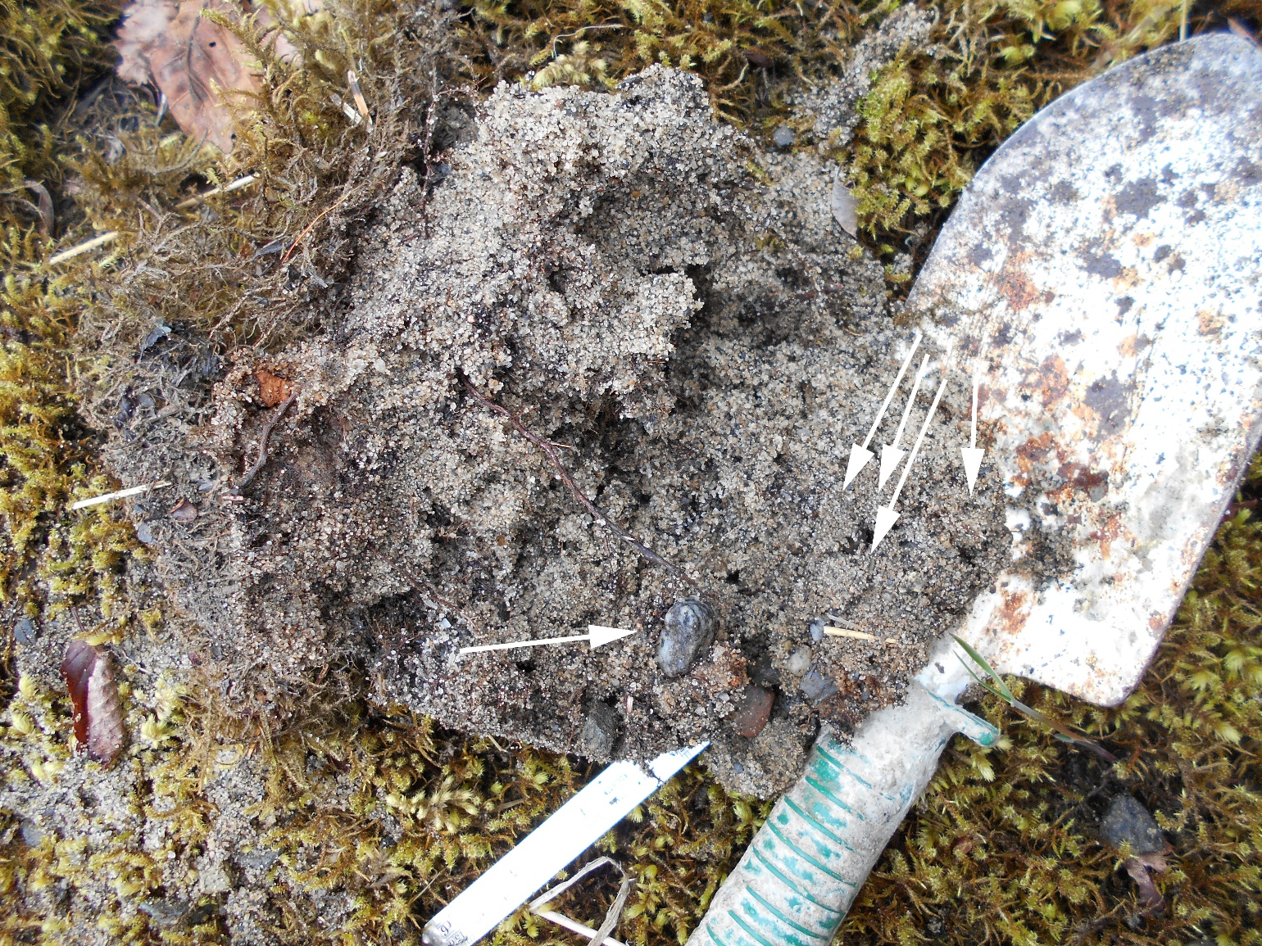
Below: The pebble at lower left in the photo above: A) there is an underlying network of what is probably fungus throughout the sample. The black arrow is aligned with strands of this dark material. B) at this point what looks like a healthy root above is abruptly dead and mineralized below. C) here the remains of organic material seems to be continuous with the pattern in the surface of the gravel particle suggesting the gravel also formed here.
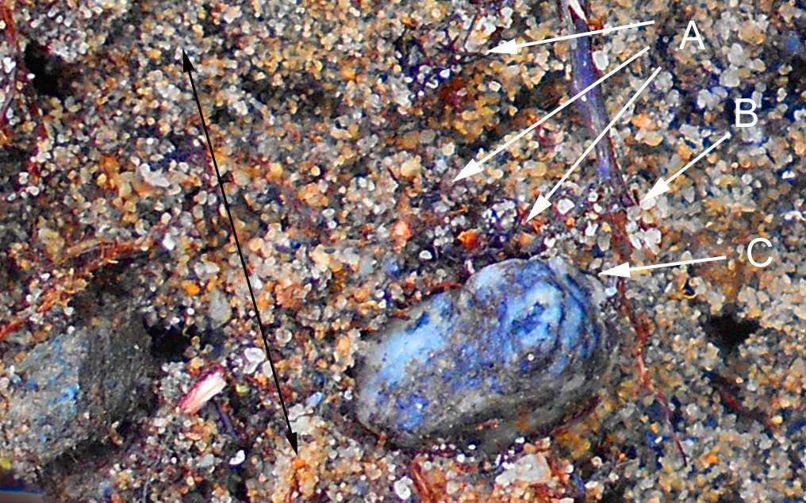
Below: These clumps of grains in the mineralized zone (D) are rounded and have surfaces that are even and smooth suggesting they represent a mineralized organic structure. Zone D sand feels like it’s held together with spider webs, some very fine fibers that are somewhat stretchy.
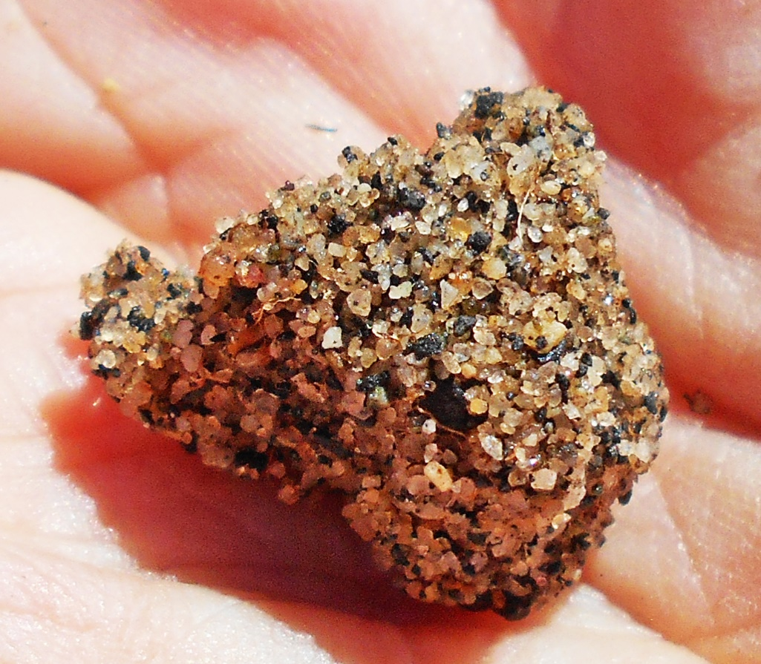
Below: when a clump of sand like the one above is broken apart the stretchy spider web like material that holds it together is revealed. It appears to be organic material in the process of being silicified.
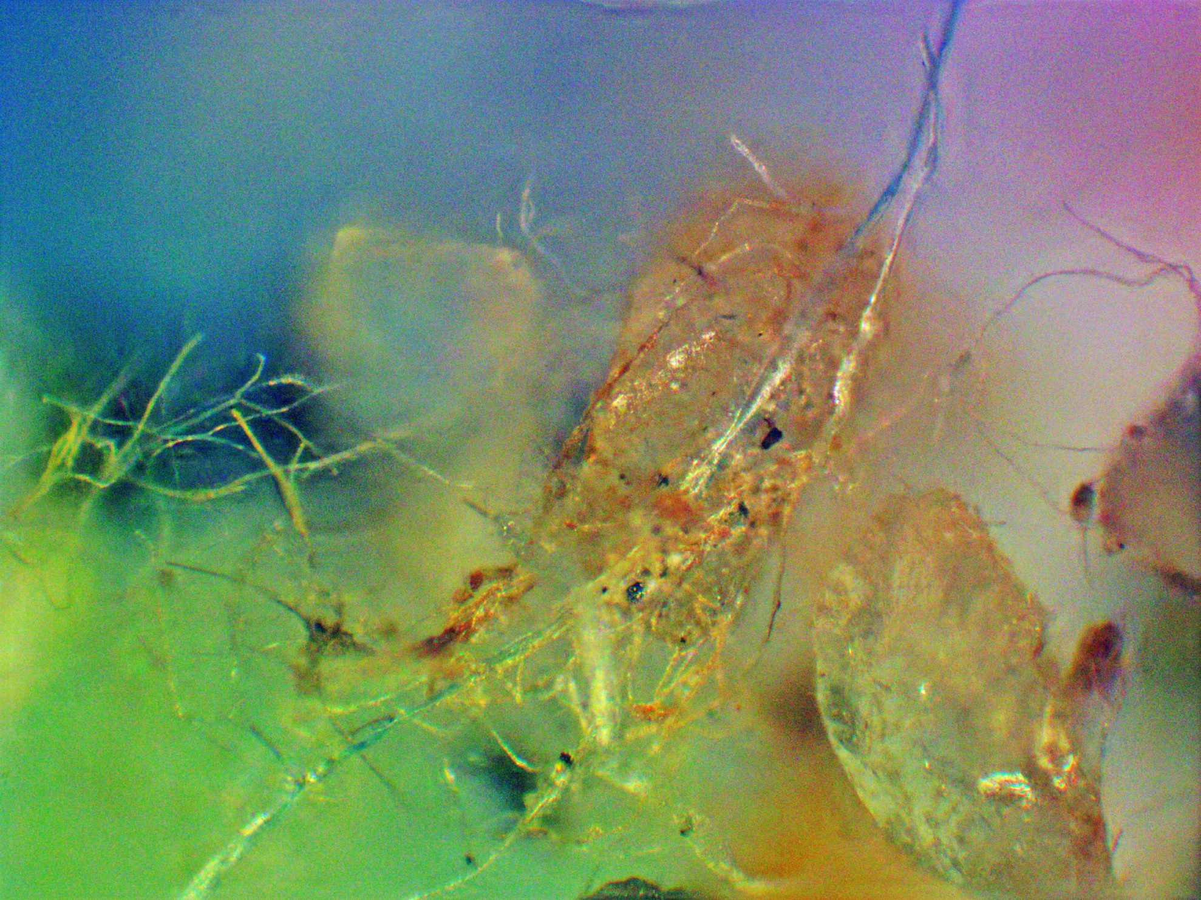

Discussion:
- This sand is not a sediment but a mineralized organic deposit. It can be made into a sediment easily.
- This seems to be an unrecognized part of the carbon-silica cycle probably mediated by bacteria as they use iron for respiration and replace carbon with silicon. The bacteria probably get something out of this silica phase change. In any event they get away with the carbon and leave silicon behind.
- It’s hard to tell fungus from roots because fungi form mycorrhizal (“fungus root”) associations with plants (Figure 3) and “All of Alaska’s trees require mycorrhizal fungi for survival and growth, as do nearly all other plants” (United States Forest Service R10, 2013).
- Closeup photos above were taken with a 21 megapixel camera, a model L32 Nikon Coolpix, that costs about $100 and is easy to carry in your pocket. If you live in glacial and recently volcanic country where there are warm springs, glacial flour in the water, gravely streams deeply stained by iron oxide, maybe you could take a few pictures of your own… you need a very small tripod and use the self-timer function, so the camera doesn’t shake. You’re looking for moss growing on sand that hasn’t been deposited or disturbed recently.
- Microphotos were taken with a MU900 Amscope digital microscope camera 10 80 200x. The “fusion” function of “Toupview” software was used to combine the most in-focus parts of several images of the same object for more depth of field. Because you’re looking for detail in materials that are like glass, you can’t use much light and it’s best if you only use one light to get the best shadows. Also, you can’t really see these things directly, multiple photos and photoshop processing are essential to seeing any detail. Much of this silica is invisible or changes in color and visibility depending on how you light it.

