An Investigation of Seiche-Induced Mobilization of Sulfide Oxidation Products
LeAnn Zuñiga¹, Nathan Johnson²
¹Department of Geosciences and Environment, California State University, Los Angeles
5151 State University Drive, Los Angeles CA 90032
²Department of Civil Engineering, University of Minnesota, Duluth
1049 University Drive, Duluth MN 55812

INTRODUCTION
All freshwater lakes experience gravity waves, which are small and wind-driven, but only larger bodies experience larger, standing, oscillating waves with the potential to transport large amounts of water long distances in shallow areas (Fig. 1). These seiches, or wind-driven large-scale periodic oscillations in lake levels, are often only studied in the context of extreme events rather than typical daily fluctuations and thus not much is known about their daily impact on coastal environments. The Great Lakes are large enough bodies of water to have significant and persistent seiches (Trebitz 2006). The Lake Superior seiche in particular can result in the regular influx of lake water similar to the action of tides in estuaries (Morrice et al. 2011). The potential for seiche-driven water level change to play a role comparable to oceanic tides in the Great Lakes wetlands is recognized, but impacts are still relatively unknown (Trebitz 2006). The Lake Superior seiche in the Duluth, MN area has a mean daily water level fluctuation range of 12.6 cm with a period of 7.8-7.9 hours (Trebitz 2006). While seiche frequency is more complex than tide frequency and varies from lake to lake, the large magnitude (~10s of cm) and long amplitudes (>6 hours) of Great Lakes seiches make it reasonable to compare seiche-induced water movement in the Great Lakes freshwater estuaries to tide-induced movements in marine estuaries.
Tidal pumping has implications for chemicals contained in estuarine sediments and sediment porewaters and, by analogy, chemicals contained in sediments that are periodically wetted and dried by seiche activity are also expected to be impacted. A study investigating seiche-driven changes in the biogeochemistry of microbial ecosystems attributes hydraulic pumping of porewater driven by seiche activity as the principal process for changes in observed nutrient concentrations in the local seawater during seiche (Basterretxea et al. 2011). In permeable beds, porewater fluxes from sediment-water interfaces can be driven by forcing, diffusion, advection or resuspension (Basterretxea et al. 2011). In the upper few meters of permeable sediments tidal pumping is the main driver of porewater exchange, especially in tidal flats. Pressure observations show that sandy sediment acts as a one-way valve that passes water from the interior of the flat to an outflow zone at the low tide water line (Santos et al. 2015). Sea level variations produced by seiche can affect the hydraulic pressure gradients that resuspend sediments and cause increase flux of inorganic nutrients from sediments near shore (Basterretxea, et al. 2011). Pressure gradients generated by standing waves can also increase fluid exchange between sandy sediment and overlying waters (Precht & Huettel 2003). Falter and Sansone 2000 found that spatial pressure gradients produced by irregularities in the topography of the sediment surface drive advective exchange of fluid between sediment porespaces and overlying water. It was also established that transport within hydraulically driven sediments can be orders of magnitudes greater than molecular diffusion (Falter & Sansone 2000).
Seiche-induced surface water mixing among estuary and lake water can vary from extensive to non-existent, depending on factors such as mouth dimensions, tributary flow and water density gradients. However, a 2 to 10 cm water fluctuation range comprises a significant portion of the depth of a shallow wetland, thus having the potential for an increased influence on water levels in shallow areas (Trebitz 2006). Sediment porewaters mobilized by seiche can be a significant source of nutrients to surface waters (Basterretxea et al. 2011). In isolated embayments that lack mixing with external, low-nutrient waters may have a consequent buildup of nutrients mobilized from sediment by seiche.
The effect of seiche activity on increasing nutrients in surface waters is limited by the depth at which porewater exchange is occurring and the time it takes the porous layer to renew nutrients. Seiches were found to produce an outflow of nutrient-rich anoxic interstitial waters, thus resetting the redox and absorption potential of sediment particles re-oxygenating the sediment zone. It has been found that advective release of phosphorous is limited to the rate of change in oxygen conditions within the sediment (Basterretxea et al. 2011).
This same seiche-driven release is expected to occur with sulfate, the oxidation product of sulfide, contained in sulfate-impacted anoxic mud from a freshwater estuary. Seiche-induced water level fluctuations change oxygen penetration into sediment and could induce more dynamic redox conditions in sediments as opposed to constant water levels or continuously inundated conditions. The reason the seiche is capable of introducing more dynamic redox conditions is due to both the introduction of oxygenated surface water, which periodically saturates a zone of sediment, and the drying and exposure to atmospheric air during low water levels. In areas where seiche does not cause much surface water mixing, sediment porewaters mobilized by seiche may be significant overall source of chemicals and nutrients in the local area. It has been shown that tidal cycles do induce porewater exchange in intertidal flats, thus it would be expected that seiche activity would show similar results in estuaries (Santos et al. 2015).
This study aims to investigate whether seiche activity’s effectiveness in flushing oxidation products out of the sediment exposed to water fluctuations depends on inundation frequency or proximity to the surface-water interface. It is expected that the efficacy of seiche activity in flushing porewater into surface waters will be limited by the oxygen renewal time of the porous layers being flushed (Basterretxea et al. 2011). To make observations to test this hypothesis, a sediment wedge containing anoxic sediments was constructed and subject to a simulated 8-hour seiche cycle. The sulfate concentration data collected from this controlled laboratory seiche experiment is used to explore the implications of seiche activity for bacterially-driven redox reactions under natural conditions.

METHODOLOGY
Experimental Setup
Sand-Mud Mixture
A tank measuring 100 cm long by 40 cm wide by 20 cm tall was used to simulate the interaction between water level fluctuations with adjacent sediment. A sediment wedge was constructed inside comprised of approximately 1% mud by dry weight to 99% coarse (2 mm) sand by dry weight. Approximately 2.6 kg of mud and 59.4 kg of sand were thoroughly homogenized using a paddle bit and power drill under anoxic conditions (N₂) prior to sediment wedge construction. The mud was collected via gravity cores from Perch Lake (latitude 46.660587, longitude -92.252278), a culvert-fed water body connected to the St. Louis River estuary just south of Duluth, Minnesota, and well-homogenized in the laboratory under anoxic conditions prior to mixing with sand.
During construction of the sediment wedge, Rhizons were positioned in characteristic locations within the wedge and connected a 100 to 150 cm length of 3 mm diameter tubing with leur fittings to allow for porewater sampling (Fig. 2). These locations were based on different “zones” (Fig. 2a) expected to experience differing degrees of air exposure in the periodically inundated sediment. Three Rhizons were placed in Zones A and B, two in Zone C, and two in the constantly Saturated Zone. Pressure sensors were also deployed to record water level changes occurring throughout the experiment as seiche activity was simulated within the tank.
The tank was fitted with a siphon producing approximately 110 mL/min of continuous outflow and a peristaltic pump was set on a timer to pump approximately 220 mL/min of water out of a lower reservoir into the tank for every other 4-hour period. The combined inflow/outflow setup produced an 8-hour water level fluctuation typical of the seiche as experienced in Lake Superior coastal waters and the St. Louis River estuary. A control Saturated Zone was kept constantly wet throughout the experiment, and a control Dry Zone atop Zones A-C was kept dry. Water quantity in the lower reservoir was limited to only fill the tank to the designated high-water mark, ensuring the dry zone stayed dry, and the siphon was positioned at a designated low-water mark to ensure the Saturated Zone stayed constantly saturated. Water used was collected at Brighton Beach, north of Duluth, Minnesota, in 200-liter increments and was replaced every 3 to 4 days to prevent sulfate buildup in reservoir waters.
Tracer Experiment
A similar setup was constructed prior to the sand and mud mixture iteration of this experiment to investigate the infiltration of a nonreactive component in surface water via the simulated seiche activity into sediment porewater. A coarse (2mm) sand wedge was constructed with Rhizons distributed within the sediment wedge in a manner similar to the prior description. An 8-hour seiche cycle was also simulated using the peristaltic pump and siphon system with matching inflow and outflow rates. A fluorescein tracer (2.5 mL tracer stock to ~40 L water) was added to the water to begin time zero and the experiment was terminated after it was deemed that the tracer-laden water had fully infiltrated the sediment pore spaces based on porewater spectroscopy wavelength readings. Porewater samples were taken using the same method utilizing Rhizons within the sand wedge and analyzed individually in 5 mL increments using a UV-VIS spectrophotometer.

Sampling
For the first seiche cycle, the porewaters and reservoir waters were sampled at time zero when the tank was filled to the designated high-water mark, one 8-hour cycle later, and then once a day with sampling alternating between high and low water levels. On low-water sampling days Rhizons positioned in the B Zone were often dry and would not produce porewater to sample. Porewater was sampled through the Rhizons by affixing a 40 mL syringe to a leur fitting affixed to a tube connecting to the Rhizon to draw water via vacuum pressure produced by the syringe. The first 1 mL of all samples were wasted to ensure the Rhizon and tube was flushed of previous sample waters. Then approximately 2.5 mL or more of sample were collected from each Rhizon. Reservoir water samples were drawn, unfiltered, directly from the surface waters.
The experiment was deemed complete based on sulfate levels generally peaking throughout porewater sample locations. Termination of the experiment occurred after 7 days.

Analytical Methods
All pore and surface water samples collected, with the exception of Bottom Reservoir samples as these were deemed to contain similar sulfate levels to the Top Reservoir samples analyzed, were analyzed in 0.5 mL increments for sulfate using a Dionex ICS-1100 Integrated Ion Chromatography system (AS-DV Autosampler). Samples were initially run without dilution, but as sulfate levels rose samples were diluted by a factor of 5 before being measured in the IC. Samples were individually filtered before dilution to remove iron present in the sample to protect sensitive IC equipment. Sulfate and chloride standards (0.3–30 mg/L) were made using sodium sulfate (Na₂SO₄) and sodium chloride (NaCl) with Millipore de-ionized water and were checked against a Thermo Scientific seven anion standard (Beck & Johnson 2014).

Data Analysis
Sulfate concentration data acquired by the IC method along with information on calculated inundation frequency and Rhizon location was used to perform statistical regression and single-factor ANOVA analyses in Microsoft Excel. Regression analysis was used to determine if relationships between variables was significant, and regression plots were produced to visually reveal relationships between sulfate concentration, and inundation frequency and proximity to the sediment-water interface. ANOVA analyses and Tukey Tests were performed to determine which zones exhibited a significant deviation in sulfate concentration. P-values were analyzed, and Q analysis were used to determine if differences between zones were significant.

RESULTS & DISCUSSION
A regression plot of sulfate concentration and time shows there is not a strong regression between sulfate concentration and time, especially at times greater than 1 day (~2.5 seiche cycles) (Fig. 3a). The B Zone shows the largest increase in porewater sulfate concentration, presumably because it experiences the longest exposure to atmospheric oxygen, and A1 and A2 show the smallest increase in sulfate (Fig. 3b,c). In Zone C, location C2 experienced higher levels of sulfate than C1 (Fig. 3d). The Reservoir showed a slight increase as porewater containing sulfate was seemingly mobilized out of the sediment by seiche activity. All locations show an increase in sulfate concentration as the sediment is exposed to atmospheric oxygen over a longer period of time (Fig. 3a). While sulfate concentrations are used as an important marker for tracking the movement of porewater in this study, it does not fully explain the distribution of sulfate in the sediment. There are two other factors that must be considered: inundation frequency and proximity to the sediment-water interface (SWI), the two factors this study focuses on.
Though there is a correlation between sulfate totals and inundation frequency, inundation frequency does not completely explain the sulfate concentrations produced in porewaters, as shown by the differences in sulfate concentrations between the three Rhizon locations in the B Zone (Fig. 4). Two pairs of similarly inundated locations in Zones A and C experienced similar inundation periods; however, locations in Zone A have a significantly lower sulfate concentration compared to Zone C (Fig. 4). This is confirmed by a regression analysis producing a p-value of 0.014 (less than the 0.05 threshold), meaning that there is a significant difference in sulfate concentrations between the two zones despite similar inundation periods. This shows that though inundation frequency is important in mobilizing sulfate in porewaters, proximity to the SWI is also an important factor in the efficacy of seiche-driven flushing of porewater.
Porewater sulfate is negatively correlated with proximity to the SWI, meaning that locations closer to the interface within the same zone experience lower sulfate concentrations than locations further away from the SWI (Fig. 5). This shows that proximity to the SWI does play a role in the efficacy of porewater flushing, as locations closer to the SWI experience lower sulfate concentrations presumably because they are flushed more rapidly than locations further away from the SWI. Regression analyses produced p-values of 0.100 and 0.123 for Zones A and B, respectively. An analysis could not be performed for Zone C as there are only two sample locations within the zone. These p-values for Zones A and B exceed the maximum value of 0.05 to be considered a statistically significant relationship, yet Zone A has a coefficient of determination of 97.55%, and Zone B has a coefficient of determination of 96.34%. This is the percent match of the regression model, or expected values, to the actual data. While these percentages seem high, combined with low p-values shows that the regression is not strong enough for proximity to the SWI to be fully responsible for flushing efficacy. The B Zone is above the line of regression for the entire dataset, and the A and C zones are both below the line of regression. This may be due to more oxidation and production of sulfate in the B zone as it was more frequently exposed to atmospheric oxygen. As mentioned previously, A1 and A2 experienced the smallest increase in sulfate. A regression analysis of Zone A and proximity to the SWI produces a p-value of 0.100. While this value exceeds the maximum value of 0.05 to be considered a significant relationship, it is still significantly lower than the p-value of 0.999 produced by a regression analysis of Zone A and inundation frequency. Zone A experiencing the lowest sulfate concentrations can then be attributed to the proximity to the SWI rather than inundation frequency. The proximity to the SWI being the more prominent cause of low sulfate concentrations suggests that Zone A, particularly locations A1 and A2, generally experienced flushing at a faster rate than oxidation. It should also be noted that locations A3, B3, and C2 experienced higher levels of sulfate than other locations closer to the SWI. This appears to be because locations closer to the SWI experienced more flushing of porewaters.
It has been shown that outflow of porewater from deeper sediment layers enhances advective nutrient exchange, which can impact sediment reoxygenation and continue to drive redox reactions (Basterretxea 2011). This may explain the rapid production of sulfate in the first 27 hours before flushing began to outpaced oxidation rates. Sansone et al. 1990 also indicates the importance of wave induced advective flows in setting the redox state of porous sediments.

CONCLUSION
This data shows that not one single factor can be the cause for seiche activity efficacy in driving the observed changes in sulfate concentrations in pore and surface waters; rather it is a combination of oxidation rates, proximity to the sediment-water interface and inundation frequency at each location. This is in line with Falter & Sansone 2000 who report that if the concentrations of nutrients in porewater is a function of both their net reactions and transport rates, then changes in hydrodynamic forces driving porewater transportation rates should influence porewater composition.
These findings have the potential to help further knowledge on how oxygen-driven nutrient cycling behaves in different locations in a riparian area experiencing regular seiche-driven flushing.

ACKNOWLEDGMENTS
I would like to extend a most sincere thank you to the National Science Foundation Research Experience for Undergraduates Program; the REU on Sustainable Land and Water Resources; Dr. Nathan Johnson, Sophie La Fond, Amber White, Rene, Marissa and Jake from University of Minnesota, Duluth; everyone at Fond du Lac Resource Management Division; Diana Dalbotten from Saint Anthony Falls Laboratory; University of Minnesota, Twin Cities; and the laboratory managers and team of custodians at University of Minnesota, Duluth.

REFERENCES CITED
Basterrexea G., Garcés E., Jordi A., Reñé A., 2011, Seiches stimulate transient biogeochemical
changes in microtidal coastal ecosystem: Marine Ecology Progress Series, v. 423, p. 15-28, doi: 10.3354/meps08949.
Beck B.F., Johnson N.W, 2014, Geochemical factors influencing the production and
transport of methylmercury in St. Louis River Estuary sediment: Applied Geochemistry, v. 51, p. 44-54, ISSN 0883-2927, https://doi.org/10.1016/j.apgeochem.2014.09.009.
Falter J.L., Sansone F.J., 2000, Hydraulic control of porewater geochemistry within the oxic-
suboxic zone of a permeable sediment: Liminology and Oceanography, 45(3), p. 550-557.
Morrice J.A., Trebitz A.S., Kelly J.R., Sierszen M.E., Cotter A.M., Hollenhorst T., 2011,
Determining sources of water to Great Lakes coastal wetlands: A classification approach: Wetlands, v. 31, p. 1199-1213, DOI 10.1007/213157-011-0232-1.
Precht E., Huettel M., 2003, Advective pore-water exchange driven by surface gravity waves and
its ecological implications: Liminology and Oceanography, 48(4), p. 1674-1684.
Santos I.R., Beck M., Brumsack H.J., Maher D.T., Dittmar T., Waska H., Schnetger B., 2015,
Porewater exchange as a driver of carbon dynamics across a terrestrial-marine transect: Insights from coupled ²²²Rn and pCO₂ observations in the German Wadden Sea: Marine Chemistry, v. 171, p. 10-20.
Seeberg‐Elverfeldt J., Schlüter M., Feseker T., Kölling M., 2005, Rhizon sampling of porewaters
near the sediment‐water interface of aquatic systems. Limnology and oceanography: Methods, 3(8):361-71.
Trebitz A.S., 2006, Characterizing seiche and tide-driven daily water level fluctuations affecting
coastal ecosystems of the Great Lakes: Journal of Great Lakes Research, v. 32, p. 102-116.

FIGURE CAPTIONS
Figure 1. Illustration of a seiche. NOAA Great Lakes Environmental Research Laboratory.
Figure 2. & 2a. Picture of sediment wedge in tank and diagram of sediment zones exposed to seiche activity.
Figure 3a. Regression plot of sulfate concentration in mg/L versus time in hours.
Figure 3b. Regression plot of sulfate concentration in mg/L versus time in hours for sample locations within Zone A.
Figure 3c. Regression plot of sulfate concentration in mg/L versus time in hours for sample locations within Zone B.
Figure 3d. Regression plot of sulfate concentration in mg/L versus time in hours for sample locations within Zone C.
Figure 4. Regression plot of sulfate totals versus inundation frequency expressed in percentage of time.
Figure 5. Regression plot of porewater sulfate averages versus Rhizon proximity to the surface-water interface (SWI).
Figure 6. Sulfate concentration data with period of time passed since beginning of experiment and level of water at sample collection specified. Inundation in percent of time, proximity of Rhizon location to the sediment-water interface, and the p-value from a regression analysis of time and sulfate concentration are also included in the table.

LIST OF FIGURES
Figure 1.
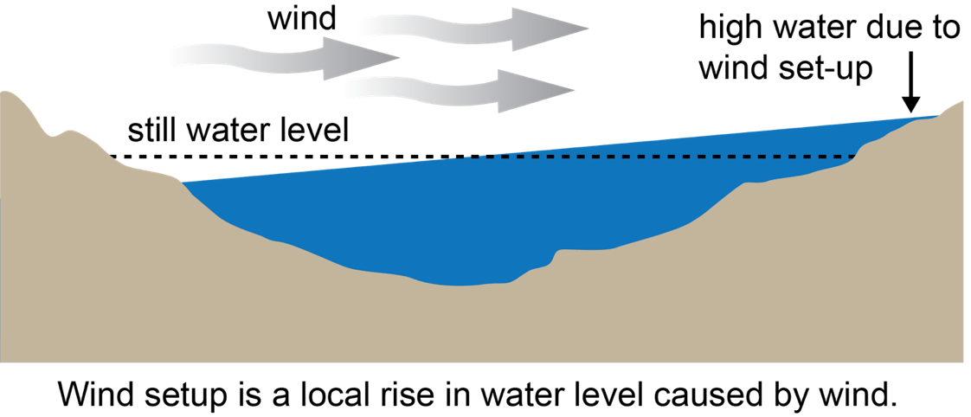
Figure 2.
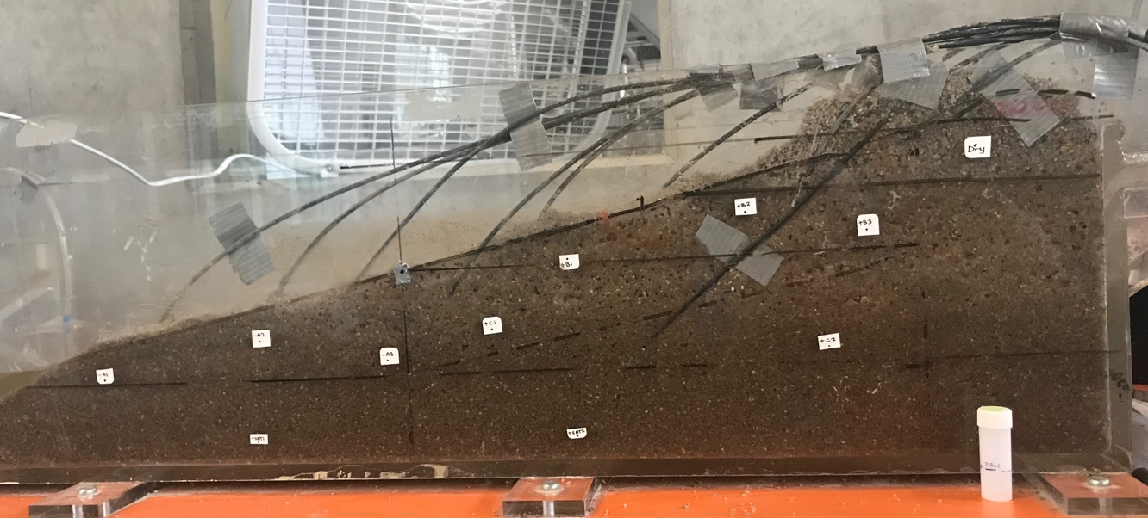
Tubing to Rhizons

Figure 2a.
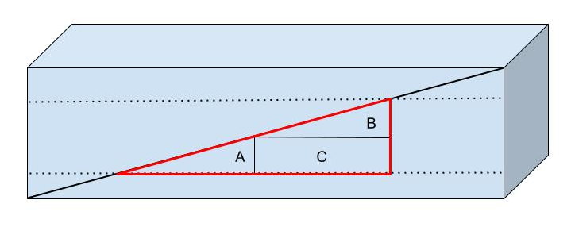

Figure 3a.

Figure 3b.

Figure 3c.

Figure 3d.

Figure 4.

Figure 5.

Figure 6.

