THE BLACK SEA DURING THE LAST 20.000 YEARS: SEA LEVEL, SALINITY, CLIMATE

Anton Preisinger, Selma Aslanian

Techn. University of Vienna, AUSTRIA

CLIMATE MARKERS IN THE BLACK SEA
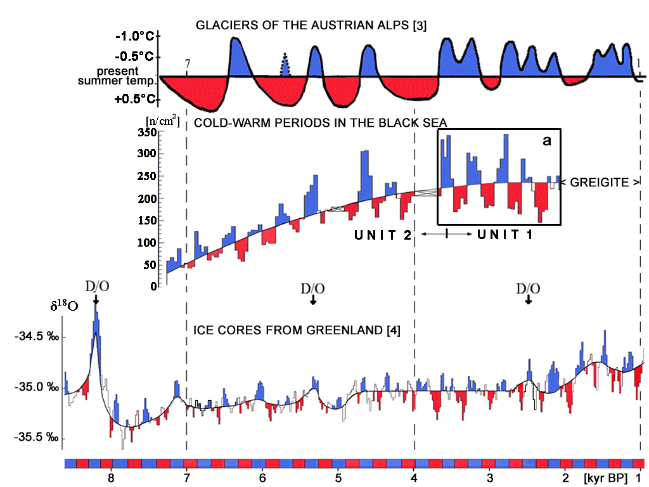
In gravity cores of the Black Sea from a water depth greater than 200 meters,
two climate markers were found: framboidal greigites (Fe₃S₄) and coccolithic calcites (CaCO₃).
A detail investigation was done on a gravity core from a water depth of 2040 m (N42°53.01’;
E 29°10.0’). Cold and warm periods are indicated by counting the number of spherical clusters of
framboidal greigites analyzed in the range from 7500 yr BP to 2000 yr BP. 11-years
sunspot cycles are indicated by blooms of the unicellular algae Emiliania huxleyi producing
coccolithic calcites with a first occurrence (FO) at the beginning of UNIT 1 [1] at a
surface water salinity of S > 11 ‰. The cluster of framboidal greigites consists
of spinel crystals of Fe₃S₄, formed in sulfate reducing bacteria which live in symbiosis
with methane consuming archaea under anoxic conditions [2] at the chemocline of the
Black Sea. These framboidal greigites are statistically distributed in the sediment of the
core, which shows a continuous increase as well as marked oscillations above and
below the mean value. The oscillations are due to a competition between the continuous
rise of the Mediterranean Sea level and the strongly varying inflow from the Danube,
Dnjepr and Don drainage area.

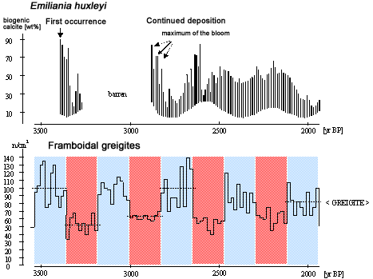
A comparison between the concentration of
framboidal greigites in the Black Sea,
the glaciers of the Austrian Alps [3],
and the δ¹⁸O
mean values of the ice cores from
Greenland (GRIP+NGRIP) [4]
shows a good agreement.
The two climate markers document
the influence of solar radiation
during 11-year and multiple
352-year sunspot cycles.

Reconstruction of the coast-line of the Bay of Sozopol during the last 7500 years
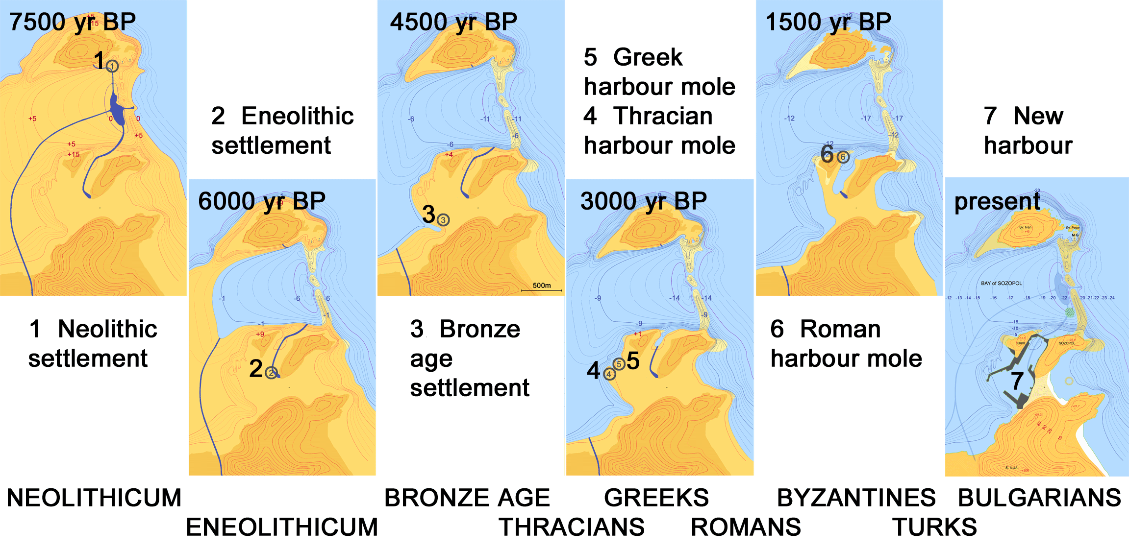
THE FORMATION OF THE BAY OF SOZOPOL

For a study of the sea level rise in the Black Sea during the
last 7500 years we have selected the Bay of Sozopol [5]. The
Bay of Sozopol is surrounded by old volcanoes: Sozopol,
Kirik, Sv. Ivan and Sv. Peter. Between Sozopol and Sv. Peter
there is an undersea wall (-15 m) formed by pillow - lava
streams from the Upper - Cretaceous. The paleo-maps,
7500 yr BP to present, are reconstructed from bathymetric
measurements from - 20 m to 0 m in accordance with the
increase of the sea level. 7500 years ago the Bay of Sozopol
was not covered by sea water. We dated the foundation of an
eneolithic settlement at 6250 years BP. 6000 years ago
Sv. Ivan was a peninsula. About 4500 years ago Sv. Ivan and
Sv. Peter was an island. 3000 years ago Kirik and
Sozopol were land and the Thracians built a harbour mole.
500 years later the Greeks built a separate harbour mole,
calling the land Apollonia. After ~ 500 years the Romans
occupied the city. 1670 years ago the name of the city was
changed to Sozopol. 1500 years ago Kirik was a peninsula
and has been an island for about 800 years. A new harbour
connected Kirik with Sozopol 75 years ago.

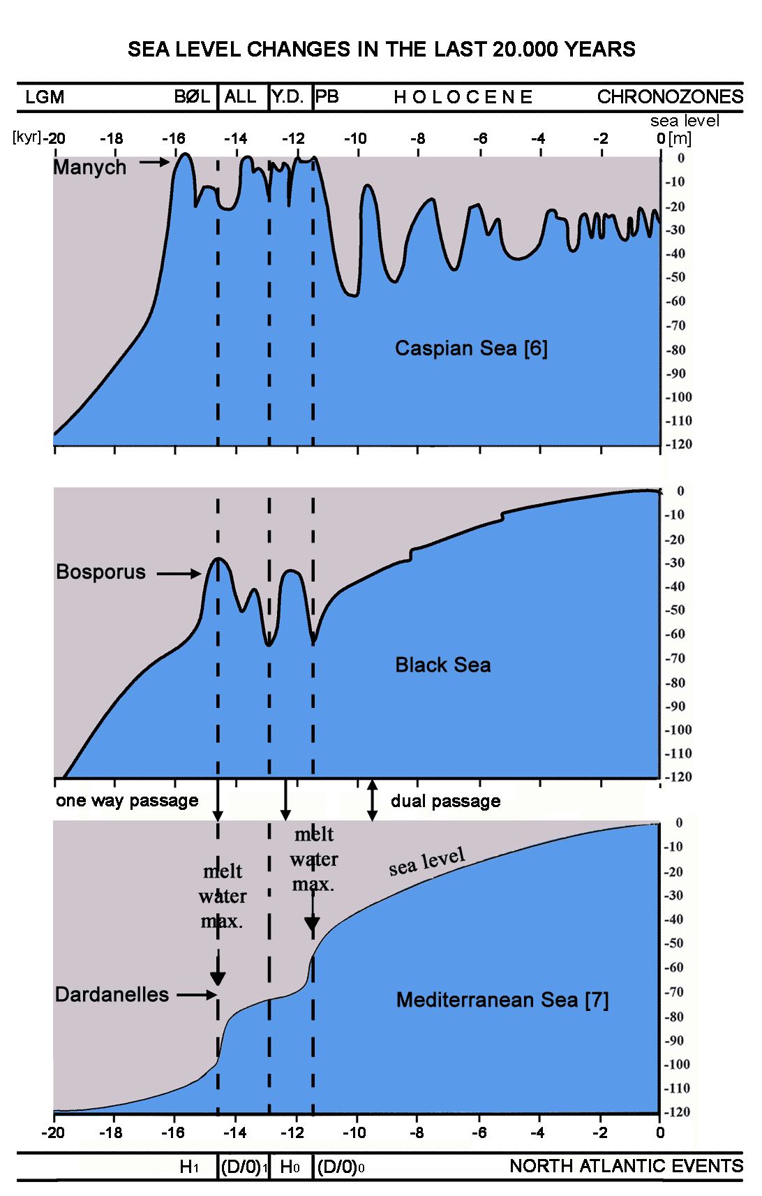

Bathymetric map
of the Bulgarian shelf-zone
SEA LEVEL CHANGES DURING THE LAST 20.000 YEARS

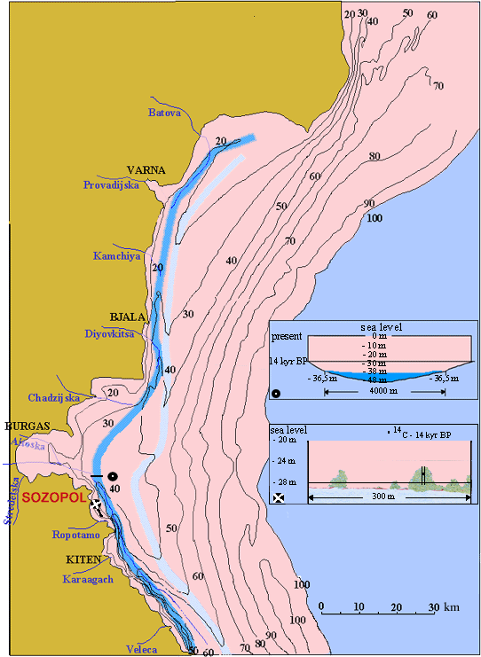
During the last glacier maximum [LGM] about 20.000 years ago, the shelf zone
of the Black Sea was not covered with water. The general rise of the sea
level during the last 20.000 years is dominated by the melt of the ice shield
in the northern hemisphere and the glaciers of the European mountains.
The sea level rise of the Mediterranean Sea through melt water is
characterized by two warm events and two cold events occurring in the North Atlantic,
the warm Dansgaard/Oeschger events (D/0)₁ and (D/0)₀, and the cold
Heinrich events H₁and H₀ , respectively. After the last big (D/0)₀ - event the temperature
rose by about 5° - 10° C [8]. From this event on, the sea level has been
rising with a slightly decreasing mean until today.
The sea level rise in the Caspian Sea is dominated by the drainage area of the
Volga and Ural rivers during the cold H₁ and H₀ - events.
The sea level changes in the Black Sea are a result of the water inflow from
the drainage area of the Danube, Dnjepr and Don, the temporary water
inflow from the Caspian Sea over the sill of Manych through the strait of
Kerch, and since 9.5 kyr BP from the inflow of the Mediterranean water via
the Bosporus [9].
The bathymetric measurements in the Bulgarian shelf zone and ¹⁴C - data
show a first maximum at 14.3 kyr BP of - 28 m and the formation of a
sediment hill parallel to the coast (light blue) and in the following
Younger Dryas (Y.D.) the formation of a sublacustrine river valley (blue)
which gets filled up rhythmically by Danube sediments with the beginning
of the (D/0)₀ - events.

The results of our investigations show that there was NO CATSTROPHIC FLOOD in the BLACK SEA during the last 10.000 years. The submergence of settlements in the Black Sea was due to the slow steady rise of the sea level in the course of thousands of years.

References

[1] Hay, B.J., Arthur, M.A., Dean, W.E., Neff, E.D. & Honjo, S. (1991). Deep-Sea Research, 38, 2, 1211-1235.
[2] Boetius, A., Ravenschlag, K., Schubert, C.J., Rickert, D., Widdel, F., Gieseke, A., Amann, R., Jørgensen, B.B., Witte, U. & Pfannkuche, O.(2000). Nature, 407, 623-626.
[3] Patzelt, G. (2000). Rundgespräche der Kommission für Ökologie, Bd. 18 „Entwicklung der Umwelt seit der letzten Eiszeit“, München, 119-125.
[4] Hammer, C.U. (2002). „Climate Development and History of the North Atlantic Realm“, Eds. G. Werfer, W. Berger, K.-E. Behre, E. Jansen, Springer-Verlag Berlin, Heidelberg, 149-163.
[5] Preisinger, A. & Aslanian, S. (2004). Bulletin du Musée nationale Varna, Bulgarie, 51-52, 1-10.
[6] Ferronsky, V.I., Polyakov, V.A., Froehlich, K., Lobov, A.L., Batov, V.J., Petrošius, R., Kuprin, P.N., Varuschenko, A.N. & Bobkov, A.F. (1998). IAEA, Vienna, 633-644.
[7] Fairbanks, R.G. (1989). Nature, 342, 637-642.
[8] Bond, G., Showers, W., Cheseby, M., Lotti, R., Almasi, P., de Menocal, P., Priore, P., Cullen, H., Hajdas, J., & Bonani, G. (1997). Science, 278, 1257-1275.
[9] Aksu, A.E., Hiscott, R.N. & Yaşar, D. (1999). Marine Geology, 153, 275-302.
GSA Paper No. 189-9
This work was supported
by the Austrian Academy of Science
Anton Preisinger
Techn. University of Vienna
1080 Vienna, Lercheng. 23/2/9
e-mail: apreisin@mail.zserv.tuwien.ac.at

