ABSTRACT

TRANSPORT OF DIABASE BLOCKS AND BOULDERS BY THE SUSQUEHANNA RIVER AT CONEWAGO FALLS, NORTHWESTERNMOST LANCASTER COUNTY, PA
SEVON, W. D., East Lawn Research Center, 30 Meadow Run Place, Harrisburg, PA 17112-3364 wsevon30@comcast.net
Conewago Falls occurs on a north-dipping (<10˚), Jurassic-age, diabase sheet eroded to its present level by the Susquehanna River. The diabase is bounded, above and below, by hornfels baked from sedimentary rocks of the Triassic-age Gettysburg Fm. (above) and New Oxford Fm. (below). The diabase separates at 1-2 m intervals along parting planes that parallel bedding-plane orientations of adjacent sedimentary rocks. Widely and irregularly spaced vertical joints cut the diabase generally in NE-SW and NW-SE orientations. The relatively flat diabase surfaces with 1-2 m topographic relief are exposed only during very low river levels.
Strewn on the exposed surfaces are many diabase blocks, very large rocks with angular to subangular edges, that were eroded from outcrops within this diabase exposure and then transported downstream for distances of a few centimeters to many meters. More than 1,200 definitely moved blocks have been identified on an enlarged aerial photograph. Dimensions of 151 blocks were measured in situ. The mean size is 5.2 x 3.2 x 1.3 m. The largest measured block is 11 x 4.5 x 1.5 m. Potholes eroded into some blocks allow positive identification of upside-down blocks.
In addition, there are many 1-2 m, nonequidimensional, diabase boulders that are moderately well rounded. There are also many very well rounded diabase boulders less than 1 m in diameter. Local derivation of all these boulders is doubtful because of their excellent rounding. They were probably eroded from another river-eroded diabase exposure 5 km upstream and rounded during fluvial transport to their present positions.
Movement of the large blocks could have been by several mechanisms: (1) traction transport by extreme floodwaters, (2) rolling during extreme floodwaters, and (3) flotation while encased in ice. Movements by (1) and (2) are real. Movement by (3) is plausible. Extreme floodwaters occurred during multiple Pleistocene deglaciations and also during multiple catastrophic drainages of Glacial Lake Lesley on the West Branch Susquehanna River.

IN THE BEGINNING
About 250 mya Africa collided with North America and created the Alleghany Mountains in the eastern part of the continent. The mountain range extended from NE Pennsylvania (PA) to Alabama. To the west of the mountains in PA a large number of thrust folds were generated (Fig. 1) (Faill, 1998). Note the alluvial plain created by erosion of the Alleghany Mountains (Fig. 2).
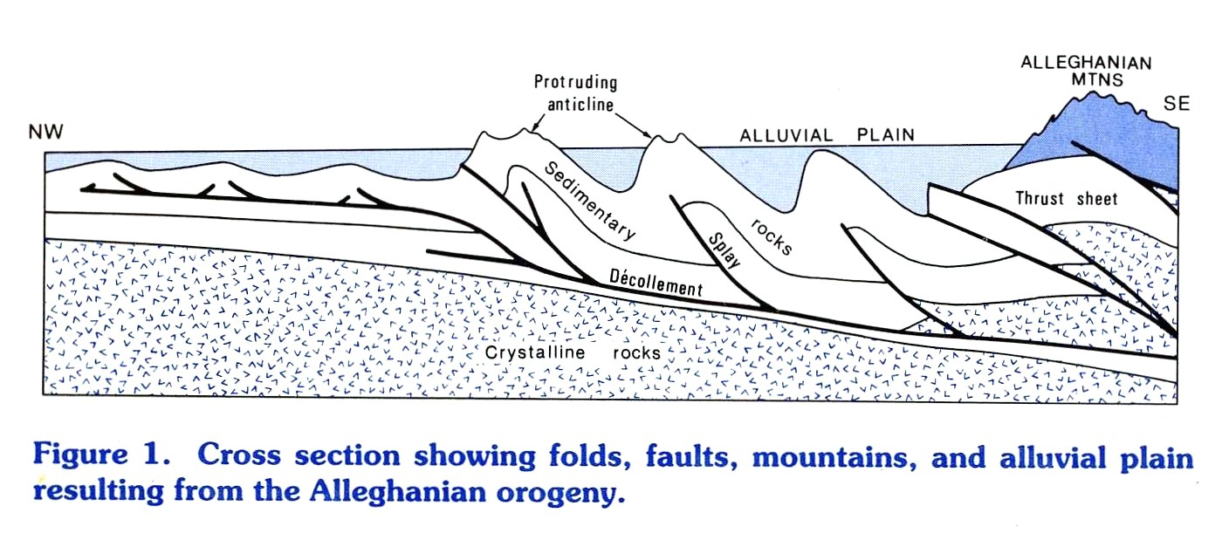

During the late Triassic, a depositional basin formed in SE PA (Faill, 1975). This is now named the Birdsboro basin, (Faill, 2003). This was the start of drainage change in PA. Drainage in the early Jurassic showed much of the Alleghany orogeny generated alluvial plain as well as some short streams creating alluvial fans in the new basin (Fig. 3).
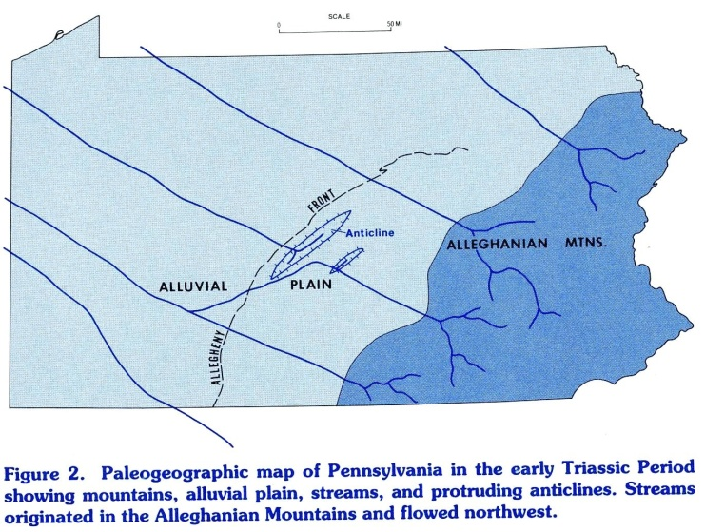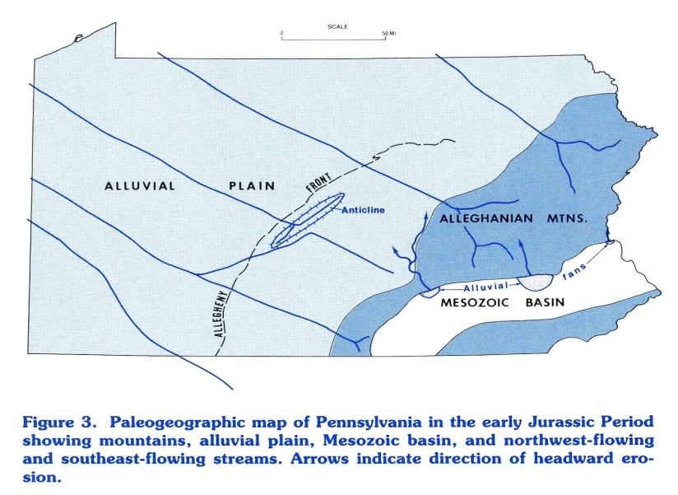
As time passed by and Africa separated from North America, the Atlantic Ocean formed and streams began the process of headward erosion from the sea margin northwestward across the eroding Mesozoic basin. The Susquehanna and Schuylkill Rivers were two of the early streams. Their early path is shown in Figure 4. As time progressed, other streams were added to the process and the Susquehanna River (SR) became lengthy and the original Alleghany orogeny alluvial plain was destroyed (Fig. 5)(Figs.1-5 are from Sevon, 1993).
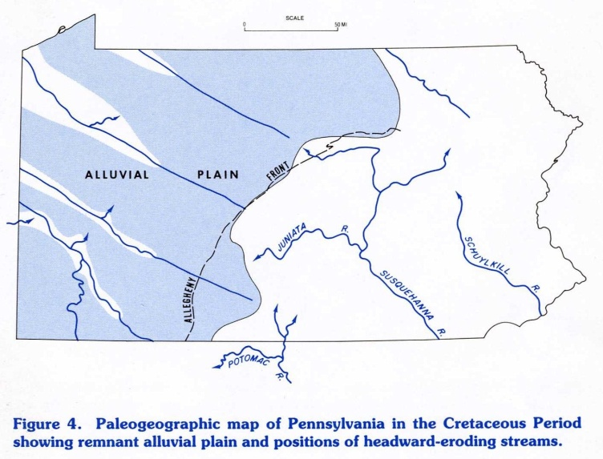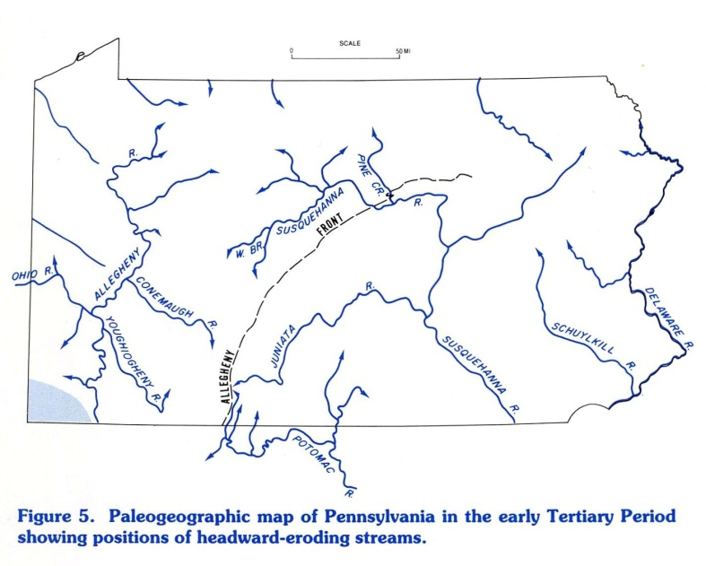

Geologists have long been concerned about the evolution of the SR and there have been many hypotheses regarding its positioning in the several water gaps north of Harrisburg (Fig. 6) (e.g., Davis, 1889), but little attention paid to erosion of rock materials south of the Susquehanna water gap (Fig. 7).
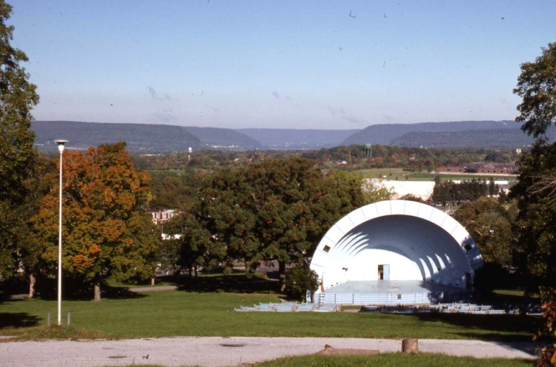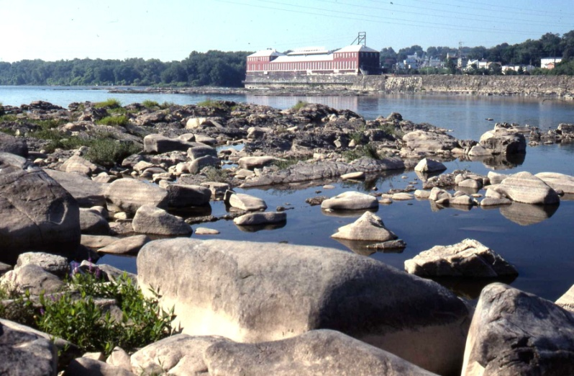 Figure 6. SR water gaps as seen Figure 7. South end of Conewago Falls,
from Reservoir Park, Harrisburg. northwesternmost Lancaster County.

CONEWAGO FALLS

Conewago Falls in northwesternmost Lancaster County, has been eroded to its present condition by the SR. The falls is eroded into a diabase sheet of the York Haven type (Smith, II, Rose, and Lanning, 1975). The diabase sheet is one of two that cross the SR south of Harrisburg, a northern one near Middletown and the southern one at Conewago Falls. These two east-west oriented sheets are connected by two north-south sheets. The sheet at Conewago Falls occurs below the Triassic Gettysburg Formation and above the Triassic New Oxford Formation. The boundaries with the above and below sedimentary rock units are marked by hornfels, baked sedimentary rock units.
The diabase sheets are shown in Figure 8. Note on the map that the southern diabase sheet is immediately south Three Mile Island, the famous nuclear power plant.
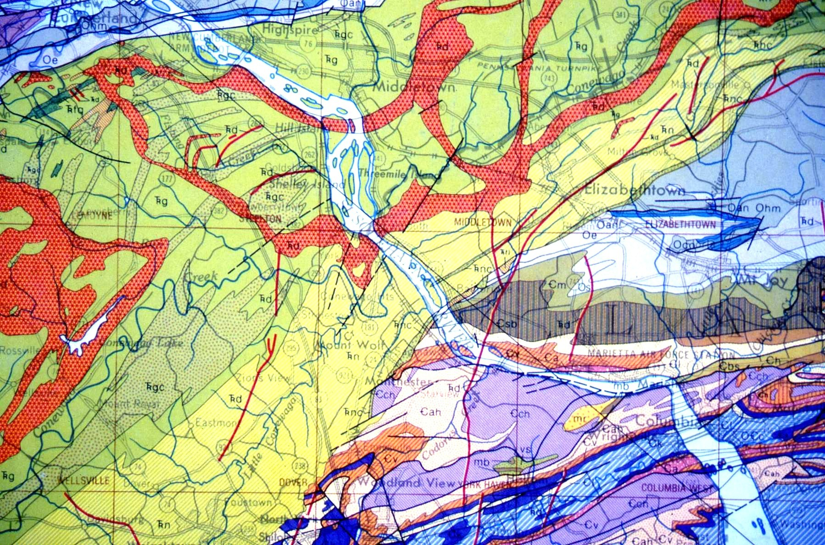
Figure 8. Geologic map of the diabase sheets crossed and eroded by the SR. Map
scale is originally 1:250,000 and is from the Geologic Map of PA (Berg and others, 1980).

Today, it is unknown how far above the SR nor how far south of Conewago Falls the diabase sheet originally extended. Any guess is idle speculation and probably not worth the time. What is important is that the diabase has been eroded to its present position by the SR.
Note that where the SR crosses each of the diabase sheets that the river narrows to about half its upstream width. This narrowing has considerable effect on the immediate downstream SR flow velocity, a large factor related to the main purpose of this poster, the transport of large diabase blocks.

LARGE DIABASE BLOCKS AND BOULDERS AT CONEWAGO FALLS

The surface of Conewago Falls is well exposed when the river level at Harrisburg is below 4 feet and at its best when that level is about 3 feet. At those times one can see that the diabase sheet surface is littered with large diabase blocks and boulders. Figure 9 presents a superb example of a definitely transported block. Other blocks of this magnitude or larger occur, but most have not been viewed or photographed by me. Consider the force required to move this block.
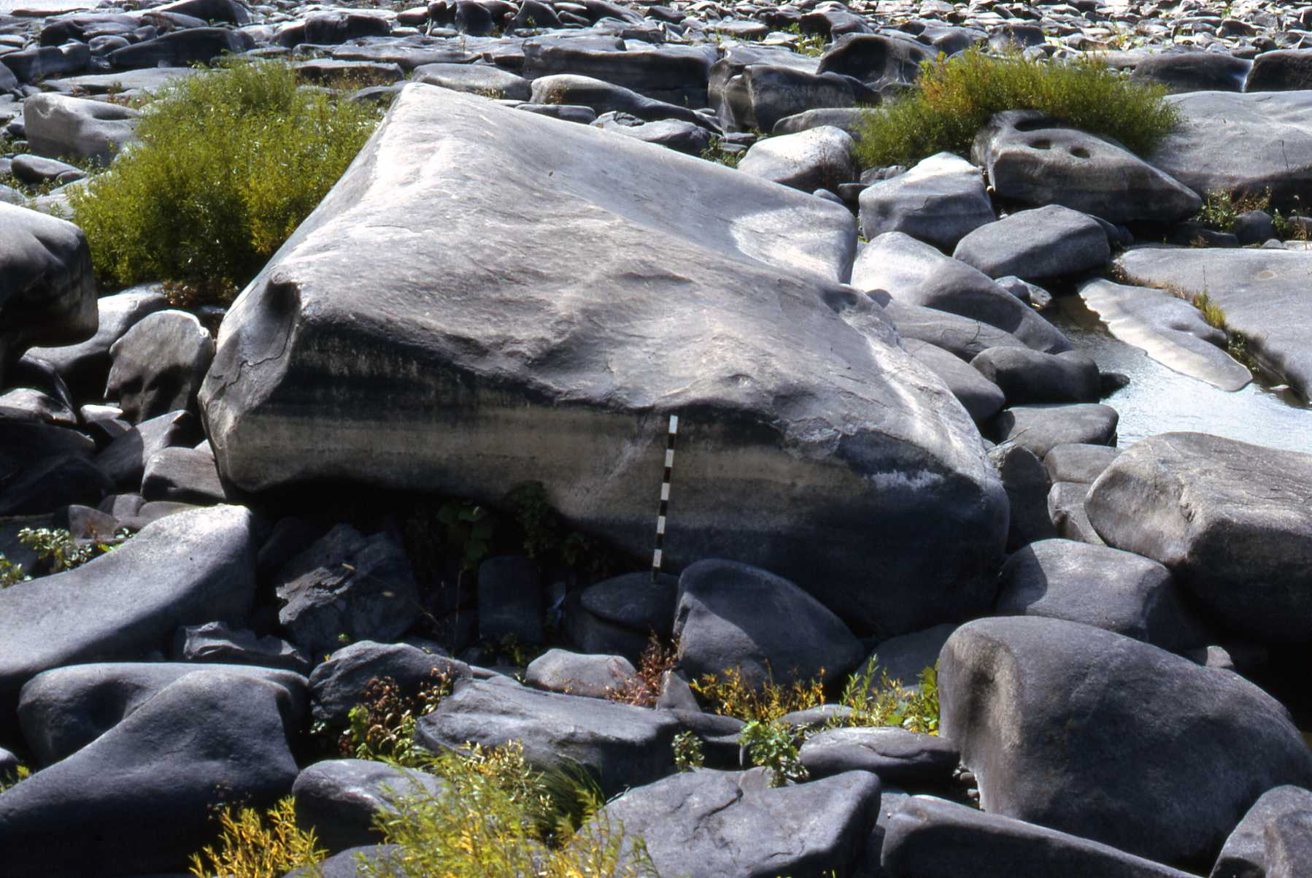
Figure 9. This large diabase block is 9 x 4.5 x 1-1.5 m. Scale is divided into 10 cm intervals. Upstream is to the right. Base of block rests on diabase boulders. Note the numerous, rounded, diabase boulders (2 m or less in diameter), those jammed behind the large block and those in the foreground. Surface erosion of the top of the block, a ripple form, suggests that its orientation is the same as that of its original position. Distance of transport is unknown.

On 11/18/91, when the SR water level was extremely low, the Susquehanna River Basin Commission had the basin flown for aerial photography and Conewago Falls was beautifully covered by a single 1:12,000 scale photograph shown in Figure 10. Using the enlargement of the original photograph, I counted more than 1,200 blocks that presumably are larger that 4 m in one dimension. The measurements of 151 blocks that I measured are presented in Table 1.
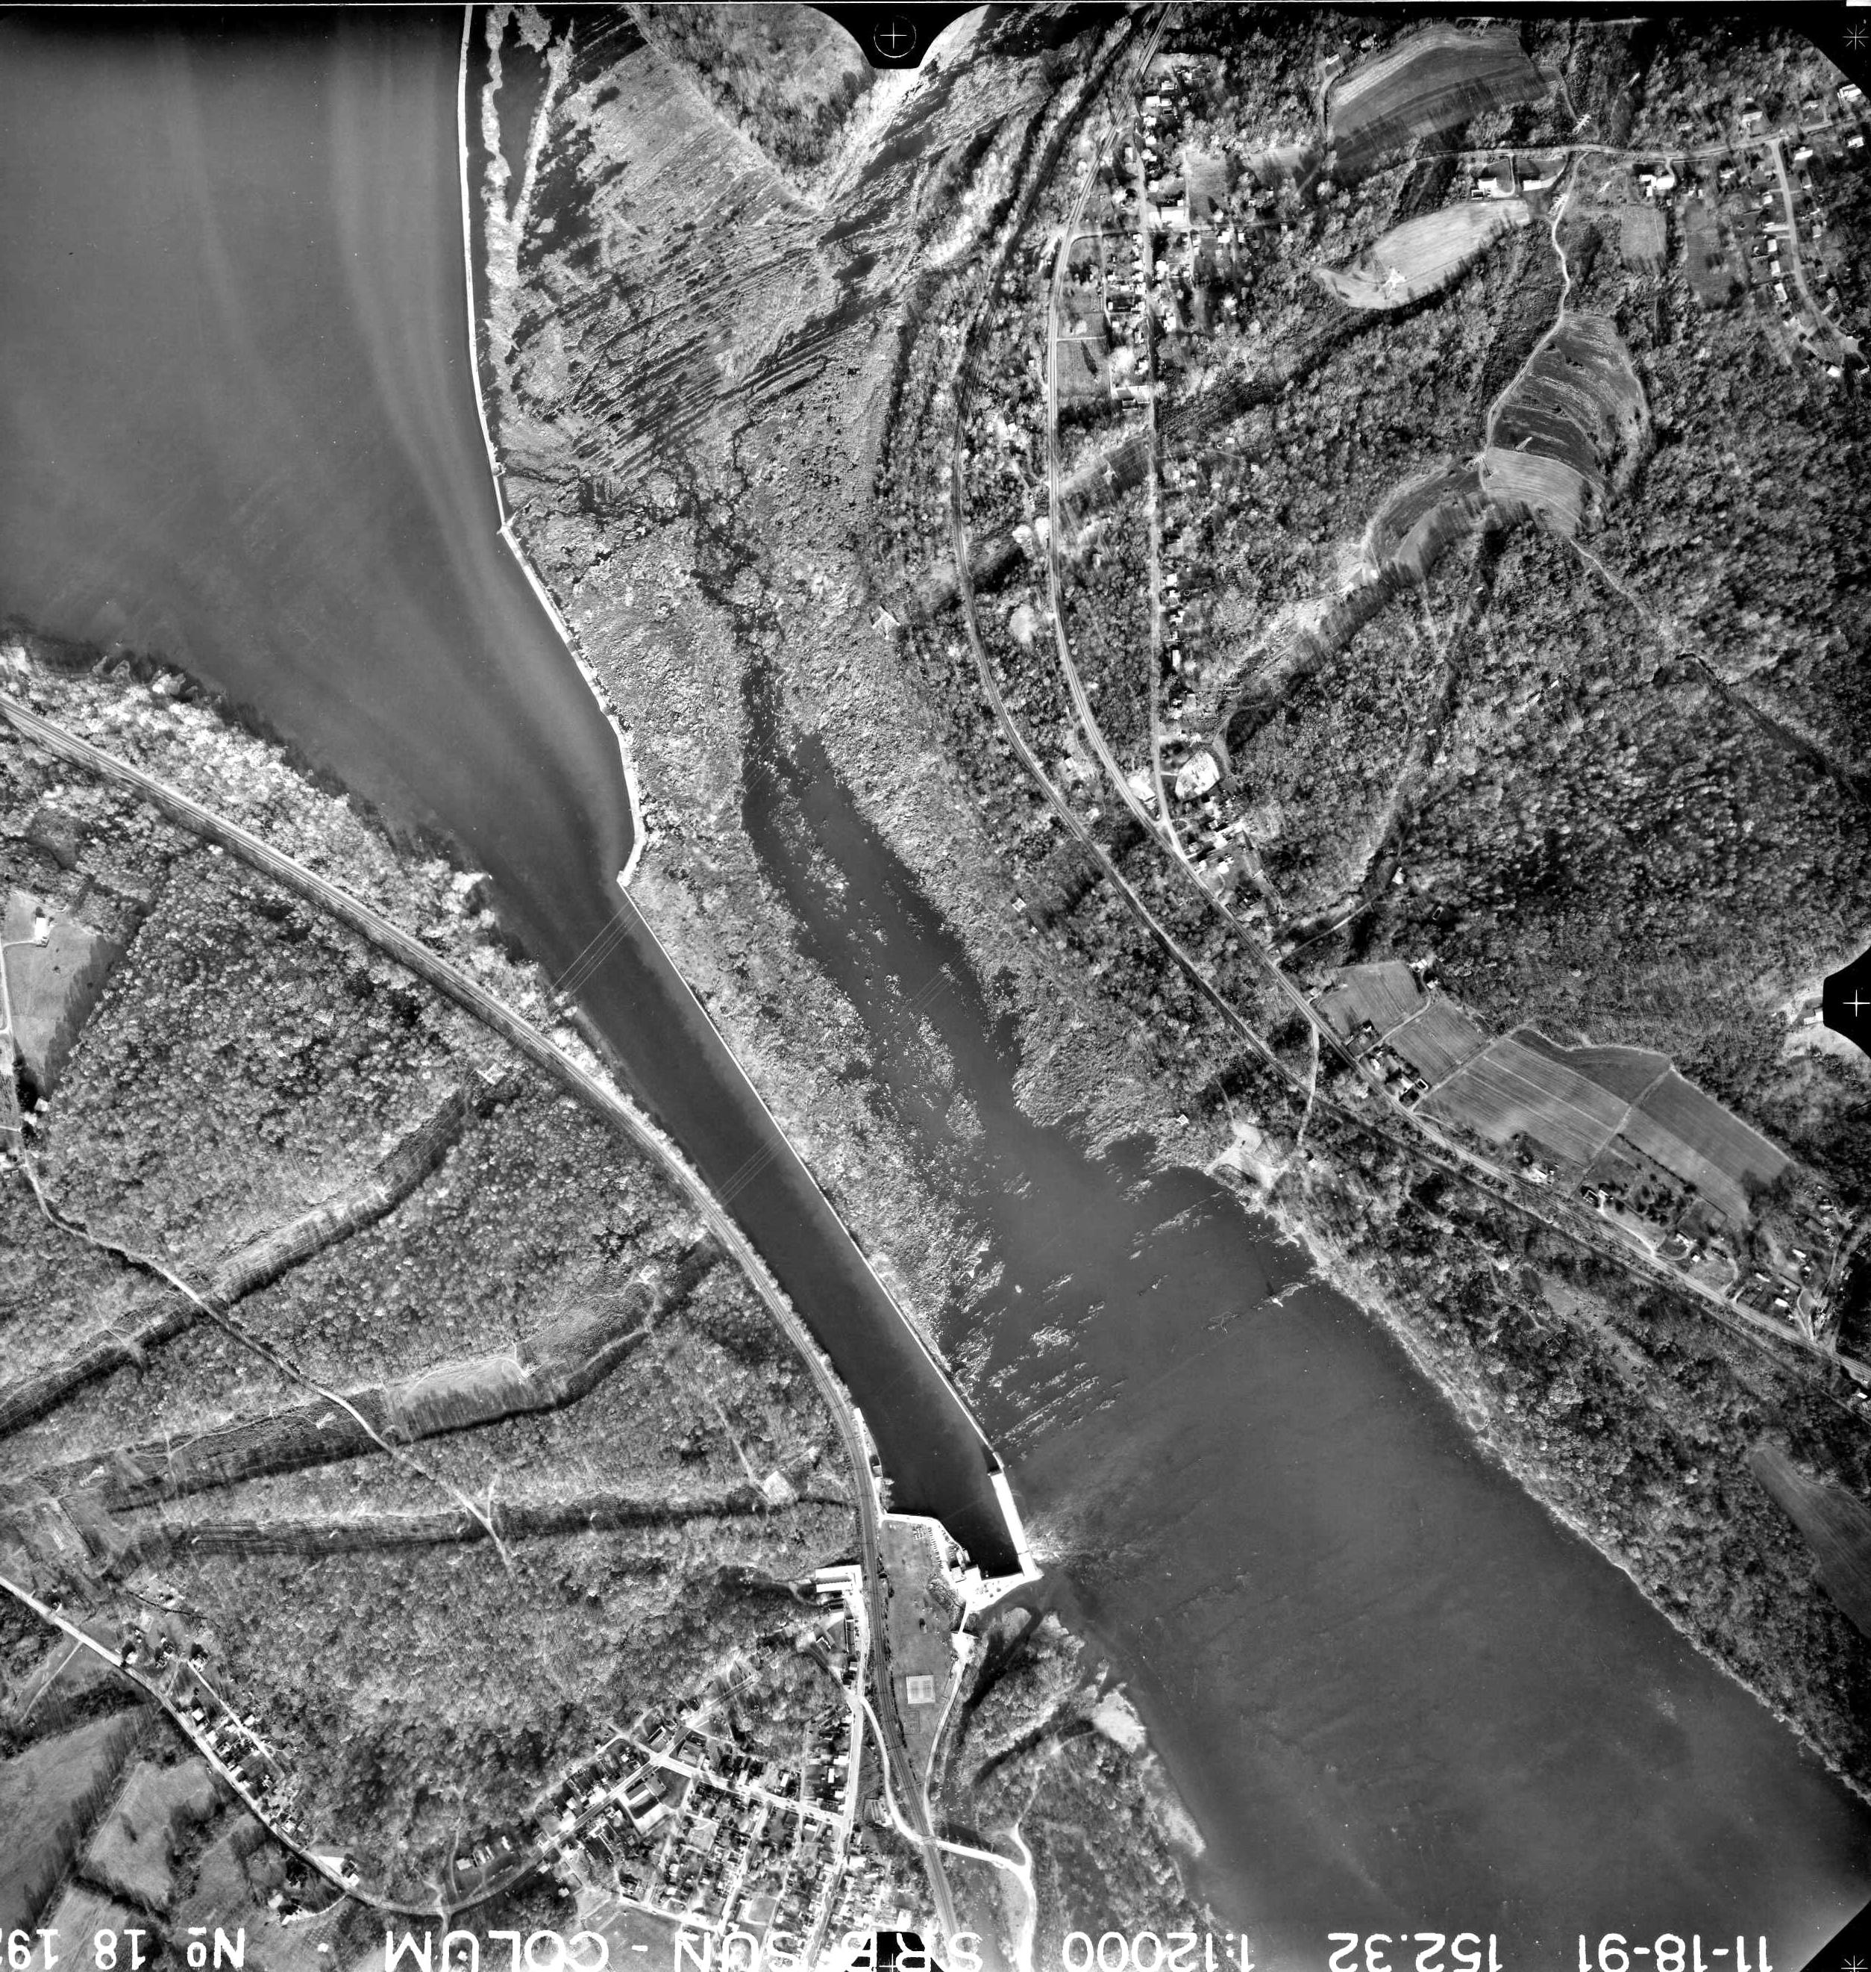
Figure 10. 1991 aerial photograph of Conewago Falls. North is to the top of this photograph as shown here. Note the layered hornfels at the north end of the falls and the vague suggestion of the same at the south end of the falls. The dam guides water to the York Haven hydroelectric plant. The white area on the left bank at the south end of the falls area is the Falmouth Fish Commission Access parking lot.

The presence of large numbers of both blocks and boulders (generally less than 2 m in largest dimension), attests to the erosion and transport of diabase at Conewago Falls and is the thrust of this poster.
As one can see, the measured blocks are not small and many unmeasured ones are larger. The block in Figure 9 is one of the best, easily accesible examples on the left bank of Conewago Falls. Other examples are shown in Figures 11-13.
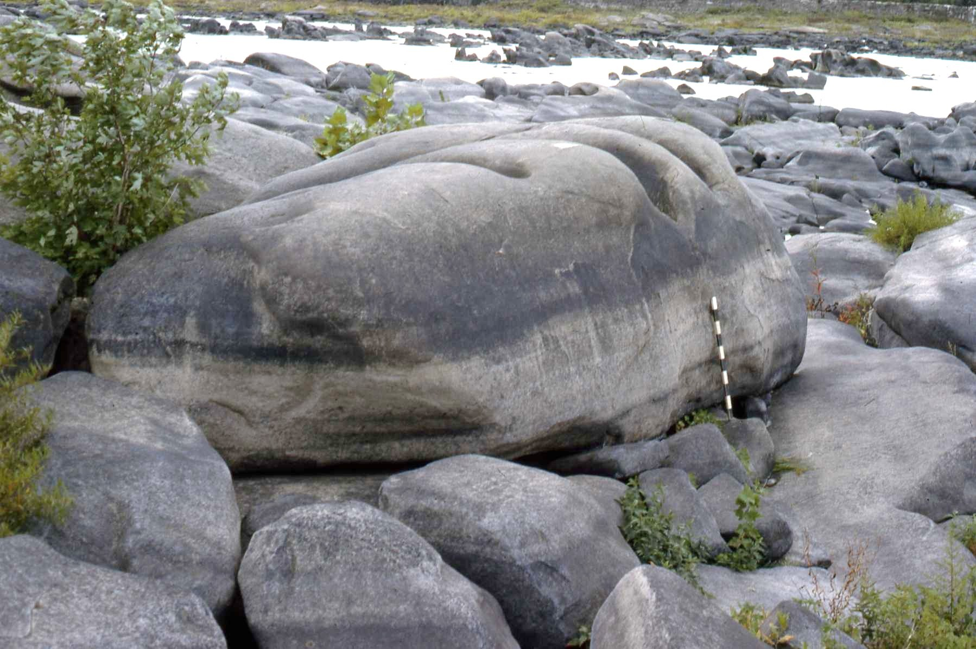
Figure 11. Diabase block is 7 x 2x 2-3 m. Note boulders in foreground. Scale is 1 m long and is divided into 10 cm units.

Table 1. Measured axes of 151 diabase blocks at Conewago Falls.
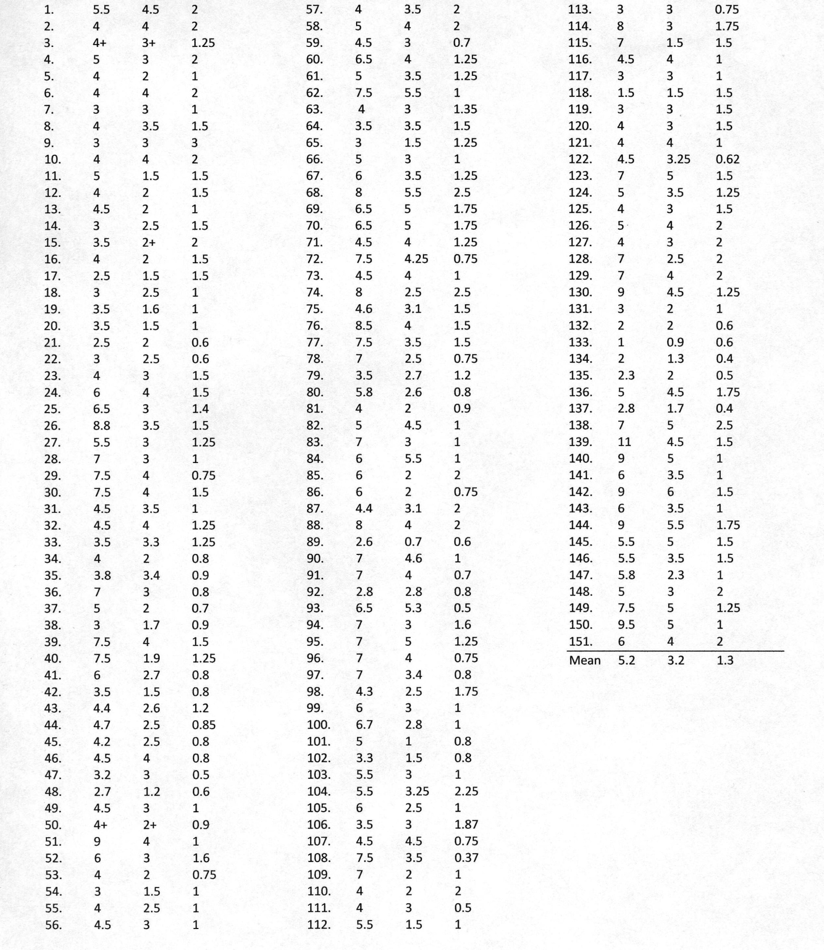
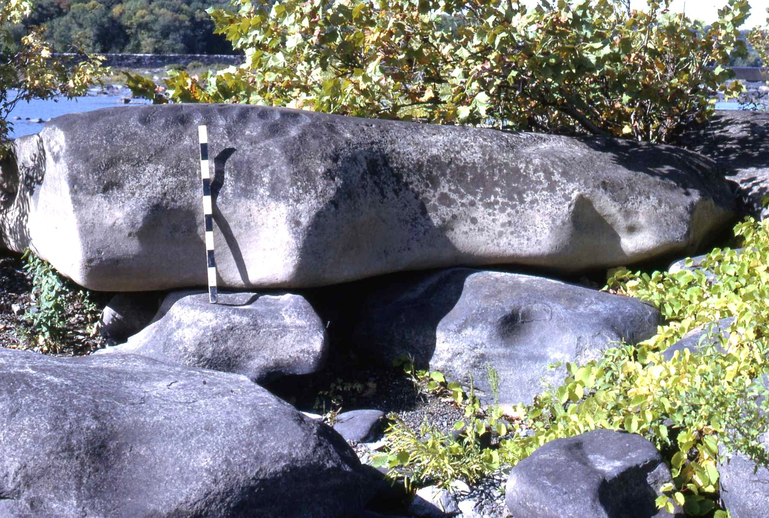
Figure 12. Diabase block is 4.5 x 4.5 x5-1 m. Note that the block is resting on smaller boulders, clear indication of transport. Scale is 1 m long and is divided into 10 cm units.

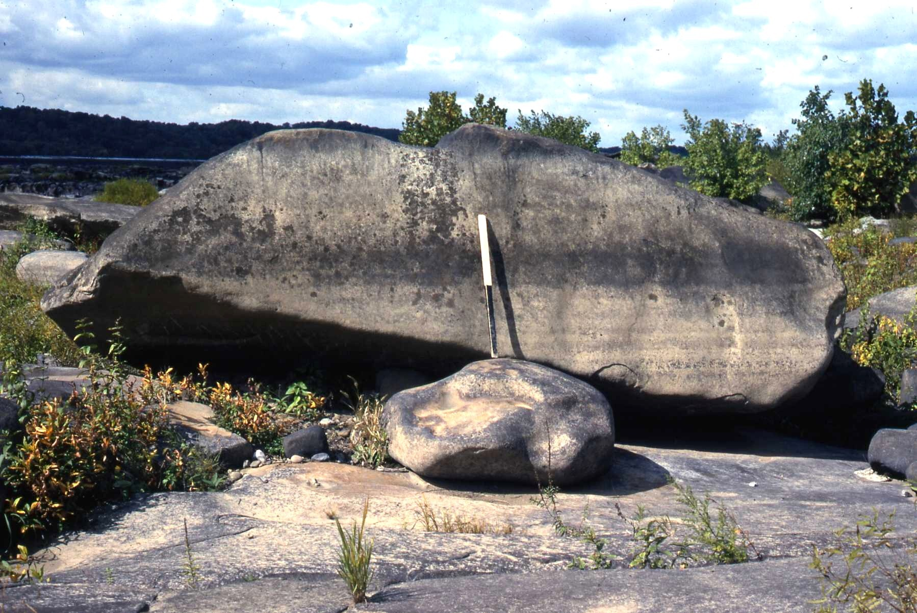
Figure 13. Diabase block is 5 x 4-3 x 1.5-1 m. Scale is 1 m long and is divided into ½ m units. Block rests on the smaller boulder which rests on in situ diabase.

In addition to the blocks shown and the boulders associated with them, there are areas on the surface of Conewago Falls that are literally covered with boulders and some blocks (Fig. 14). Such surfaces are visual indications of the amount of diabase that has been moved but not removed from the falls area.

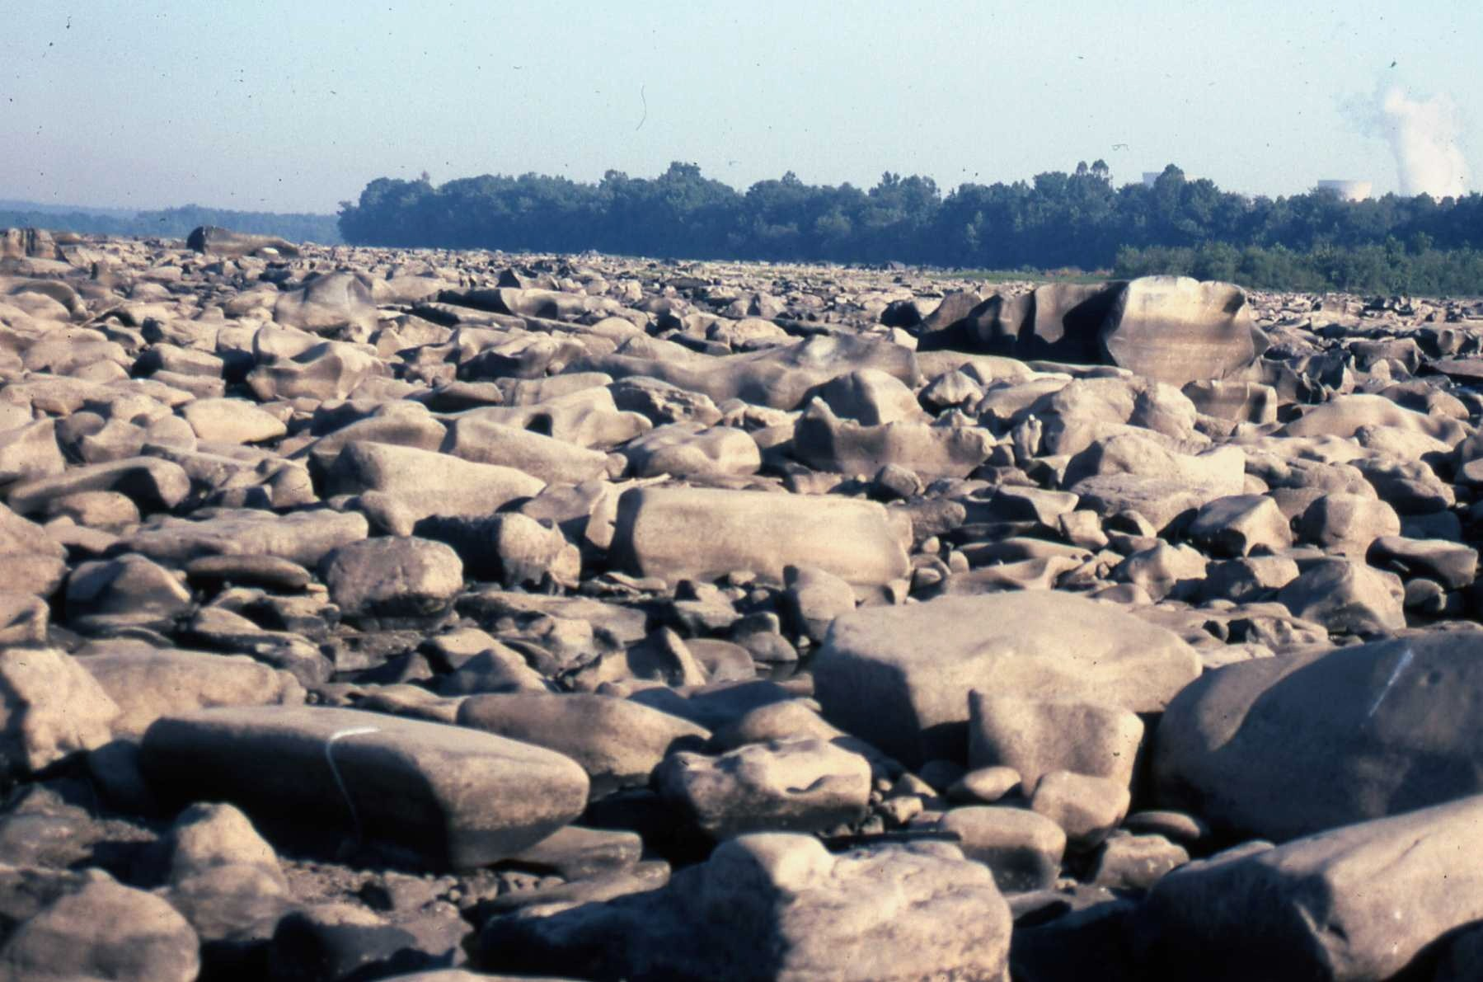
Figure 14. A surface of diabase at Conewago Falls that is essentially totally covered with boulders of all sizes and a few blocks. The large block in the right mid-ground and the one in the left background have not been measured, but are quite large. In the right background are two inactive cooling towers of Three Mile Island and steam from one tree-obscured, active cooling tower.

If we look at the aerial photograph (Fig. 10) we see a center water-filled channel separating two marginal areas where all the blocks and boulders lie. What lies below water level in the center channel and beneath the water downstream from the falls all the way to Safe Harbor dam, 25 miles (40 km) downstream, we do not know, but can suspect that there is a lot of eroded diabase. The upper end of the center channel of water ends in exotically sculptured diabase (Fig. 15).
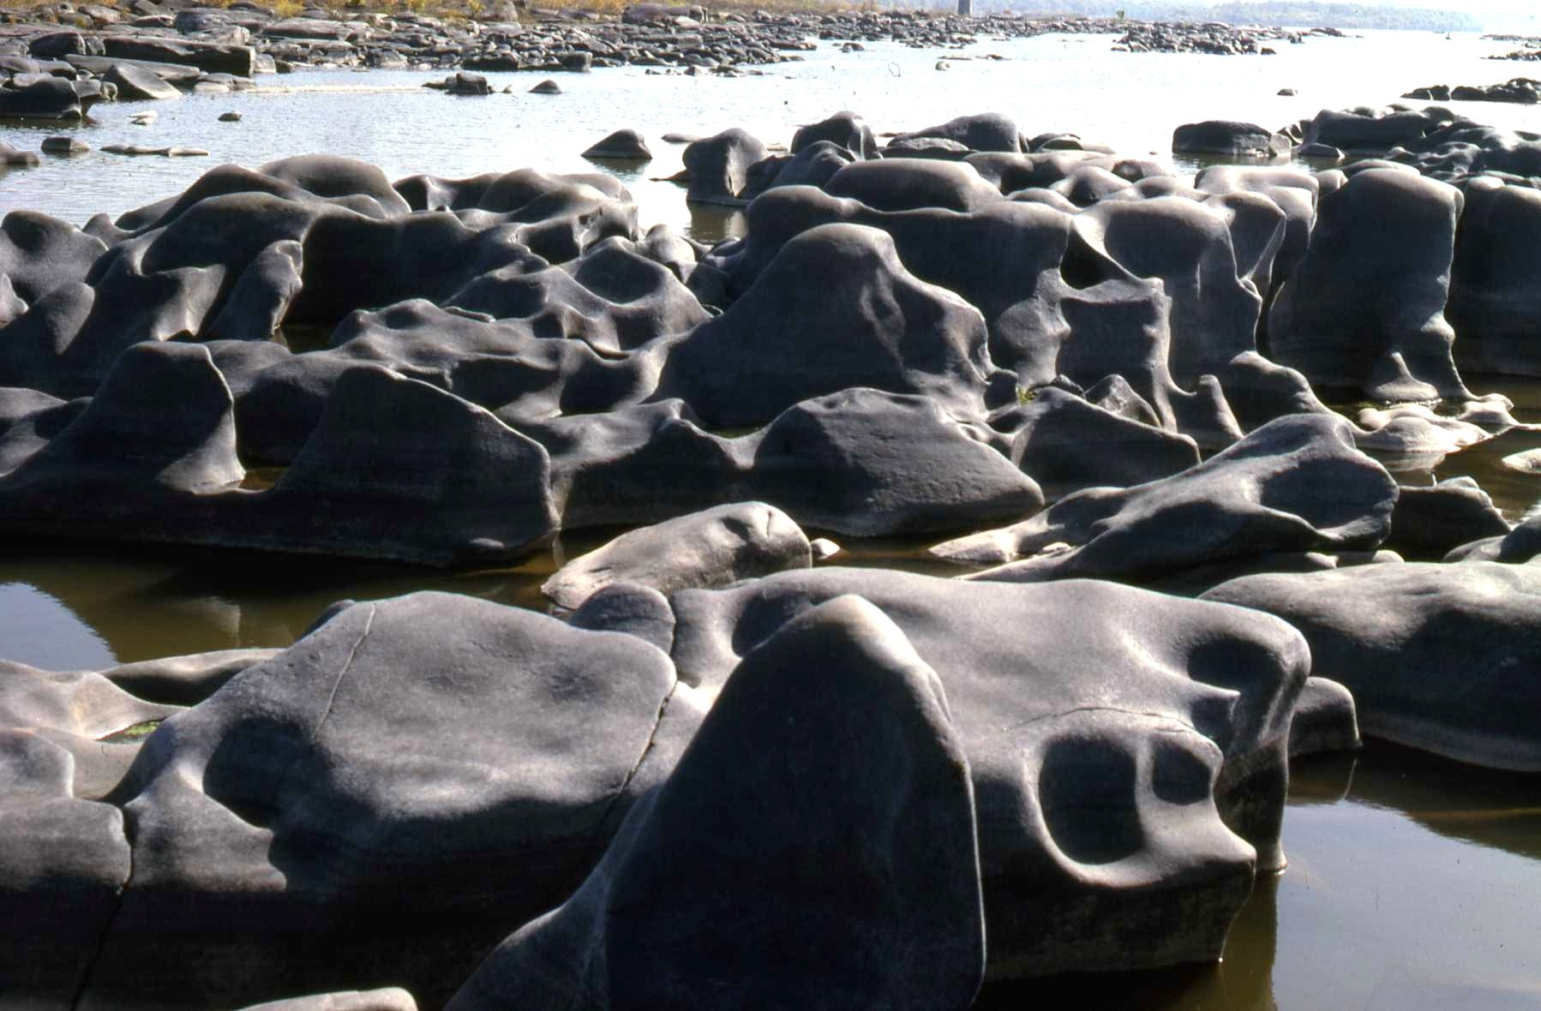Figure 15. Exotically sculptured diabase present at the upper end of the center channel. This sculpturing results from progressive erosion that goes from ripples to potholes. See Figure 16 for amplification. The center channel is well shown in this photograph and is downstream from the sculptured diabase shown here.

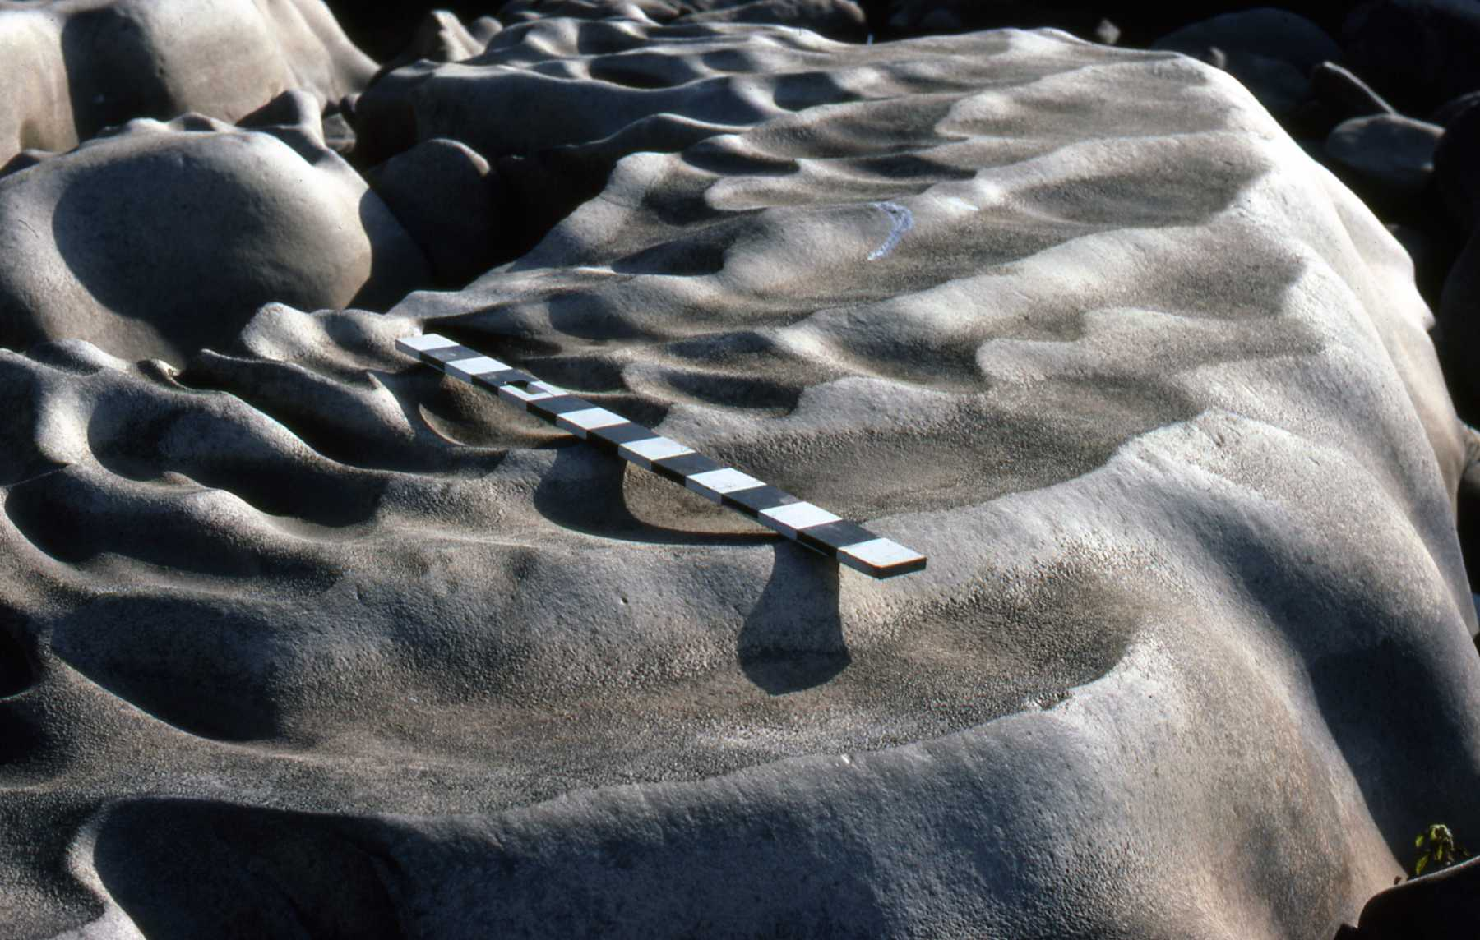
Figure 16. Erosion sculptured diabase at the upper end of the center channel. Erosion progresses from ripple forms to elongated furrows to potholes. Scale is divided into 10 cm intervals. Upstream is to the lower right.

When examined carefully and plotted in general, one finds that the exotic sculpturing occurs only in the central channel area. Random potholing and some surface erosion occurs on the left and right bank exposed rock surfaces. The main features on the exposed surfaces are transported blocks and boulders as shown in Figures 9, 11-14. Figure 17 is a generalized diagram of this distribution. Figure 18 is a diagram of flow velocity distribution in a river such as the SR. Maximum flow velocity in the center channel corresponds with the area of maximum erosion by abrasion, cavitation, or both. Lesser degrees of similar erosion would occur in the side channel areas.
What does this mean for movement of blocks and boulders? We need to consider how the blocks and boulders were moved. But first we should consider where all ot these blocks and boulders came from. The diabase sheet has partings that are generally 1-2 m apart and NE and NW oriented irregularly spaced fractures (Fig. 19). These partings and fractures allow separation of blocks and boulders which are then available for downstream transport. That such separation occurs is seen at both a small scale (Fig. 20) and a large scale (Fig. 21).

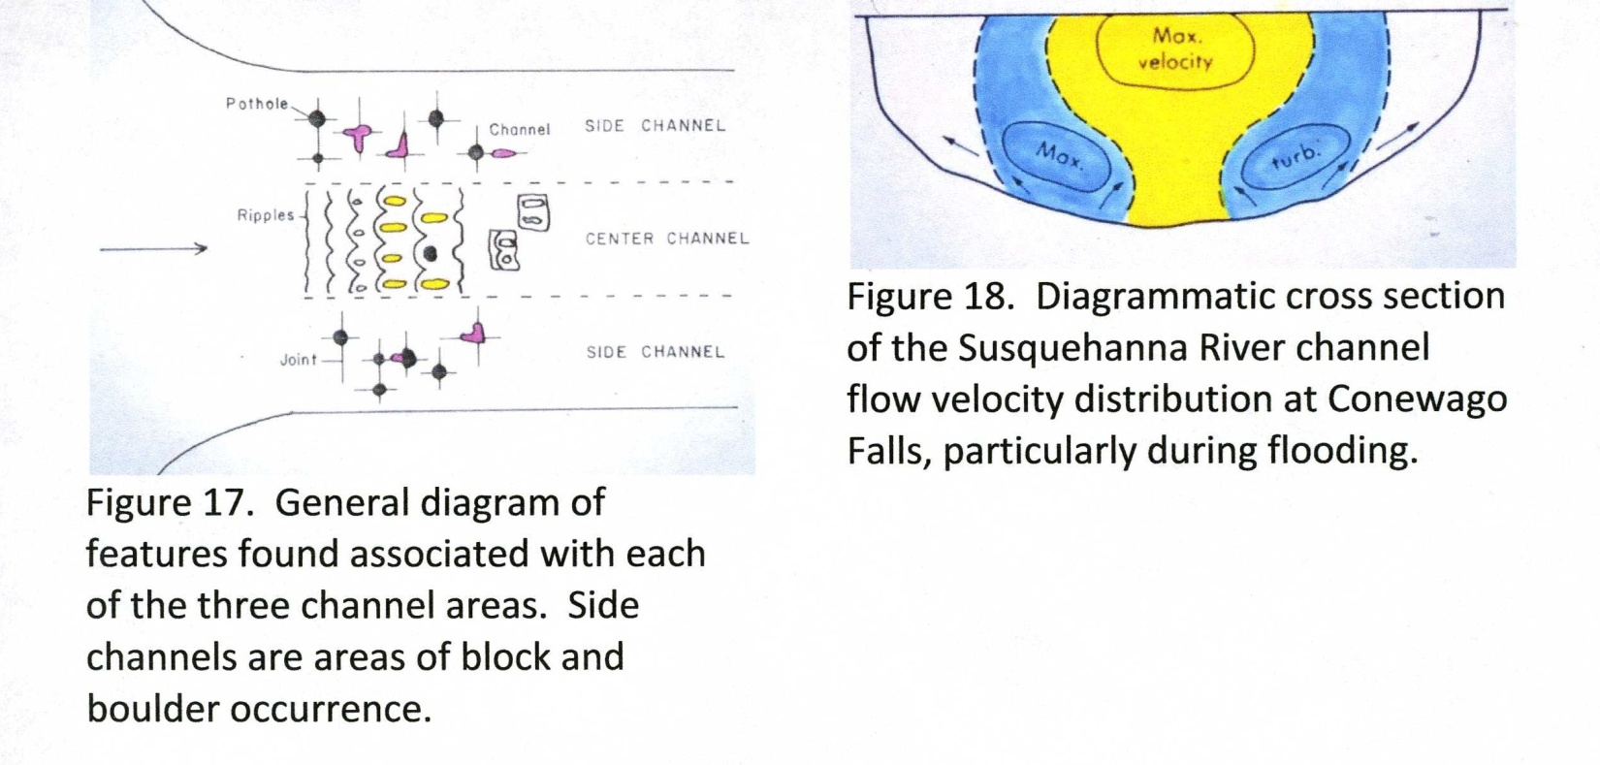

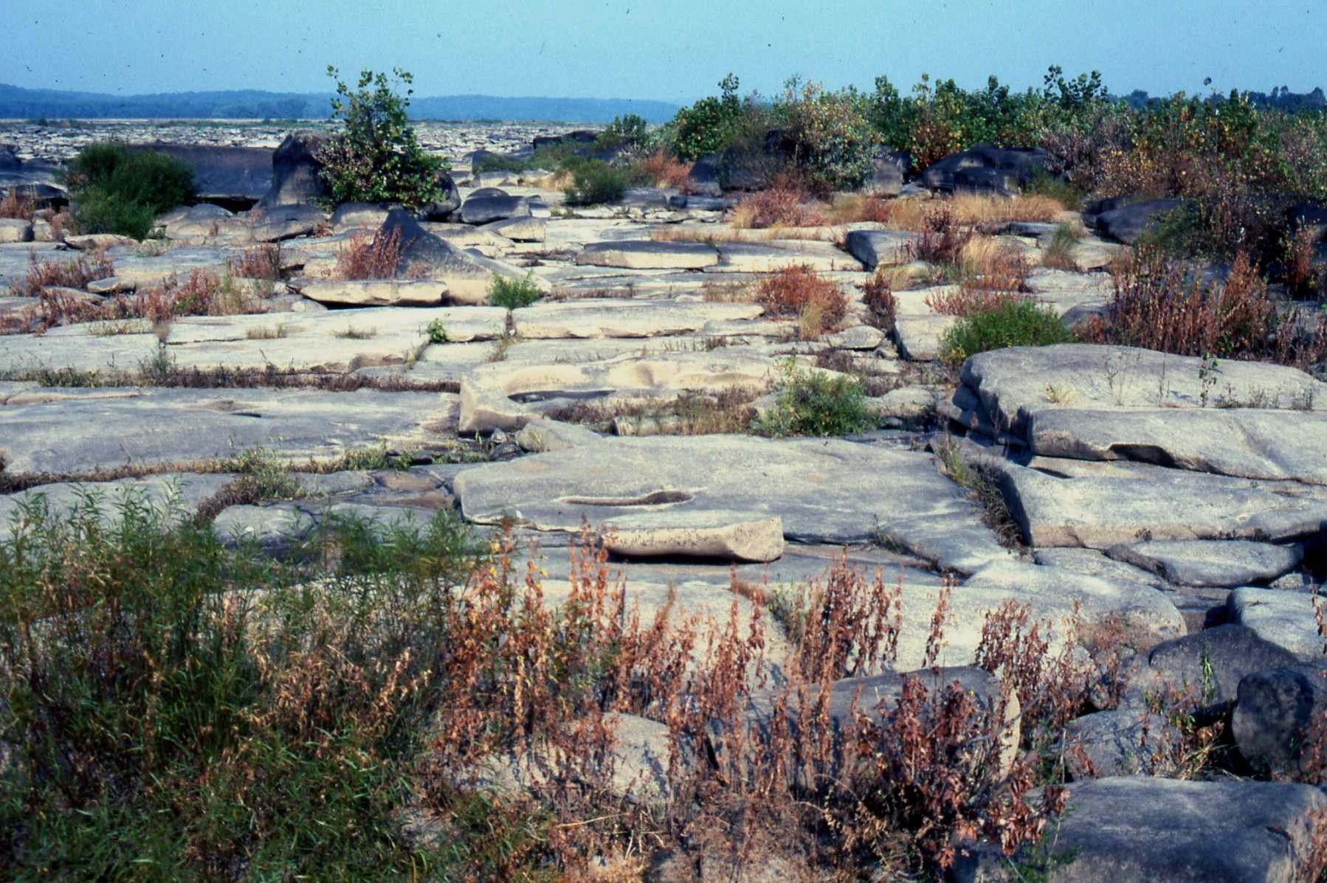
Figure 19. Surface of diabase on the left bank which shows parting separations and fractures. Partings here are less than 1 m apart. Partings elsewhere are often up to 2.5 m apart. These partings and fractures provide ample weakness in the rock to allow erosion and movement under the correct conditions.

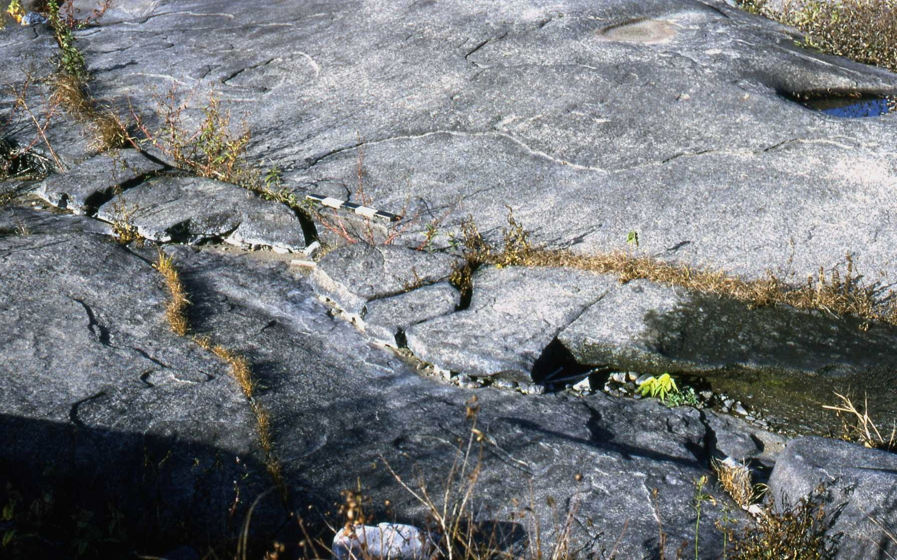
Figure 20. Thin pieces of diabase separated a few cm from parent piece. Scale is divided into 10 cm intervals. These pieces have separated from rock below along a parting plane and have moved only slightly downstream to the bottom left. The vacant area downstream from the scale suggests that a piece has been removed from there by erosion.

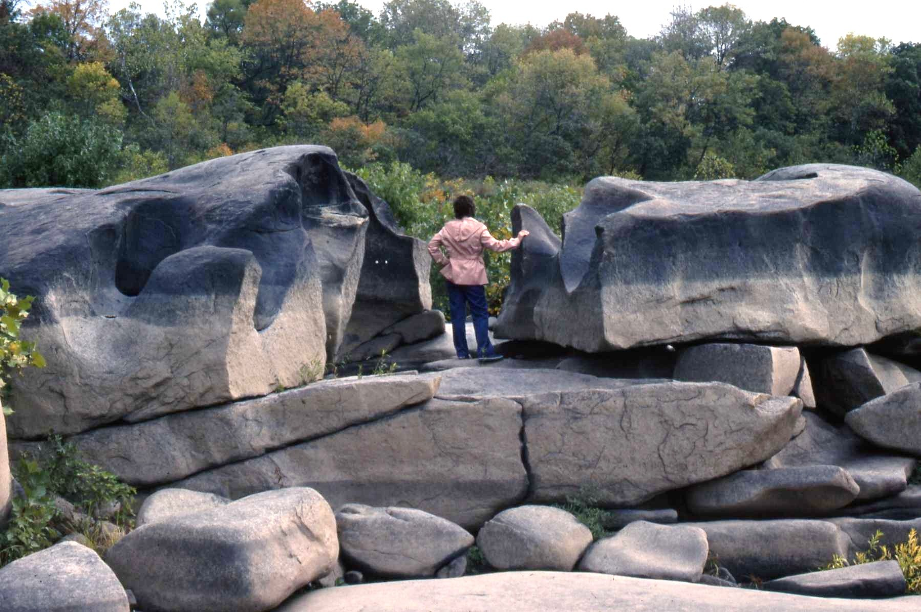
Figure 21. The large block on the right has been separated from the block on the left as indicated by potholes that can be matched. The block on the left probably has not moved, but is separated from the diabase sheet by a parting plane. Person is 5’2’’ tall.

MOVEMENT OF BLOCKS AND BOULDERS BY THE SUSQUEHANNA RIVER AT CONEWAGO FALLS

There are three possiblities for movement of blocks and boulders at Conewago Falls: traction transport, rolling, and flotation while encased in ice. The last of the possibilities is possible and, perhaps, even highly probable because the SR does freeze over during the cold of some winters and could have done so even more in the prehistoric past, particularly the Pleistocene. So, even though unproven, this movement mechanism must be entertained.
Movement by rolling is not only possible, but definitely proven by some of the blocks at Conewago Falls, particularly the block shown in Figures 22 and 23.
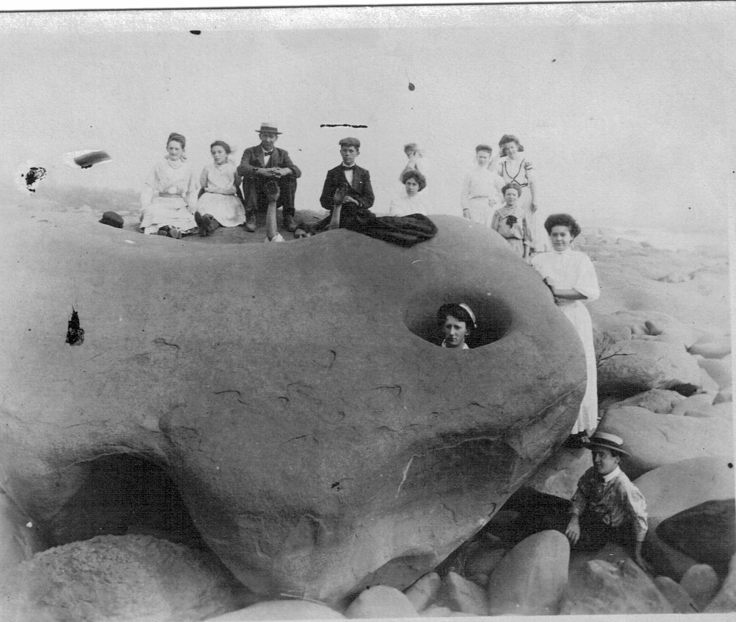
Figure 22. This large block of diabase has been overturned, presumably by
rolling. This is evidenced by the fact that the potholes are upside down. The pothole opening on the right is the lower part of the pothole, not the top.
Pothole forms seen on the other side of the pothole (Fig. 23) further verify this. The date of the photo is unknown, but clothing would suggest sometime in the early 20th century. The photo was given me by Charlie Rich, deceased, Geology Dept., Bowling Green Univ., Ohio. Of considerable importance is the fact that recent examination indicates that the smaller boulders along the base of the block have not been moved since the photo was taken. Thus, the two SR floods of record, 1936 and 1972, had no effect on the block or the loose boulders at the block base.

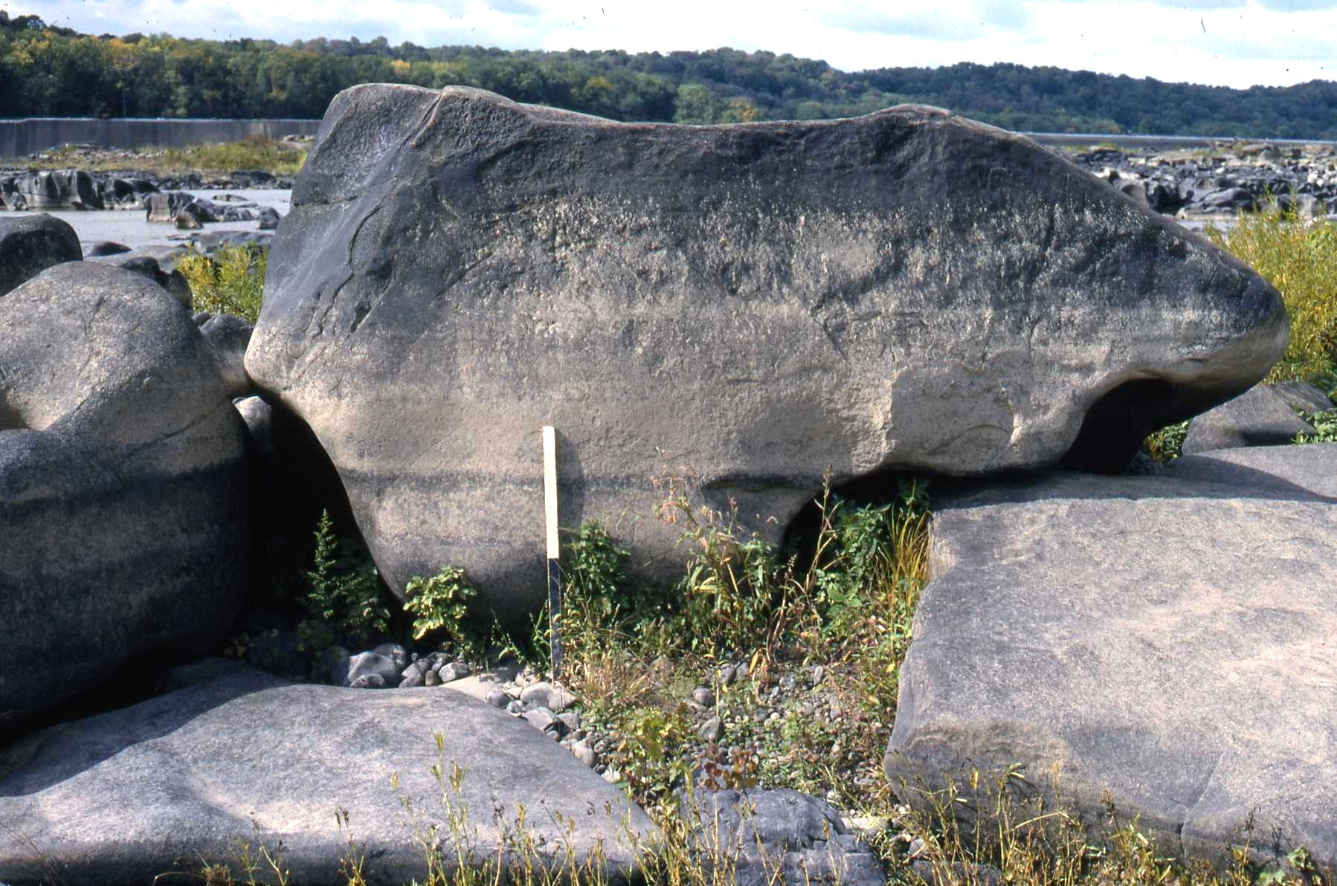
Figure 23. The other side of block shown in Figure 22. Scale is divided into ½ m intervals. The block size is 4 x 3 x 2 m. The top of a large pothole occurs at the bottom left of the boulder, another occurs behind the scale, and a third at the right end of the block. These pothole tops definitely confirm that the block is upside down and has been rolled.

Thus, we can ask, what is the magnitude of flood required to move these materials? Answer: large and calculable to some extent. Consider the lovely block shown in Figure 9 which has a size of 9 x 4.5 x 1.25 m. That calculates out to be a block of 50.625 m³. A m³ of water weighs 1,000 kg. Diabase has a specific gravity of 2.8 and a m³ of diabase weighs 2,800 kg. Thus the block weighs 141,750 kg or about 156 tons. Not what one would consider a light block. We must then ask, what force could move this block.
The first obvious answer is Pleistocene deglaciation. Floods of considerable magnitude came down the SR during three and possibly more deglaciations that occurred in PA. Certainly these floods carried enormous quantities of silt, sand, and gravel that would have contributed to abrasive erosion of the center channel as well as development of isolated potholes on the side channels. The smaller boulders are all moderately well to very well rounded and that rounding could have been developed, at least in part, by transport. There is a high
probability that many of the smaller boulders did not come from the diabase sheet at Conewago Falls, but rather the sheet 5 km upstream at Middletown (see Figure 8). Transport from there to Conewago Falls would have allowed for considerable rounding.
A further possibilty is the catastrophic failure of Glacial Lake Lesley on the West Branch Susquehanna River. This very large lake was created by glacial ice damming. As the ice melted and its front retreated northward, at some point the lake would have broken through and flowed down the SR channel. The valley narrowing at Conewago Falls would have enhanced its considerable power. Figure 24 shows the size and dam area of Glacial Lake Lesley.
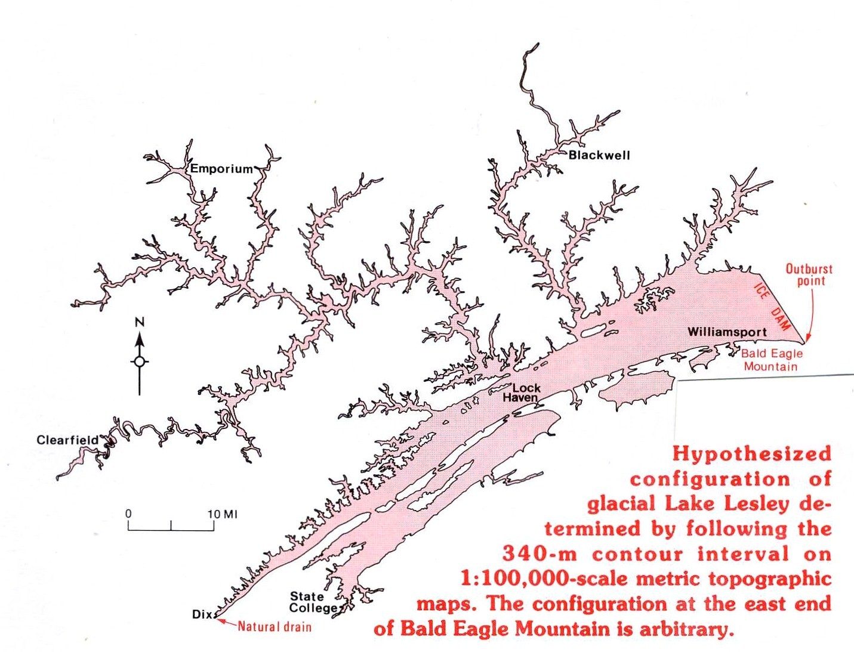
Figure 24. Glacial Lake Lesley on the West Branch of the Susquehanna River. As can be seen, the most probable point of catastrophic failure is at the east end of Bald Eagle Mountain SE of Williamsport. The volume of the lake has not been calculated but it had a large area and consderable depth in its lower reaches.

I have made no attempt to calculate the hydraulic forces required to move a block such as that in Figure 9. The forces would be considerable and must have required a flood of a magnitude larger than any on record. Figure 25 presents the flood stage, discharge and flow velocity of three known floods of record and a low flow on the SR as recorded at Harrisburg.
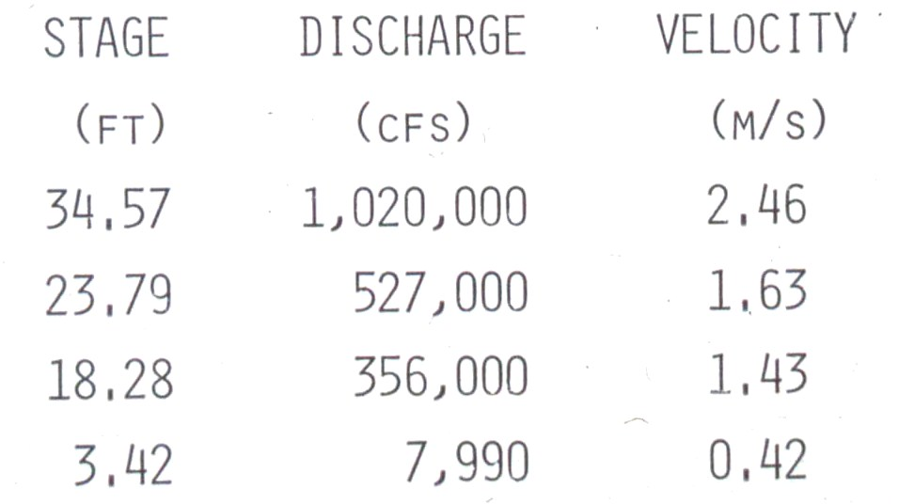
Figure 25. Stage, discharge, and flow velocity for three floods of record and a low flow on the SR at Harrisburg. Highest was in 1972 and second was 1936.

MISCELLANEOUS

The material presented covers about everything I know regarding the large blocks at Conewago Falls. The blocks and boulders are there, they have been moved, and at low SR water levels, below 4 ft at Harrisburg, can be viewed and studied.
A few additional photographs may add to the diversity of the site.

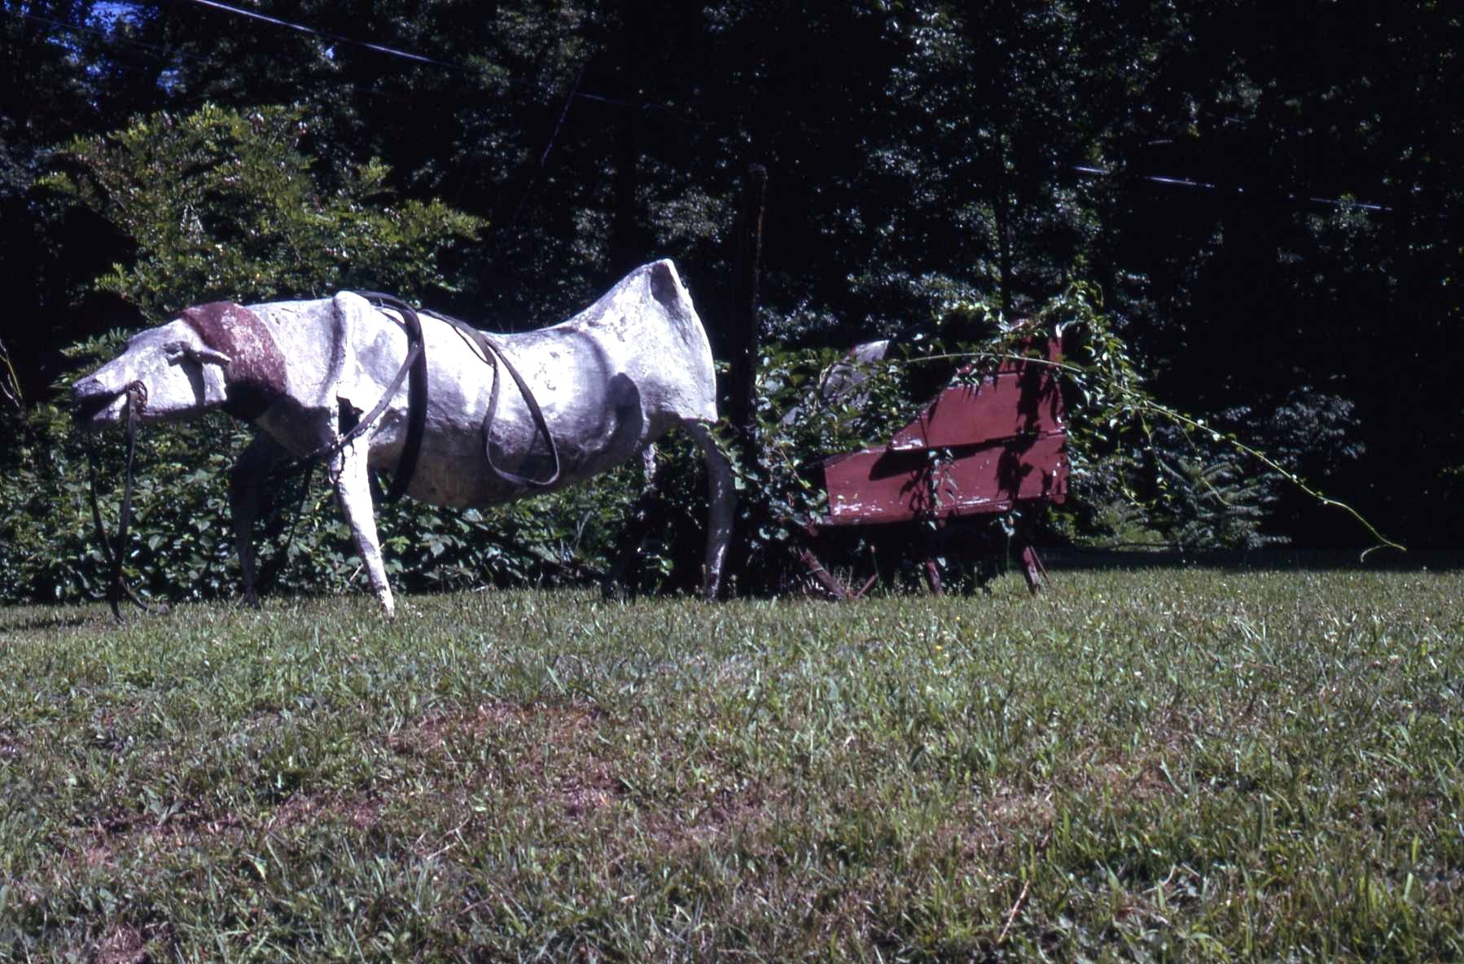
The well worn horse looks toward Conewago Falls from its position on the east side of PA 441 near the entrance to Falmouth Fish Commission Access road. Recently, after the diasaster in Japan and questions about the safety of Three Mile Island, this horse had a sign saying “I survived Three Mile Island.”

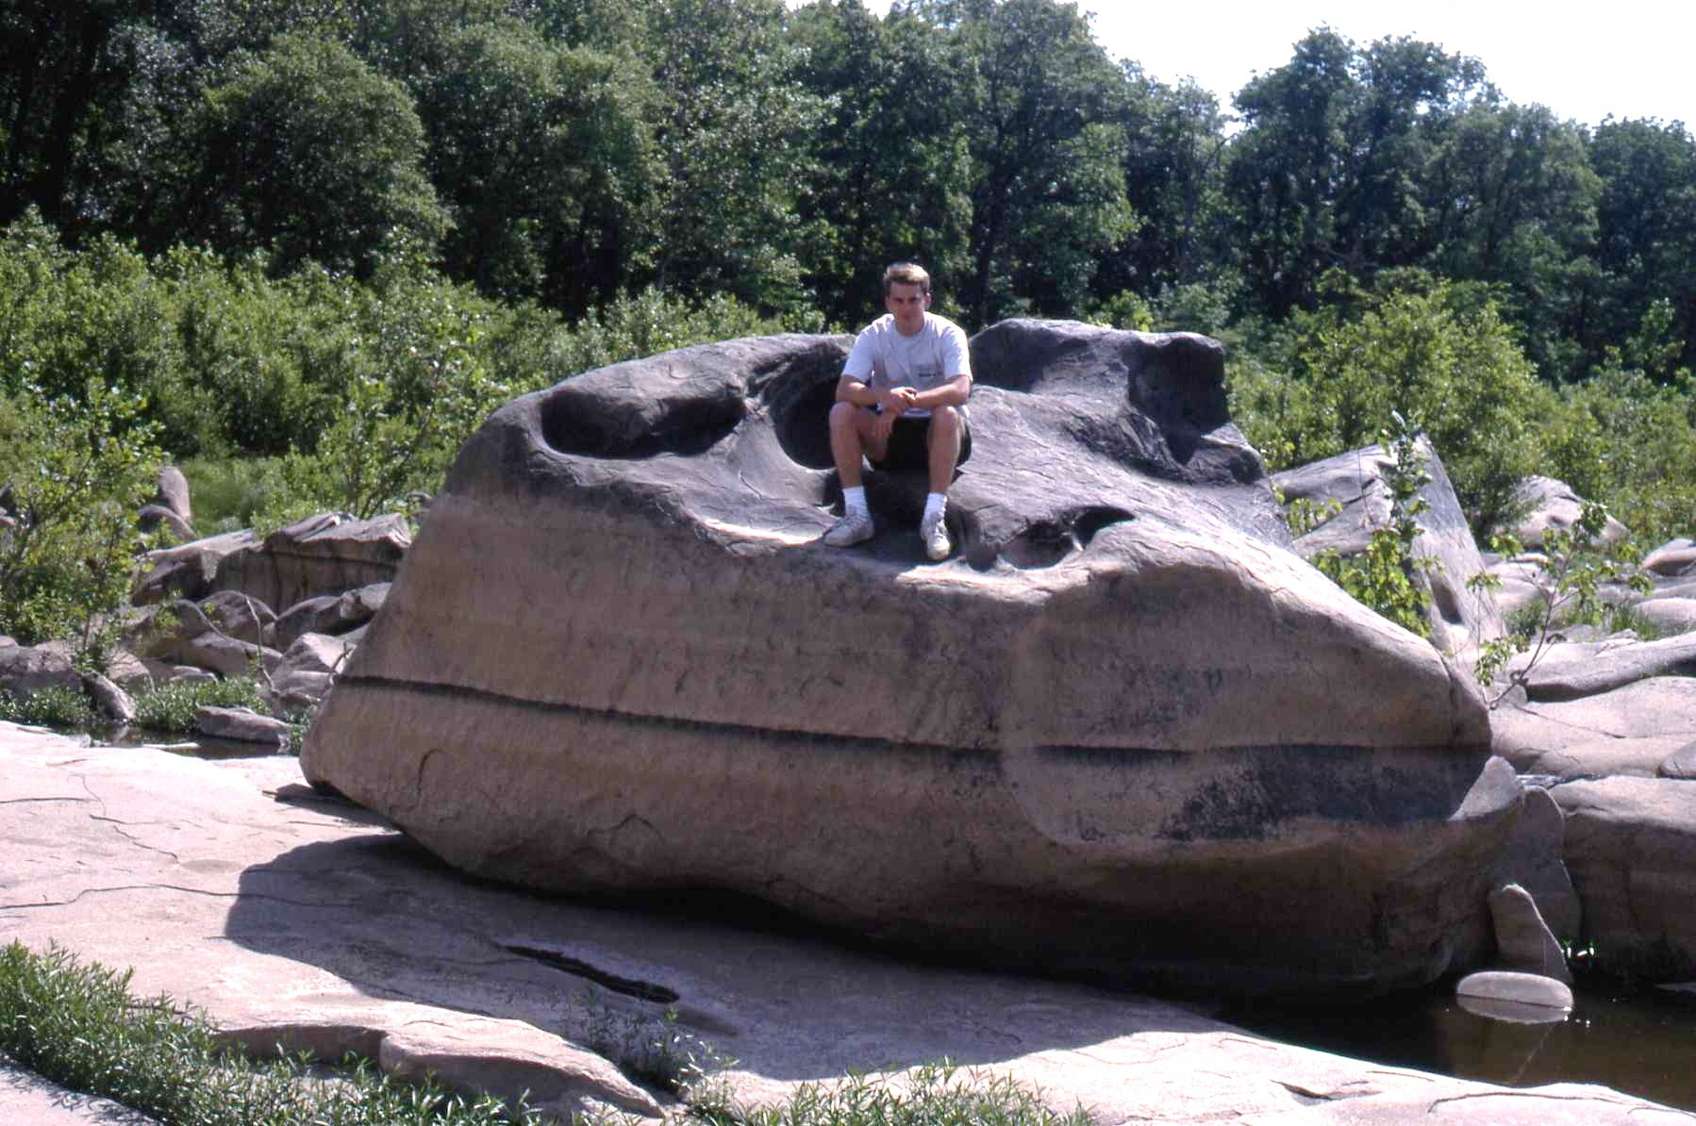
A large block is a fine position to serve as a scale.

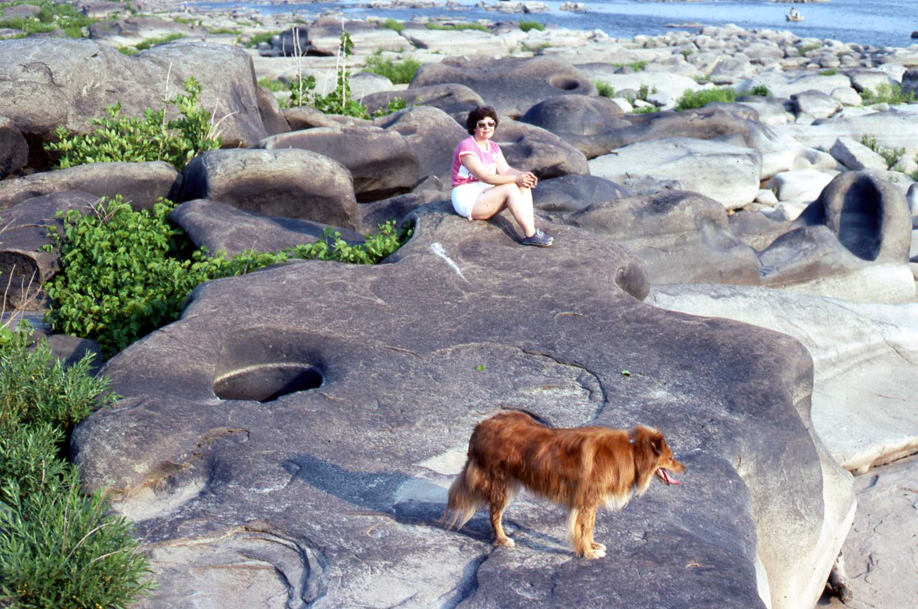
A block is a fine place to sunbathe and watch the dog.

As the sun is setting in the west, a block is not a bad place for a young couple to sit and contemplate their future together.

REFERENCES CITED
Davis, W. M., 1889, The rivers and valleys of Pennsylvania: National Geographic Magazine, v. 1, p. 183-253.
Faill, R. T., 1973, Tectonic development of the Triassic Newark-Gettysburg Basin in Pennsylvania: Geological Society of America Bulletin, v. 84, p. 725-740.
Faill, R. T. 1998, A geologic history of the north-central Appalachians, Part 3. The Alleghany orogeny: American Journal of Science, v. 298, p. 131-179.
Faill, R. T., 2003, The early Mesozoic Birdsboro central Atlantic margin basin in the Mid-Atlantic region, eastern United States: Geological Society of America Bulletin, v. 115, p. 406-421.
Sevon, W. D., 1993, River on a rampage: Pennsylvania Geology, v. 24, no. 2, p. 2-7.
Smith, R. C., II, Rose, A. W., and Lanning, R. M., 1975, Geology and geochemistry of Triassic diabase in Pennsylvania: Geological Society of America Bulletin, v. 86, p. 943-955.

