A
Brief History
of the
Science Graduation Requirement Change
from an
Elective Earth Science
to a
Required Earth/Environmental Science

Fred L. Beyer, Jr.

Southeastern Section
Geological Society of America
Wilmington, North Carolina
March 25, 2011

A Brief History of the Science Graduation Requirement Change
from an Elective Earth Science to a
Required Earth/Environmental Science

1. In the late 1950's interest began to grow nationwide in the earth sciences. The National Science Foundation funded many earth science projects including the most successful and influential Earth Science Curriculum Project (ESCP). ESCP was largely responsible for the national development of the earth sciences as a course area of equal importance to the physical sciences and life sciences.

2. In North Carolina, Earth Science was established as a required course at the eighth grade level in 1962.

3. In 1982, a Science Curriculum Study Committee was established by the State Board of Education and the NCDPI to make recommendations for improving the total science program in the public schools of North Carolina. This was a two year study by business and industry leaders, IHE representatives, superintendents, principals, local supervisors and teachers. One of the Committee’s recommendations was that Earth Science be moved to the high school level. The State Board of Education made Earth Science as essential BEP high school course in 1985. This required that Earth Science be offered in every high school as part of the elective courses available to all students.
4.

This action eliminated the Earth Science Course being taught at the eighth grade level. The Middle school curriculum became three years of integrated science. With in one year, the number of students enrolled in earth science related courses at the high school level was significantly smaller than the enrollment in high school physics courses.
the

Later in 1985 a the Education and Industry Committee for Earth Science in North Carolina was formed. Dr. C. Q. Brown from the geology department at East Carolina University, Mr. Alex Glover, geologist for Martin Marietta Corporation and Fred Beyer, Science Supervisor with the Cumberland County Schools co-chaired the committee. The committee began assembling a group of more than 30 interested professional earth scientists, educators, and industry leaders from across the state. Subsequently they launched a campaign to solicit letters and other contacts directed at the State Board of Education supporting the need for an Earth Science course at the high school level.
5. In 1988, a major study of the status of Earth Science in the schools of North Carolina was conducted by NCDPI. Findings from the study demonstrated high student interest, high teacher interest, and confidence on the part of teachers in their ability to teach the subject. The study showed there was an adequate supply of teachers with over 70% of earth science teachers holding comprehensive certification and 22% holding earth science certification only.

6. In 1992, the State Board of Education made numerous changes in the high school graduation requirements. Included was Biology for all students and increasing the number of science courses required for graduation from two to three.

7. In the summer of 1992 and the summer of 1993 two major forums were held involving over 200 people (teachers, principals, superintendents, higher education representatives, business/industry representatives) interested in the state science curriculum which was in the process of being revised. At both of these meetings, it was strongly suggested that Earth/Environmental Science be added to the high school graduation requirements as the third elective science.

The Education and Industry Committee for Earth Science had significant representation at these forums. They emphasized the need for Earth Science in the high school curriculum to provide a base for educated citizens to understand and cope with the environmental challenges which North Carolina would face in coming decades.
8. In 1993, the American Association for the Advancement of Science published Benchmarks for Scientific Literacy calling for the exposure of high school students to the life sciences, earth sciences, and physical sciences.

9. In December of 1995, the National Academy of Sciences published the National Science Education Standards which called for the exposure of high school students to the earth sciences, physical sciences, and the life sciences.

The only significant opposition came from parents of gifted students who wanted their children to take as many Advanced Placement courses as possible. This was effectively silenced by allowing AP Environmental Science to meet the proposed requirement.
10. In the fall of 1994, a survey of all NC Public School Superintendents revealed only two expressing concern relative to the idea of the Earth/Environmental Science requirement.

The proposal was voted down the Superintendent’s Council when it was first presented. The opposition came from two superintendents who had been lobbied by parents of gifted children. Their votes were later changed after they were contacted by members of earth science related industries in their areas of the state.
11. In 1995, the High School Principals Advisory Council for Instructional Services in NCDPI completely supported the idea at their spring meeting. This body represents all the high school principals in North Carolina.

12. In 1994-95, over 100 letters were received from business, industry and government leaders supporting the requirement.

13. The NC Science Teachers Association has gone on record in 1995 and 1996 supporting this graduation requirement.

14. The NC Science Leadership Association has in 1995 and 1996 endorsed the concept.

14. When contacted in 1994-95, strong support was voiced by a large majority of higher education institutions, and none have expressed opposition

The Education and Industry Committee for Earth Science for Earth Science initiated the letter writing campaign and requested the statements of support from both science leadership organizations. The committee at that time included representation from every major college and university in the state. Those representatives were responsible for the endorsements of the proposal to add earth science to the high school curriculum.
15. A survey taken each of the last five years of the high school science department chairpersons has shown overwhelming support of 96% in favor of the requirement.

The environmental education lobby indicated that they would actively oppose the proposed course requirement unless environmental science was included as a significant element of the course. Their cooperation was assured by 1) including the term “environmental” in the course title and 2) Agreeing to write the course syllabus in a manner that would include appropriate environmental concerns with each major topic.
16. Based on this background, the proposal was presented to the State Board of Education in July of 1996 and was adopted in August of 1996.

17. Information concerning the State Board action was shared with science educators across the state through professional meetings and with local school system administrators through the State Board of Education minutes which are sent to each school system.

18. A public hearing was held in July of 1997 with overwhelming support given by over 30 (47) presenters including representatives of several school systems. There was only one negative response. The negative response was countered by two teachers from the same school system.

19. The State Board of Education took final action on September 4, 1997 by approving the change in high school science graduation requirements to include one elective unit in the earth/environmental sciences.

20. On October 30, a memorandum explaining the change was sent to all superintendents, central office science contacts, high school principals, high school guidance counselors, and high school science department chairpersons.

21. To date (December 5, 1997), the Science Team of NCDPI has received 68 contacts relative to the change. Three of these (4%) have expressed negative concerns while the rest of the contacts have been of a positive nature.

22. In December, 1997 the North Carolina Rules Review Commission approved the proposed change making an earth/environmental science elective of the three science courses required for graduation. This requirement becomes effective with the graduating class of 2002.

23. In March of 1998 the State Board of Education delayed the implementation of the new graduation requirement, mandating that the requirement would be implemented when the class of 2004 enters school in the Fall of 2000.

- In the Fall of 2000 the new graduation requirement was implemented across North Carolina without incident. At the present time most students take earth/environmental science as ninth graders. Honors classes are taken by eleventh or twelfth grade students and the Advanced Placement Environmental Science course is being taken by twelfth grade students.

- The required End-of-Course test has not been developed and is presently (2002) not on the NCSDPI Assessment Division’s future test development list. This is in direct violation of the state statute which requires an end-of course test for all courses required for graduation. As a result, the earth/environmental science course has become a “dumping ground” for weak teachers. Apparently, the only way to solve this problem is to find a way to have the Assessment Division move to develop and administer the required end-of -course test.

General Comments: It should be noted that this requirement does not specify a single course but rather may be satisfied by one of a series of courses included, but not necessarily restricted to one of the following:
Earth/Environmental Science (regular or honors)
Advance Placement Environmental Science
The International Baccalaureate Environmental Systems Component

This document was produced and distributed by the NC Department of Public Instruction (NCDPI) in December of 1997. The presenter’s editorial comments are shown in bold and/or italics. Comments in boxes were added by members of the Education and Industry Committee for Earth Science in North Carolina which still exists and functions on an as needed basis.

As of February 2010, the Earth/Environmental Science course was operating successfully in all North Carolina high schools. Enrollment in earth science related courses had increased to include astronomy, meteorology, and oceanography. Advanced Placement Environmental Science course enrollment has also increased significantly. [See table below.]

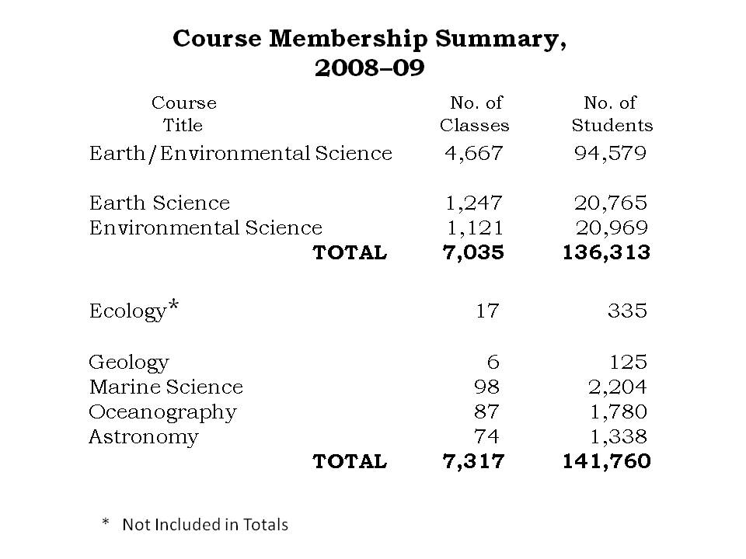

During 2009 - 2011 the Science Division of the Department of Public Instruction prepared a new Essential Skills Curriculum. The curriculum which was adopted by the State Board of Education in March of 2010 for implementation in the 2012 academic year was intended to significantly reduce the number of major concepts for every course in grades K-12. The goal was to allow teachers more time to deal with concepts in depth. Unfortunately, the Earth/Environmental Science Essential Skills Curriculum significantly reduced the critical concepts in several areas which effectively shifted the emphasis from geology, meteorology, and oceanography to ecology. While the concept of ecology is important, it is also a significant part of the required biology course. The table below shows the concepts which were reduced to a supporting role in the revised course.
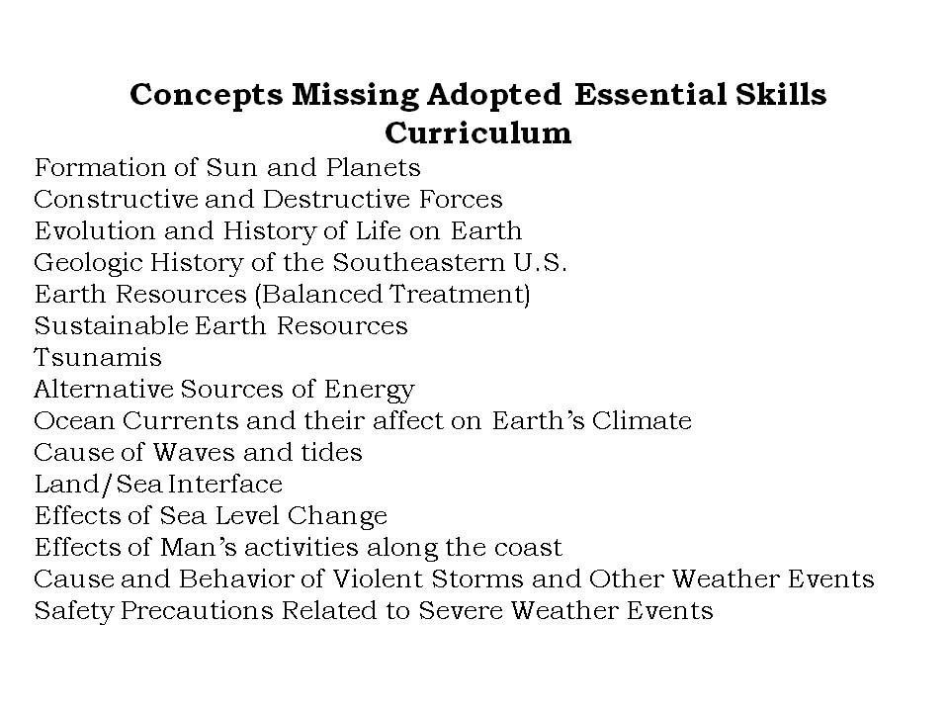
Efforts are presently underway to request the State Board to make changes in the Earth/Environmental Science Essential Skills Curriculum that will include the concepts listed above and balance the emphasis on this course on the entirety of planet Earth. The goal for the Earth/Environmental Science course should be to provide every student with the understanding and knowledge they need to make well thought out decisions as adult citizens in society regardless of the level of education they pursue beyond high school.

