Statewide Well Drilling Trends
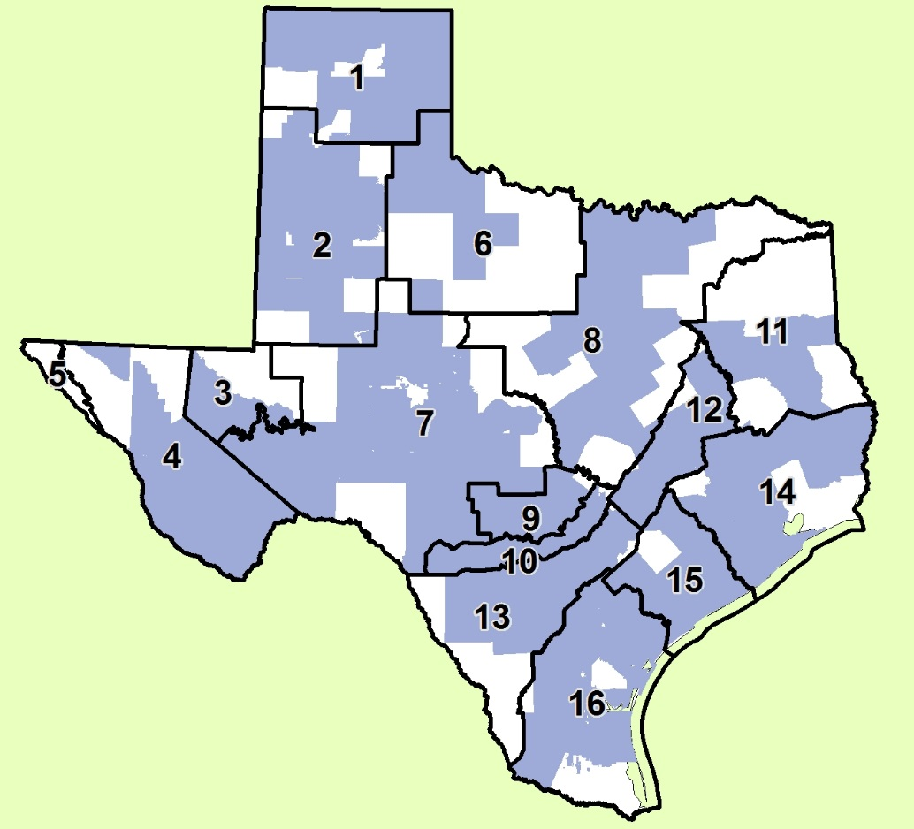
Map showing GCDS and GMAs

GMA | %  Area | %  Domestic | %  Industrial | %  Irrigation | %  Public Supply
1 | 17 | 23 | 4 | 2 | 7
2 | 18 | 8 | 14 | 2 | 4
3 | 46 | 73 | 63 | 51 | 97
4 | 26 | 4 | 63 | 4 | 8
5 | 100 | 100 | 100 | 100 | 100
6 | 60 | 73 | 87 | 38 | 65
7 | 26 | 59 | 43 | 48 | 41
8 | 43 | 16 | 19 | 33 | 16
9 | 5 | 11 | 5 | 65 | 18
10 | 3 | 1 | 4 | 6 | 1
11 | 52 | 55 | 30 | 70 | 56
12 | 7 | 4 | 11 | 2 | 8
13 | 34 | 11 | 18 | 3 | 2
14 | 21 | 13 | 15 | 13 | 6
15 | 9 | 14 | 9 | 4 | 6
16 | 26 | 26 | 30 | 66 | 70

Table showing % outside a Groundwater Conservation District (GCD) by Groundwater Management Area (GMA)

