Name: _______________________________ ENVR 373 Methods in Microscopy

Lab Assignment: Electron Imaging

Part 1: Average Atomic Number Calculations

Backscatter Electron (BSE) images show the average atomic number (Z_{avg}) of different phases through varying shades of grey. The higher the Z_{avg}, the brighter the shade of grey. The BSE image below shows three different mineral phases and epoxy (black) in a thin section of rock. From other analyses, you have determined the phases present are:

calcite CaCO₃
tremolite Ca₂Mg₅Si₈O₂₂(OH)₂
talc Mg₃Si₄O₁₀(OH)₂

On the following page, you are to calculate the average atomic number (Z_{avg}) for each mineral phase and match them to the image below.

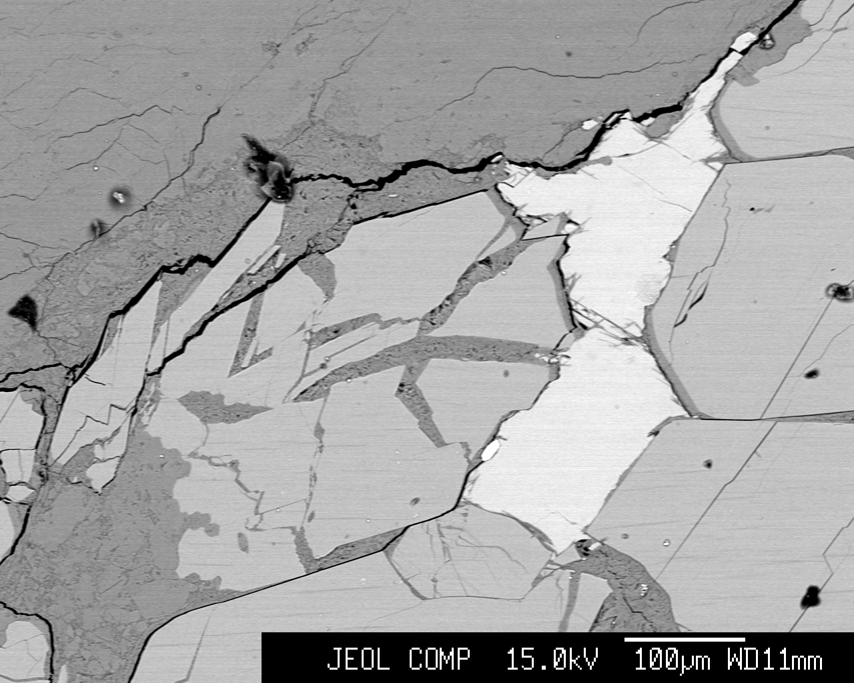
bright grey
medium grey
dark grey

1. Calculate the Z_{avg} for each mineral phase using the tables below. Then label the phases on the photograph on the first page.

calcite CaCO₃
element | no. of atoms in formula | Z of the element | Z_{sum}  atoms in formula * Z
Ca | _____________ | _____________ | _____________
C | _____________ | _____________ | _____________
O | _____________ | _____________ | _____________
total = | _____________ | total = | _____________ |  | calcite  Z_{avg} = | __________

tremolite Ca₂Mg₅Si₈O₂₂(OH)₂
element | no. of atoms in formula | Z of the element | Z_{sum}  atoms in formula * Z
Ca | ____________ | ____________ | ____________
Mg | ____________ | ____________ | ____________
Si | ____________ | ____________ | ____________
O | ____________ | ____________ | ____________
H | ____________ | ____________ | ____________
total = | ____________ | total = | ____________ |  | tremolite  Z_{avg} = | __________

talc Mg₃Si₄O₁₀(OH)₂
element | no. of atoms in formula | Z of the element | Z_{sum}  atoms in formula * Z
Mg | _____________ | _____________ | _____________
Si | _____________ | _____________ | _____________
O | _____________ | _____________ | _____________
H | _____________ | _____________ | _____________
total = | _____________ | total = | _____________ |  | talc  Z_{avg} = | __________

2. Label the three main mineral phases on the photograph on the first page by correlating the Z_{avg} with the shade of grey.

3. Briefly describe some errors with analyzing materials by relying on the BSE detector and the calculated Z_{avg} of each phase.

Part 2: Diffraction Limit Calculations

Resolution in microscopy is limited by diffraction, the bending of a wave as it goes through an aperture. The amount of diffraction is related to the wavelength of the light (or particle). Follow this exercise to compare the optimal resolution of light microscopy and electron microscopy. (We say “optimal” resolution here, because resolution is also limited by other effects such as aberration and distortion. Aberration and distortion can theoretically be eliminated by using more precise—and thus more expensive—instruments. The diffraction limit, on the other hand, is due to the wave like nature of light and particles and cannot be avoided.*)

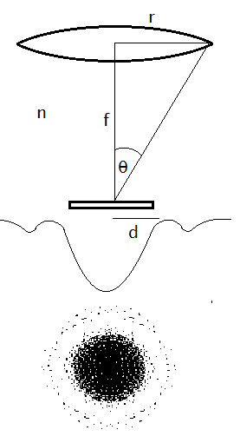
When a microscope forms an image, the light that goes through the aperture of the lens diffracts, i.e. bends, and light from the edge of the aperture interferes with light from the center. This causes the image from a point like object to be “fuzzy” or spread out. The radius of this fuzzy image, d, is essentially the resolution. The radius of the image is determined by the radius of the aperture, r, the distance between the last aperture and the sample, f, the index of refraction of the medium between lens and sample, n, and the wavelength of the light or particle, λ, by the Abbe diffraction limit:
where NA is the numerical aperture given by:

The wavelength of visible light ranges from 400-750 nm, approximately. Particles have a wavelength determined by the de Broglie relationship which depends on their momentum, p, and Planck’s constant, h:
.
For this exercise, we’ll calculate the spatial resolution, d, for visible light and electrons which have been accelerated through various accelerating voltages. Remember that the velocity of an electron is related to the accelerating voltage. The potential energy of the electron at the top of the gun is all converted to kinetic energy as it accelerates toward the anode. This lets us equate kinetic energy, , to the electric potential energy, . In these equations, m_{e} is the mass of the electron, e is the charge of the electron, v is the electron velocity, and V is the accelerating voltage setting of the SEM. Don’t forget the momentum is the product of mass and velocity: . (Note, this approximate derivation ignores the effects of relativity.)
First, find the de Broglie wavelength of particles accelerated through 1 kV, 10 kV, and 30 kV and fill those into Chart 1. Then, fill out Chart 2 to compare the resolution of UV light, yellow light, and red light. (Note the prefix “k” as in kV means 10³, so 1 kV = 1000 V.)

*Even this isn’t totally true, near field optics and interferometric microscopy allow the diffraction limit to be overcome, but these are specialty techniques only applicable to certain types of specimens.

Chart 1: The de Broglie wavelength of electrons of various accelerating voltages
Accelerating voltage, V | 1 kV | 10 kV | 30 kV
Electron velocity, v
(in m/s)
Electron momentum, p
(in kg·m/s)
De Broglie wavelength, λ_{de Broglie}
(in nm)

Chart 2: The optimal spatial resolution of various optical and electron microscopies
wave | UV light | Yellow light | Red light | 1 kV electrons | 10 kV electrons | 30 kV electrons
λ  (in nm) | 250 nm | 590 nm | 750 nm | (from above) | (from above) | (from above)
NA  (unitless) | 1.4 | 1.4 | 1.4 | -- | -- | --
Working distance, f | -- | -- | -- | 5 mm | 5 mm | 5 mm
Final aperture radius, r | -- | -- | -- | 50 μm | 50 μm | 50 μm
Resolution, d
(in nm)

Note, the metric prefix “m” as in mm means 10⁻³, the prefix “μ” means 10⁻⁶, and the prefix “n” means 10⁻⁹. Express your answers for resolution, d, and de Broglie wavelength, λ_{de Broglie}, in units of nm.

Planck’s constant, h, is 6.626×10⁻³⁴ J⋅s. The mass of the electron is m_{e} = 9.11×10⁻³¹ kg (Note, kg is the SI unit for mass. Do not convert this number to grams in your calculations.) The charge of an electron is 1.6×10⁻¹⁹ C. The units should all work as long as you convert all distances to meters, m. If you’re interested in units, a Joule, J, is a . A Volt, V is a .
Name: _______________________________ ENVR 373 Methods in Microscopy

Lab Assignment: Energy Dispersive Spectroscopy

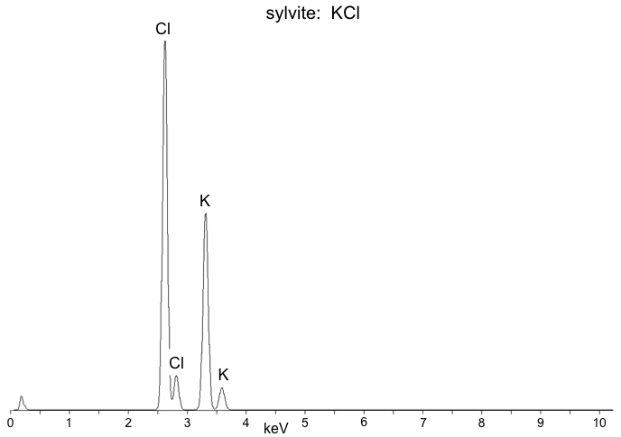
Part 1: This exercise compares the intensities seen on an energy dispersive spectra with the atomic weight percents of two known materials. The small, unlabeled peak on the far left of the spectrum is beryllium and is a relic from the Be window in the EDS detector so disregard it from your calculations.

To determine the percentages of each element, measure the height in cm of each peak and write it above each peak on the spectra below. Next, fill in the first table below to calculate the ratios of each element. The second table will walk you through calculating the weight percent of each

Element | Total Peak Intensity | Atomic Percent | Weight of element in formula | Atomic wt%
 | sum of intensities for all of the peaks labeled under the same element | element peak intensity/  total peak intensity  x 100 | atomic percent x  atomic weight (from Periodic Table) | weight of element in formula /  total weight of elements
K
Cl
total |  | - - -

Element | APFU | Atomic Weight of Element | Weight of element in formula | Atomic wt %
 | atoms per formula unit | refer to Periodic Table of Elements | APFU x atomic weight | weight of element/  sum of all element weights  x 100
K
Cl
total |  | - - -
Do the same for diopside, a silicate mineral in the pyroxene group.

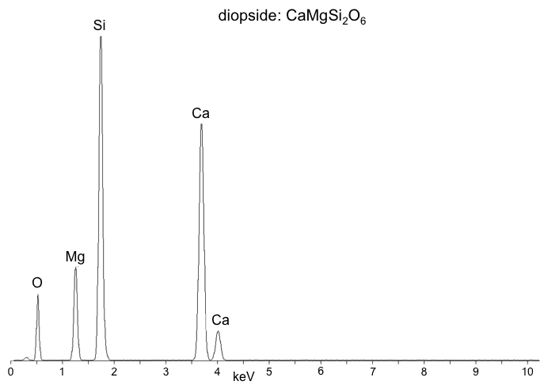

Element | Total Peak Intensity | Atomic Percent | Weight of element in formula | Atomic wt%
 | sum of intensities for all of the peaks labeled under the same element | element peak intensity/  total peak intensity  x 100 | atomic percent x  atomic weight (from Periodic Table) | weight of element in formula /  total weight of elements
Ca
Mg
Si
O
total |  | - - -

Element | APFU | Atomic Weight of Element | Weight of element in formula | Wt% of element
 | atoms per formula unit | refer to Periodic Table of Elements | APFU x atomic weight | weight of element/  sum of all element weights  x 100
Ca
Mg
Si
O
total |  | - - -

Part 2
What are the differences in the atomic weight percent by measuring the intensities of the spectra versus calculating from the chemical formula for the materials in Part 1? How do the calculations for the two materials compare with one another?

Why are the atomic weight percent by measuring the intensities of the spectra versus calculating from the chemical formula different?

Name: _______________________________ ENVR 373 Methods in Microscopy

Lab Assignment: Optical Properties of Materials

Part 1: Use the handouts of material optical properties and the interference charts to identify the properties of quartz in the prepared grain mount.

quartz
color (PPL): _________________________________________________________________
RI (<, =, or > than liquid): _______________________________________________________
optic type / sign: _______________________ | 2V (if applicable): ______________________
other properties/notes: _________________________________________________________
___________________________________________________________________________
___________________________________________________________________________

We can estimate the thickness of anisotropic materials by their maximum interference color and their known birefringence.

Using the interference charts, what is the maximum retardation seen among the quartz grains in nm?

If the birefringence of quartz is .009, what is the greatest thickness of the quartz grains in the sample?

Part 2:

unknown mineral
color (PPL): _________________________________________________________________
RI (<, =, or > than liquid): _______________________________________________________
optic type / sign: _______________________ | 2V (if applicable): ______________________
extinction angle: _______________________ | length fast / slow: ______________________
other properties/notes: _________________________________________________________
___________________________________________________________________________
___________________________________________________________________________

If we don’t know the birefringence of a material, we can estimate it by measuring the maximum size of the grains and their maximum retardation.

If at the 5x objective each cross-hair division is .02mm, then what is the largest width along the short axis of particles?

What is the maximum retardation of the grains in nm?

Using the information you provided above, estimate the birefringence of the mineral.

Name: _______________________________ ENVR 373 Methods in Microscopy

Lab Assignment: Powder X-ray Diffraction Phase Identification

X-ray diffraction can be used to measure the spacing between planes of atoms in solid materials. X-rays of a known wavelength are directed onto the solid sample and those that diffract and constructively interfere with each other will be counted by an X-ray detector. The angle between the sample and detector/x-ray tube are increased in steps to determine which d-spacings are more prevalent. The d-spacing can then be calculated by Bragg’s Law nλ=2dsinθ and searched in material diffraction databases. The following scans were created by using Cu K_{α1} X-rays of wavelength 1.54056 Å.

Part 1: Identify the three major peaks in the diffraction scans of unknown 1 and unknown 2. Next to each of the three peaks, label their relative intensities. The highest peak will be 100% and the 2nd and 3rd highest will be percentages of the highest intensity. Then calculate the d-spacings of each peak in angstroms (Å) or 10⁻¹⁰m using Bragg’s Law.

Unknown Mineral 1
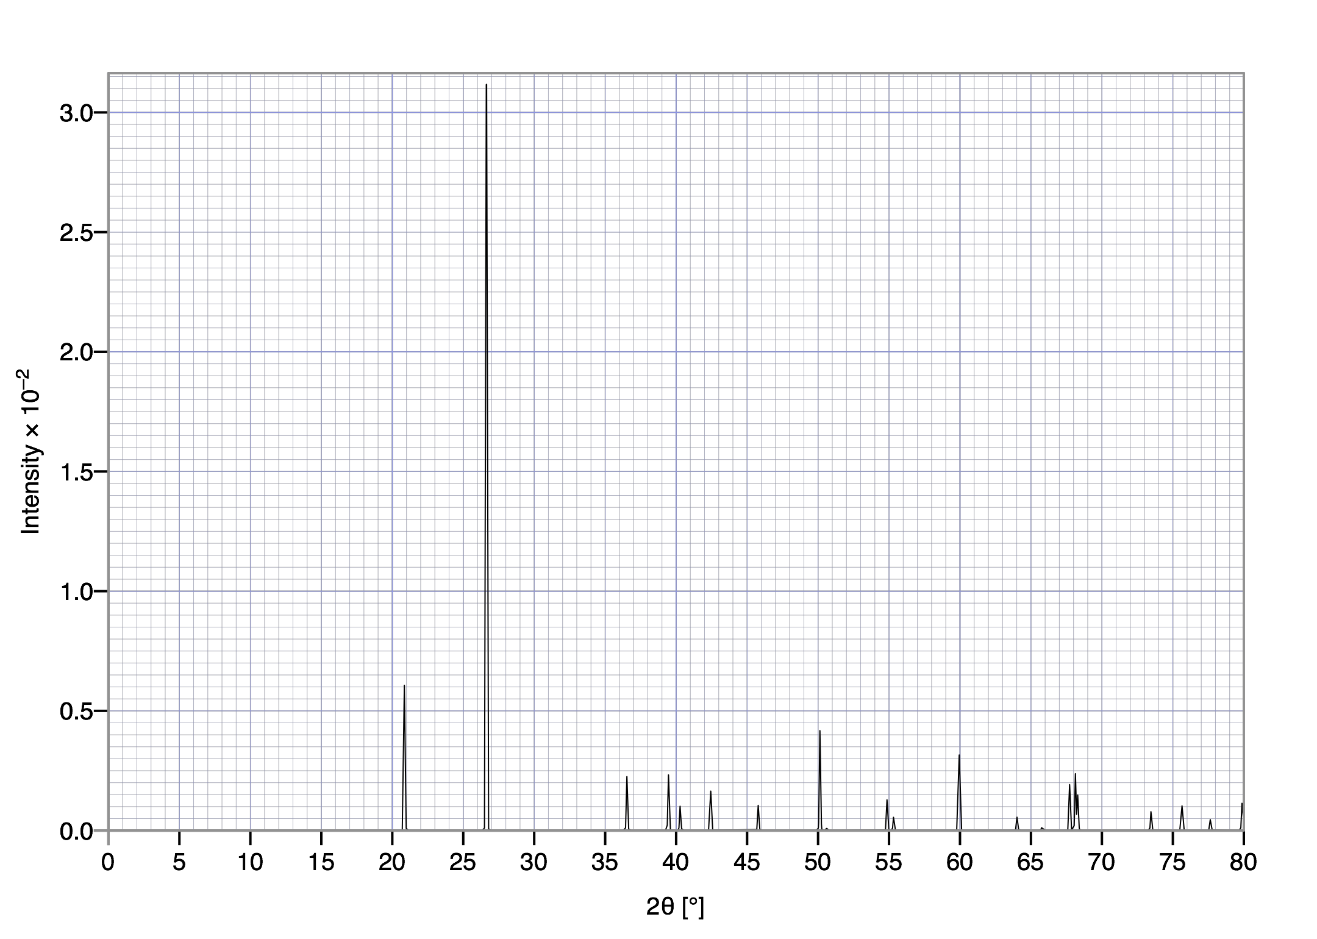

D₁ Å = _______________ D₂ Å = _______________ D₃ Å = _______________

Unknown Mineral 2
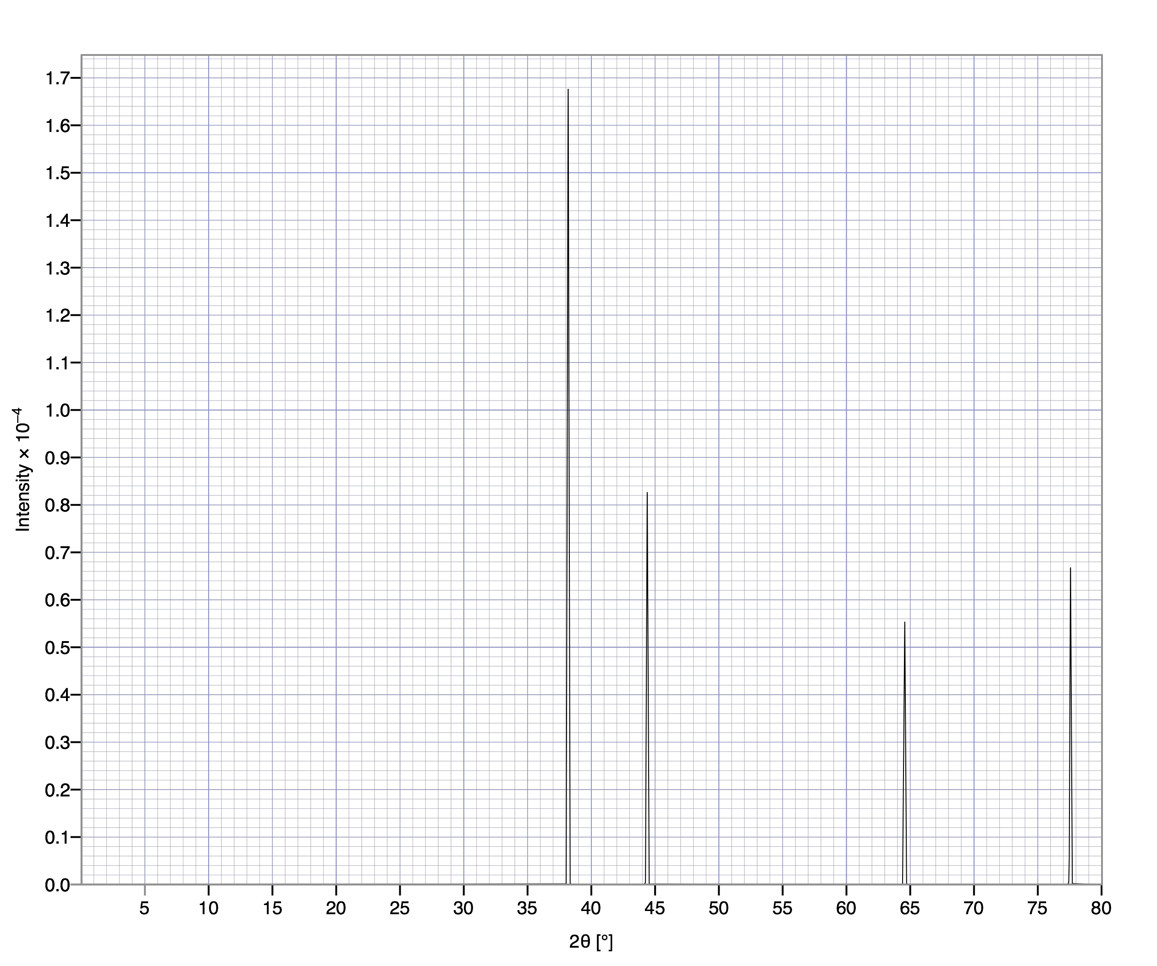

D₁ Å = _______________ D₂ Å = _______________ D₃ Å = _______________

Part 2: The structure of minerals and other solid materials are indexed by the three most common d-spacings within the structure. Go to http://webmineral.com/help/XRayDiffraction.shtml#.WBtQuOErKV5 and input the d-spacing values you calculated to identify the unknown minerals in Part 1. Use a 10% tolerance.

Unknown Mineral 1: ________________________

Unknown Mineral 2: ________________________

