To watch the associated video, just click on the following link.
https://www.youtube.com/embed/ullnFQD4F1I

The following are screen shots from the above URL showing how Centramatic autobalancers work on wheel assembly and how the process mimics Continental Drift.

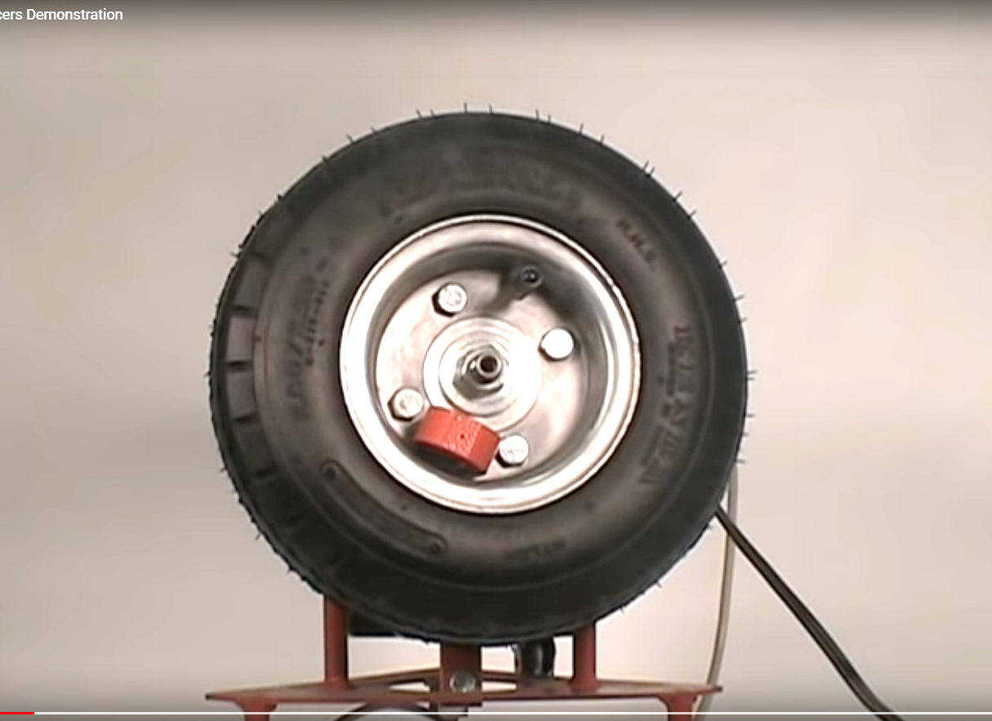

1) Tire and wheel assembly is imbalanced by placing a magnet on the rim. The magnet is representative of the location of the supercontinent Pangaea at the end of Stage I and at the beginning of Stage II rotation.

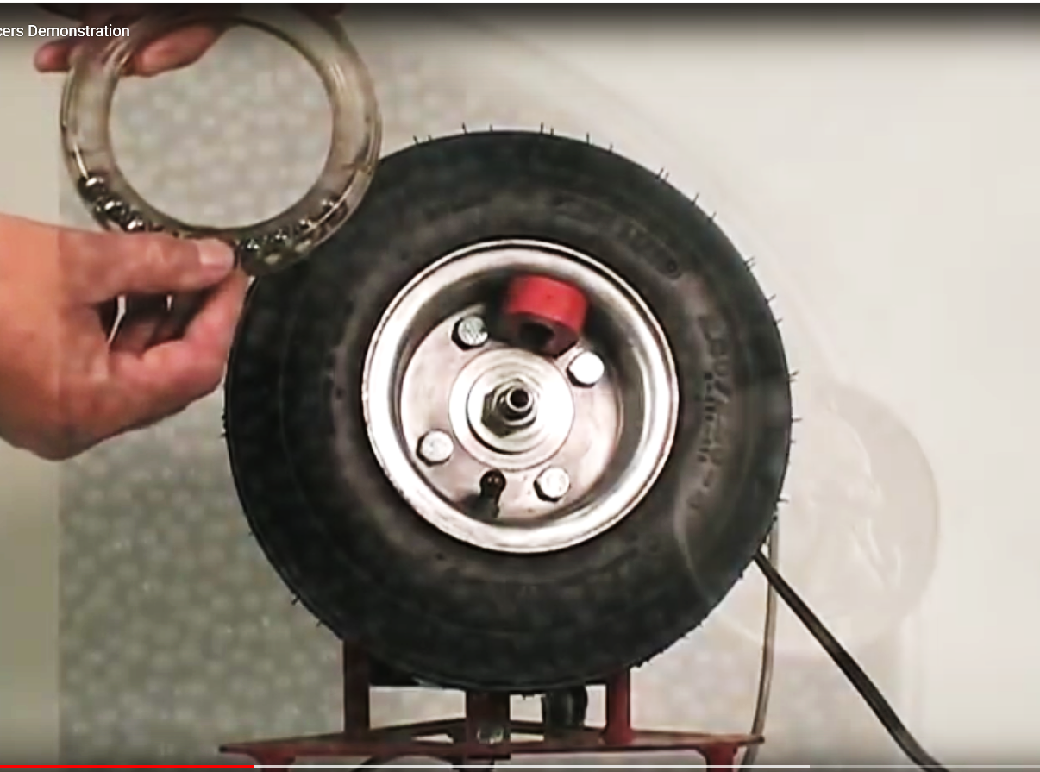

2) A balancing ring containing mobile ball bearings. is placed on the out-of-balance assembly
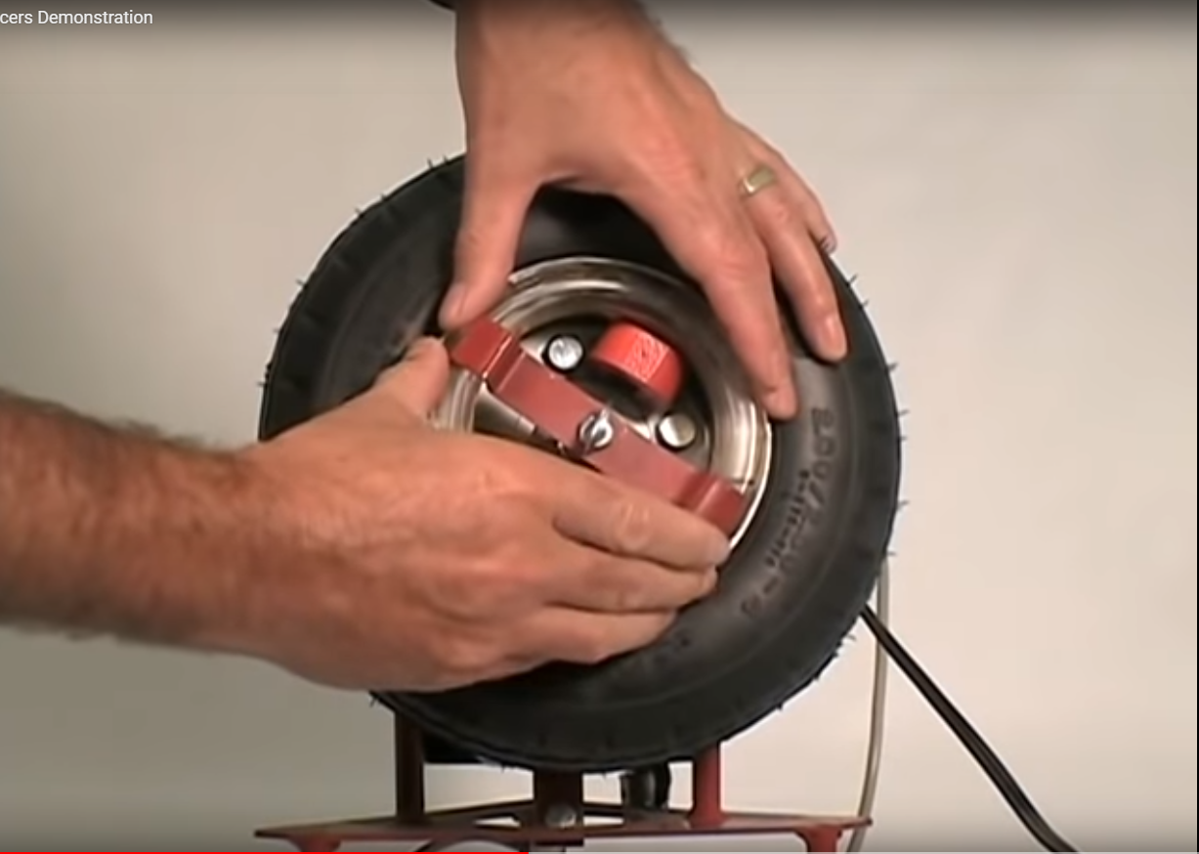
3) The balancing ring is secured with a clamp

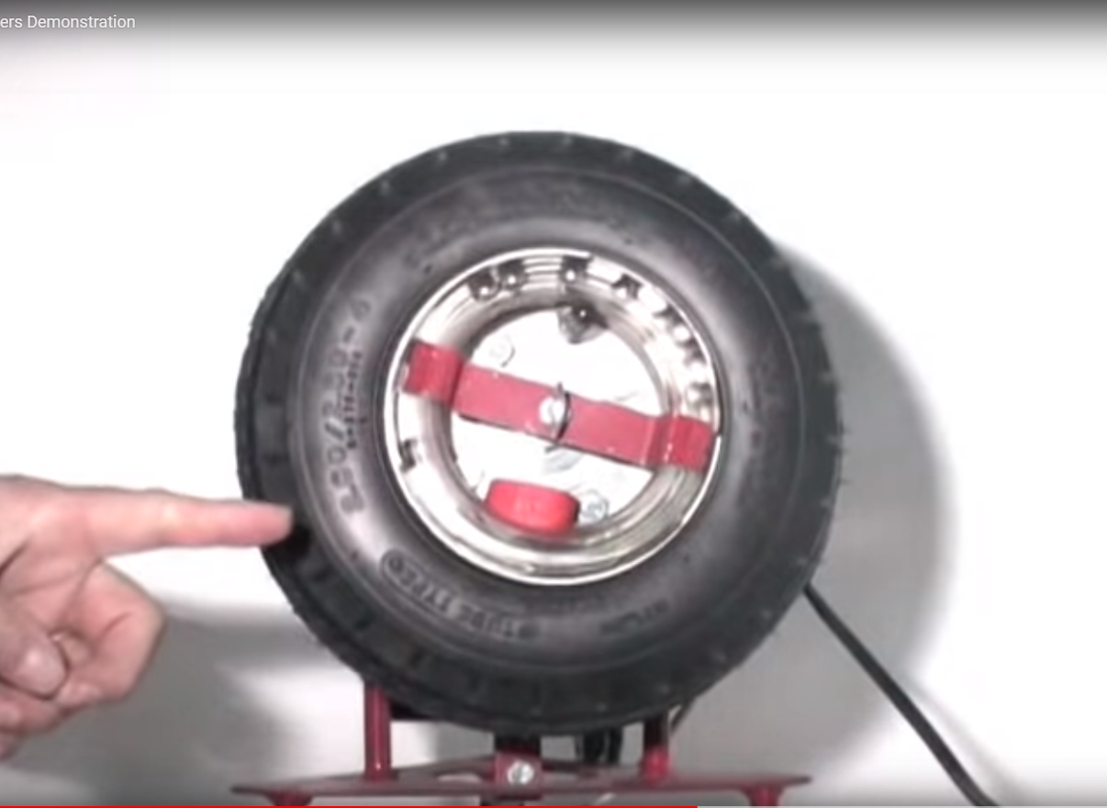
4) The wheel assembly with the balancing ring is run up to speed and the rotation is freeze-framed with a strobe light showing how the ball bearings have repositioned themselves to find the points of neutral balance. The ball bearing illustrates the motion of the continents during Stage II rotation after Pangaea has fractured and the continents are seeking points of balance on the surface of Earth.
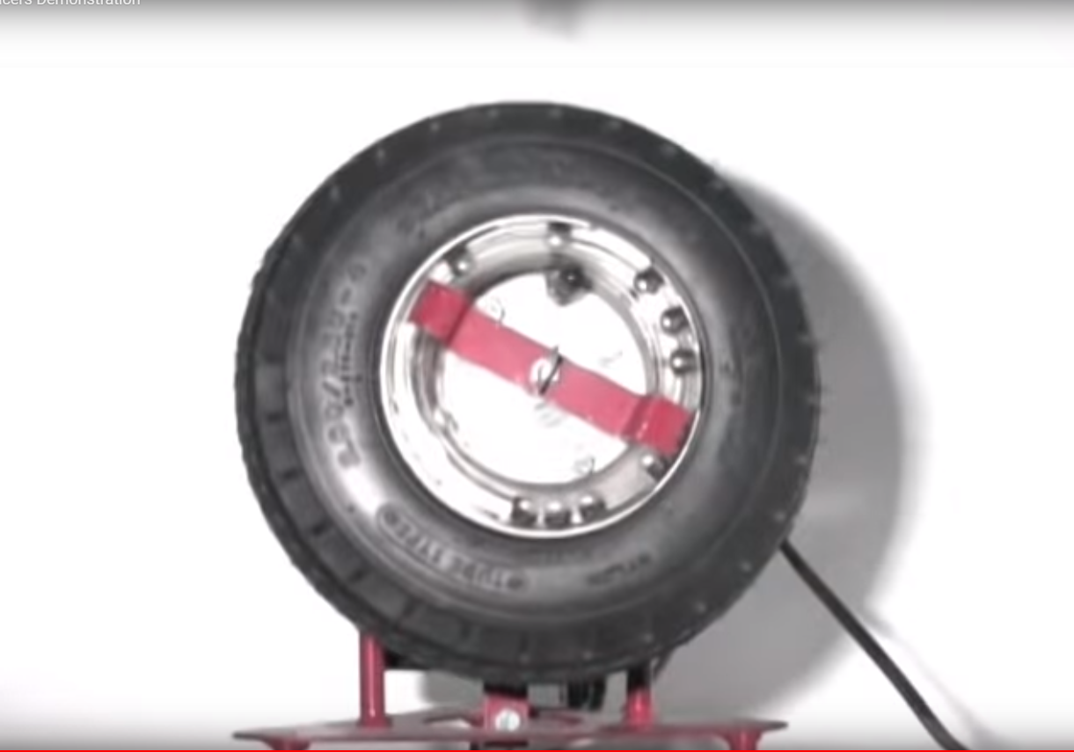
5) Freeze-framed rotation of the wheel assembly after removing the magnet imbalance showing how the ball bearings, once again, seek out the points of neutral balance. This illustrates the rebalancing of Earth after Pangaea has fractured and the continents begin to drift. Drifting will stop when all the continents reach locations of perfect balance.

