"Seismic facies or how geophysics helped shape submerged paleolandscape studies on the Gulf of Mexico OCS."
E. G. GARRISON¹
1. Departments of Geology and Anthropology, University of Georgia, Athens, GA, USA
CONTACT Ervan G. Garrison egarriso@uga.edu Department of Geology, University of Georgia, Athens, GA, 30602, USA

ABSTRACT
Seismic facies are a well-known and well used interpretative output of the interpretation of geophysical data. The term indicates its source – acoustical or seismic geophysics. The “facies” concept is a geological methodology for the classification of sedimentary lithologies. The use of seismic facies represents an effort to create a methodological analogue in order to correlate geophysical data with the geology where these data were obtained. Early efforts to characterize submerged landforms for potential prehistoric cultural resources used this methodology to interpret shallow geophysical data taken by subbottom profilers (SBP) and similar acoustical devices. This article will examine the efficacy of this approach and how it helped shape the search and characterization of submerged prehistoric landscapes and cultural resources on the Outer Continental Shelf (OCS).

Key Words
Facies, geophysics, methodology, prehistory, submerged, archaeology, regulation

Introduction
The following quote provides a succinct synopsis of the genesis of use of geophysics for oil/gas exploration and subsequently for submerged prehistoric cultural resources:

“The seafloor …. of the Gulf of Mexico hides evidence of prehistoric landscapes and resources important for the economic development of the United States. Oil and gas reserves created through geological processes and fish and shellfish resources are all extracted or harvested from the waters offshore of Texas and Louisiana, in the northwestern Gulf of Mexico (GOM). Competing economic interests for GOM resources are regulated by the federal government, which has jurisdiction over waters extending from three (Louisiana) to nine (Texas) nautical miles offshore to the edge of the Exclusive Economic Zone, located 200 nm offshore (Madden, et al NOAA CSC 2009). The densest area of offshore development and resource extraction in the northwestern GOM is on the outer continental shelf (OCS), which is defined as those portions of the seabed and submarine sediments adjacent to the shoreline and
extending out to a depth of 200 m (656 ft) BSL (CLOS 1982). The OCS is a high probability area for submerged prehistoric landscapes. In order to protect prehistoric landscapes against damage related to resource extraction it is necessary to identify where preserved elements of the prehistoric landscape exists (Evans, 2011).”

The late Melanie Stright stated in 1986, that relict landforms on the continental shelf were more easily detected with high-resolution seismic profilers operating at frequencies of 3.5 to 7.0 kHz (1986). Archaeological sites associated with these landforms generally do not have enough vertical dimension or acoustic contrast to be differentiated from natural sedimentary sequences by seismic profilers. Physical sampling of relict Wisconsinan glacial (Marine Isotope Stage/MIS 2) landforms identified from seismic data was, therefore, necessary to confirm the presence or absence of archaeological sites. This is what Coastal Environments Inc. (CEI) researchers and, other, later investigators (Evans, 2011) did.

Stright, along with others, argued those prehistoric sites were buried by sediments deposited during post-Last Glacial Maximum (LGM) sea-level rise, and therefore require sub-seafloor imaging that may be supplemented by sediment sampling. Sedimentation, post-LGM, has filled paleo-valleys incised by streams crossing the OCS (Anderson 2007:20-46; Nelson and Bray 1970). On the Gulf of Mexico OCS, evidence of relict valleys is generally not visible at the seafloor. Consequently, first, side-scan sonar and, later, multi-beam instrumentation are not useful tools for submerged prehistoric research in the northern GOM. The identification of formerly subaerial paleolandscapes offshore is dependent upon careful interpretation of sub-seafloor sediment horizons (CEI 1977; Pearson et al. 1986; Stright 1986a,b). In the GOM, predictive models were created and commonly applied in the development of geophysical remote sensing survey protocols (Coastal Environments, Inc [CEI] 1977; Pearson et al. 1986; Johnson and Stright 1992).

In the GOM, one frequently used paradigm for the prediction of submerged prehistoric extrapolates observed terrestrial settlement patterns onto the formerly exposed continental shelf (CEI 1977). This predictive model was based, primarily, on the hypothesis that prehistoric sites in coastal Texas and Louisiana occur near fresh water sources, and that inhabitants occupied or exploited landforms associated with fluvial systems, including naturally occurring levees and inset river terraces (Pearson et al 1986; Ricklis and Blum 1997). Coastal Environments, Inc. (CEI), based in Baton Rouge, undertook a pilot study to examine landforms with a high probability to contain sites, both prehistoric and historic, in the Gulf of Mexico Outer Continental Shelf (OCS).
The emphasis on landscape features within the prehistoric predictive model exists because submerged, buried prehistoric archaeological sites are ephemeral and not likely to be detected using the geophysical techniques associated with oil and gas exploration – such as seismic or even subbottom profiler methods. Those techniques, notably seismic, utilized frequencies/wavelengths incompatible with the detection of features at archaeological scales.

The ‘Why’ CRM studies are done on the OCS and ‘How’ this involved geophysics

A very little history vignette. Offshore oil and gas exploration, in the GOM, began in 1938 with the first platform built by Brown & Root Marine Operators in 14-feet (3 m) of water about a mile offshore. The chosen drilling site was a 320 by 180-foot (96 x 55 m) freestanding wooden deck near Creole, Louisiana (American Oil & Gas Historical Society). The State and Federal governments eventually took over the sale of leasing rights for minerals exploration and, after passage of the National Environmental Policy Act (NEPA) in 1969, implemented environmental protection required, under NEPA, in the GOM. Since NEPA defined the environment as biological, physical and cultural, historic and prehistoric “cultural resources” as they came to be called, Federal agencies – Bureau of Land Management (BLM), primarily – developed policy, pursuant to the National Historic Preservation Act (NHPA), in their regard. The Minerals Management Agency (MMS) supplanted BLM regarding offshore mineral development and since 2011; the Bureau of Ocean Energy Management (BOEM) provides enforcement of Federal policies for submerged cultural resources. Stright, working at MMS, in 1981 and 1982, was one of the first Federal archaeologists to address management of submerged cultural resources on the OCS (Stright, 1981; 1982).

Minerals Management Service required OCS lessees and operators and pipeline right-of-way
holders to conduct surveys within those areas of high archaeological potential, as determined by studies funded by MMS, and to submit the results to MMS. Federal regulations require these operators to include archaeological resource reports with their Exploration Plans (EP), Development Operations Coordination Documents (DOCD), and pipeline applications. The purpose of those reports was (and is) to provide information for use in determining the potential existence of submerged archaeological resources that may be affected by their proposed operations. The subsequent reports were based primarily on an assessment of data obtained from remote-sensing surveys (author’s italics). These remote sensing surveys all included shallow seismic profiling as well as side scan sonar and magnetometry. So, from the inception of the management of submerged cultural resources on the OCS, geophysics played a leading role in site detection and characterization.

Evolution of a Seismic-based Methodology

As Faught and Joy (2019) note, the continental shelf is a vast submerged landscape with abundant evidence for paleo-drainage systems and potential for sites, but it is a large, complex, and dynamic expanse to study. Identifying submerged sites is dependent upon landforms that remained minimally disturbed by the destructive processes of marine transgression. The potential for the survival of transgressed sites has been confirmed on eastern and western continental shelves as well as the Gulf of Mexico (Faught and Gusick 2011; Masters 1983; Masters and Flemming 1983; Stanford et al 2014; Stright 1995).

I concur with Faught and Joy (supra) with regard to the beginning of cultural resources management (CRM) contributions and the use of a geoarchaeological focus for submerged pre-contact sites. CEI in their seminal study of the paleo-Sabine River valley for prehistoric sites used seismic data were collected using a hull-mounted 3.5 kHz subbottom profiler system (SBP) (O.R.E. Model 140 Pinger) (CEI, 1986) (fig. 1). This system provided excellent resolution of the upper 21 meters of sediment. A 100 to 300 joule seismic system (O.R.E. Boomer) was added to supplement the 3.5 kHz data. That system provided more penetration (46 to 76 meters) with less resolution than the 3.5 kHz system. Data from the two different seismic systems were complementary and provided increased interpretive capabilities to the researchers. These studies were enabled by MMS (Stright, 1986 a,b), and this methodology, SBP remote sensing and testing reflectors with coring to determine their composition, remains as a fundamental approach.

In the Sabine River Valley study, the SBP data produced excellent examples of fluvial terraces, preserved natural levees, point bars, and tributaries at their confluence with the major river valley (fig. 2). CEI then collected seventy-seven vibracores within five areas which, based on the seismic data, were assessed as having the highest potential for preserved archaeological sites. The cores were collected using a 12-meter pneumatically driven vibracorer operating from a jack-up barge. The cores were split, photographed, and logged. Samples were then extracted for grain size, point count, palynological, foraminiferal, geochemical, and Carbon-14 analyses. The gross morphology of the split cores (fig. 3), the palynological and foraminiferal analyses confirmed the initial seismic interpretations of the river valley’s geomorphic history. The transitional sequence from fluvial to estuarine to marine environment, as sea level rose during the Holocene transgression, were represented by distinct, well-preserved lithosomes aka “facies.” The excellent preservation of the lithosomes within the ancient Sabine River Valley suggested the preservation of archaeological sites that were subsequently identified by use of the proxies defined in their predictive model (fig. 2).

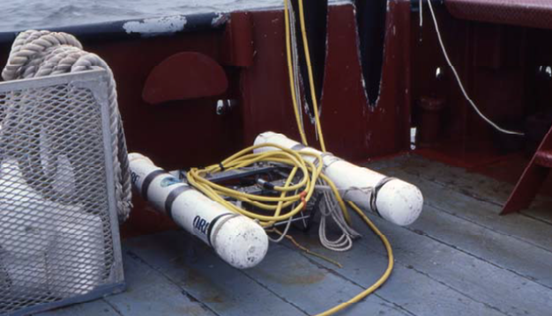

Fig. 1. A “boomer” pinger-subbottom profiler used in the CEI study. Courtesy Charles Pearson.

Fig 2. Acoustical profile and schematic view of sonar images produced by an acoustic subbottom profiler of a drowned paleochannel in 15 m water depth in the Gulf of Mexico. Sediment vibracore locations are ndicated. This ancient estuary is illustrated its drowning at transgression ca. 9000 BP. (Pearson, et al., 2008)

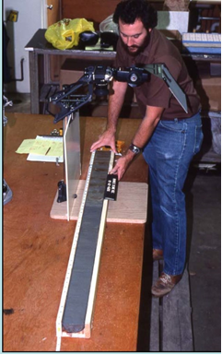
Fig. 3. Left, sampling the drowned Sabine estuary shown in preceding slide with a vibracorer; right, analyzing the sediments in a vibracore taken from the estuary (Pearson, et al 2008).

The Identification of submerged sites is largely dependent upon landforms preserved from the destructive processes related to marine transgression (Faught and Joy, ibid). It was only in the 1970s with the development of what is now called “sequence stratigraphy” by geophysicists and geologists at Exxon (Vail, et al 1977) that the identification and the effect of marine trangression became a major topic of study. The Exxon researchers built on the seminal work of Johannes Walther (1894) who proposed what is now known as “Walther’s Law of Facies Succession”; 1909, Eliot Blackwelder ‘s published use of unconformities as time markers and introduced concept of time represented by surfaces (erosional removal and sedimentary hiatus); and 1917, Joseph Barrell’s identification of the time-space distribution of sediment deposition and non-deposition: the alternating rise and fall of Base-level (aka sea level). Barrell formalized his concept based in large part on the recognition of the importance of a river’s Base level first proposed by John Wesley Powell (1875).

In regard to this discussion, unconformities result from the erasures of landform surface by marine transgression. Transgression erodes land surfaces and by extension any presence of prehistoric occupation by animals or humans. In terms of preserving prehistoric facies, burial by sediments before transgression is, perhaps, the best protection against erosion and loss. The conundrum that sediment burial raises is that of a lack of visibility of prehistoric archaeology on, ca. 14 the sea floor unless, of course, those deposits have been exposed by erosion. This situation has been observed, personally, at Gray’s Reef National Marine Sanctuary (GRNMS) (fig. 4). Sediment coring at this site in 1996 and 2000, yielded only stratified deposits far earlier than even pre-Clovis times or ca. pre-13.3 ka BP – MIS 3 or older (fig. 5). ) All paleontological and archaeological materials (fig. 6) recovered Gray’s Reef exist primarily as palimpsest deposits (Garrison, et al 2016).
Fig. 4. Location map for Gray’s Reef National Marine Sanctuary (GRNMS).

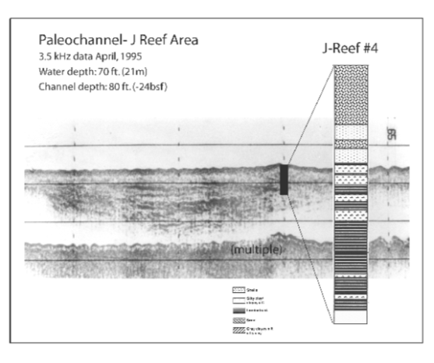
Fig. 5. Profile of sediment core placed into a buried paleochannel in the Georgia Bight, north of Gray’s Reef NMS, showing estuarine/fluvial sediment deposits below transgressive sand sediments.

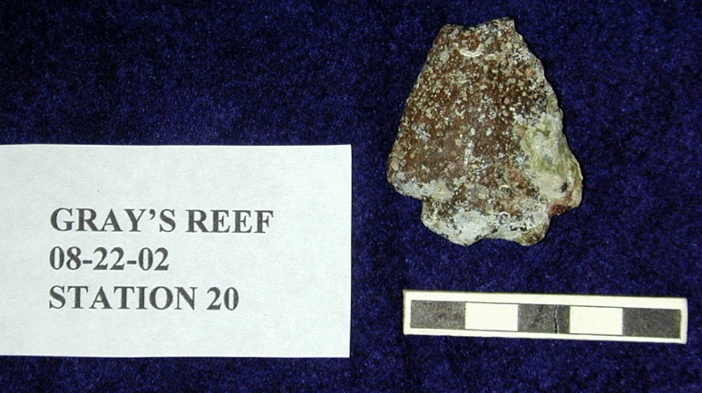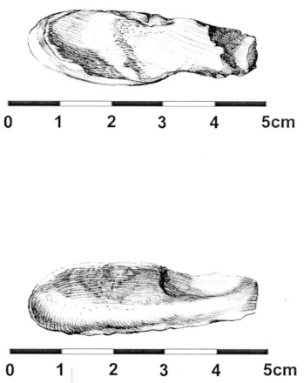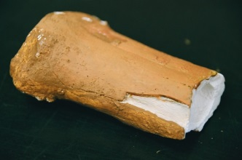

Fig. 6. Archaeologic and paleontologic assemblage items from Gray’s Reef NMS. Top, bifurcate projectile point; lower left, antler tool or atlatl hook; lower, right, cast of a bison metapodial section (length is 10.5 cm).

The use of shallow seismic profiling followed by sediment coring faithfully mirrored, the protocol developed in the Gulf of Mexico by CEI. It had become and, indeed, remains today as the “ruling paradigm” in the search for submerged prehistoric sites (Kuhn, 1962). While the first part of this methodological approach – seismic profiling – has proven a productive means to examine large portions of sea floor, the second element – sediment coring - has proven less effective. Evans, in her 2019 paper, has succinctly addressed this:

“On the Gulf of Mexico's (GOM) northwestern outer continental shelf (OCS), only two previous studies
have conducted archaeological testing of submerged landscapes (Evans 2014; Pearson et al 1986). Together, these two studies collected a combined 106 sediment cores, ranging from 6 to 12 m in length, and all approximately 10 cm (4 in) in diameter. The recovered cores represent a surface area of approximately 0.8 m² across the entire northwestern GOM OCS. Using the state of Louisiana's guidelines for terrestrial archaeological survey as a comparison, a standard 30 cm diameter shovel test covers a surface area of approximately 0.07 m². Depending on if the area is defined as low or high probability for the presence of archaeological sites, 1 to 4.5 shovel tests are required per acre. The 106 existing sediment cores from the OCS are equivalent to approximately 12 terrestrial shovel tests. This is simply not enough data from which to extract meaningful conclusions or attempt to identify patterns of specific human behavior. The diameter of cores used for testing offshore reduces the likelihood of identifying artifacts but does not negate the ability to build meaningful data sets (Evans, 2019).”

In a 2019 paper, I addressed this sampling issue by comparing its efficacy with actualistic studies of sediment coring of eleven buried prehistoric sites in the Netherlands carried out by Crombé and Vorhegge( 2015)(Garrison, 2019). In their study they used core barrel diameters of 7, 10, 12 and 15 cm. The 10 cm diameter corer had an increase in positive recovery over the 7 cm diameter barrel by 18.4%. Increasing the barrel diameter to 12 and 15 cm resulted in an increase in recovery of materials with a 37% gain from 12 to 15 cm, the largest barrel size. Their findings demonstrated grid intervals of 10 m or less using 10/12 cm auger diameters optimized both time and recovery. By way of comparison to the numbers given by Evans (2019), Crombé and Vorhegge collected 702 core samples on 11 buried prehistoric sites. On a site with a quite high artefact density of 80-100 items per meter they had 17.6 to 35.3% positive (10 vs 15 cm diameter) findings over 69 cores using 5-meter grid spacing.

In that 2019 paper, I paraphrased the methodology just described as “sound, software, and three-inch pipes” - the sound being the pulse from the SBP instruments, the software being the methods by which those sound pulses are processed and displayed, and the three-inch pipes, of course, denoting the coring tube diameter used to sample targets on landforms identified in using sound and software. My conclusion, along with that of others such as Evans, Faught and others, is their application and results have been, at best, uneven.

Discussion and Some Conclusions
Recalling my title – “Seismic facies or how geophysics help shape submerged prehistoric studies on the OCS" – I would like to mention the enthusiastic embrace of a seismic-based facies methodology by our UK colleagues in their attempt to model submerged prehistoric landscapes in the southern North Sea (Fitch and Gaffney, 2005; Gaffney et al, 2007). Like the GOM OCS before it, the North Sea has been subjected to extensive remote sensing surveys in the service of oil and gas exploration. Where, it seems, geophysics leads, archaeology is not long to follow. “Doggerland” (fig. 7) is a hot topic in European submerged prehistory with studies on-going based on the synthetic use of geophysical data (supra). Recent ground-truth studies of locales such as Area 240 have yielded firm evidence of a prehistoric human presence (Bicket, et. al 2014). While sediment coring has been utilized in those Doggerland studies, dredging and bottom-grabs have been systematically deployed along well-demarcated transects over seismically characterized landforms. It would seem the use of seismic facies for characterizing buried submerged landscapes continues alive and well.

“Seeing the Unseen” is how one textbook title describes geophysics in the service of archaeology (Campana and Piro, 2008). On the GOM OCS, the “unseen” is visualized utilizing geophysical techniques, as standard regulatory compliance. As Charles Pearson recently noted, that compliance activity does not require physical sampling (Pearson, 2019). Consequently, avoidance has been industry’s chosen means of mitigation for any potentially threatened cultural resources. Avoidance is one of the approved mitigative measures for cultural resources, submerged or not. Despite the potential for archaeological discovery, in the GOM and the U.S. OCS, in general, the results of geophysical surveys remain relatively untested.

Figure 7. Doggerland at LGM (from Garrison, 2016).

The upshot of this lack of testing is our continued reliance on the conceptual usage of seismic facies to interpret the geophysical record. As Evans and Keith have pointed out, that “after four decades
of regulatory compliant survey and assessment, no definitive prehistoric archaeological sites have been
identified on the outer continental shelf (Evans and Keith, 2019).” I am more ready to view the 1986 findings of Pearson, et al, on a more positive light than Evans and Keith. Their sediment cores did intersect deposits that met the criteria set forth in their model as indicative of anthropogenic deposits origins (Pearson et al 1986; Pearson, et al, 2008.) Evans and Keith seem to overly conservative in that they state that: “success does not depend on the identification of artifacts…. macro-sedimentary characteristics can be identified from physical samples, such as the presence of exotic shell in a non-natural habitat, or an abundance of worked shell, or unnaturally large percentages of a specific shell type or size (Gagliano et al 1982:53). Chemical alteration of sediments……. have been cited as indicators of human activities (Gagliano, et al 1982:90). Areas of crushed shell or mechanically packed sediment may indicate an intensive activity area (Gagliano et al 1982:90).” Many of the findings of Pearson, et al, 1986 meet these objectives.

Still, examining the micro-world found in sediment cores may our best option. Sonnenburg et al (2011) has identified micro-debitage (chipped stone flaking debris) from analysis of cores from Lake Huron, indicating the presence of people at that locale, a finding also discussed by Gagliano, et al (1982). Cook Hale found the same type of micro-debris in her sediment samples from Apalachee Bay, Florida GOM (Cook Hale, 2019). The analysis of pollen or environmental DNA samples, or both, from core sediments can result in paleoenvironmental reconstructions. These investigative areas of modern sediment analysis were missing from the 1986 and 2011 studies. Sediment DNA has recently been used to examine the timing of the opening of the 1,500-km-long "ice free corridor" or ICE (Pedersen et al 2016; Smith et al 2015). Pedersen et al (2016) concluded that steppe vegetation, bison and mammoth entered the corridor by 12,600 cal BP. By 11,500 cal BP, moose and elk entered the corridor as boreal forest began to grow approximately 10,000 cal BP. Similar studies of sediments such as those recovered by the earlier GOM studies, would have potentially identified species that may have been selected and used by prehistoric groups.

I digress. My subject is seismic facies and their role in helping shape submerged prehistoric studies on the OCS. I remain enamored with Evans and Keiths’ numerical description of the northwestern GOM regarding its area and seismic survey coverage. To wit, ….” The northwestern Gulf of Mexico outer continental shelf includes approximately 38,660,700 acres (15,645,430 ha) of submerged land under federal permitting authority, which are in turn subject to NEPA and NHPA Section 106-compliant archaeological survey (Evans and Keith, 2019).” Further… “Archaeological surveys conducted for compliance purposes have produced thousands of line miles of valuable data for mapping relative landscapes on the OCS (ibid).” I would love to see the exact number of miles covered in those survey tracks. When taken in comparison to these numbers, those cited, again, by Evans and Keith, for the total sediment sampling area on the GOM sub -seafloor of “approximately 12 terrestrial shovel tests” or ~0.8 square meter, one must laugh.

As archaeologists we are left with volumes of shallow seismic records for the sub-seafloor thanks to those” thousands of miles of valuable data…” From those records we have used the seismic facies heuristic for the construction of buried, submerged landscapes of the prehistoric coastal plain of the GOM as well as the OCS elsewhere. We have had to. Why? It is too easy within a 9 sq. mile (23.3 sq. km.) lease block for drill site to locate anywhere within it and successfully extract oil/gas from a reservoir within it. Simple avoidance has become the rule for oil/gas developers on the OCS.

I will close with a figure that the late James Henry produced in 1978 for the OCS of the southeastern U.S. (fig. 8). What I love most about this graphic is its overt simplicity in presenting what we know to have been a large volume of seismic data. Henry synthesized these data and compiled this elegant map of – you guessed it - seismic facies.

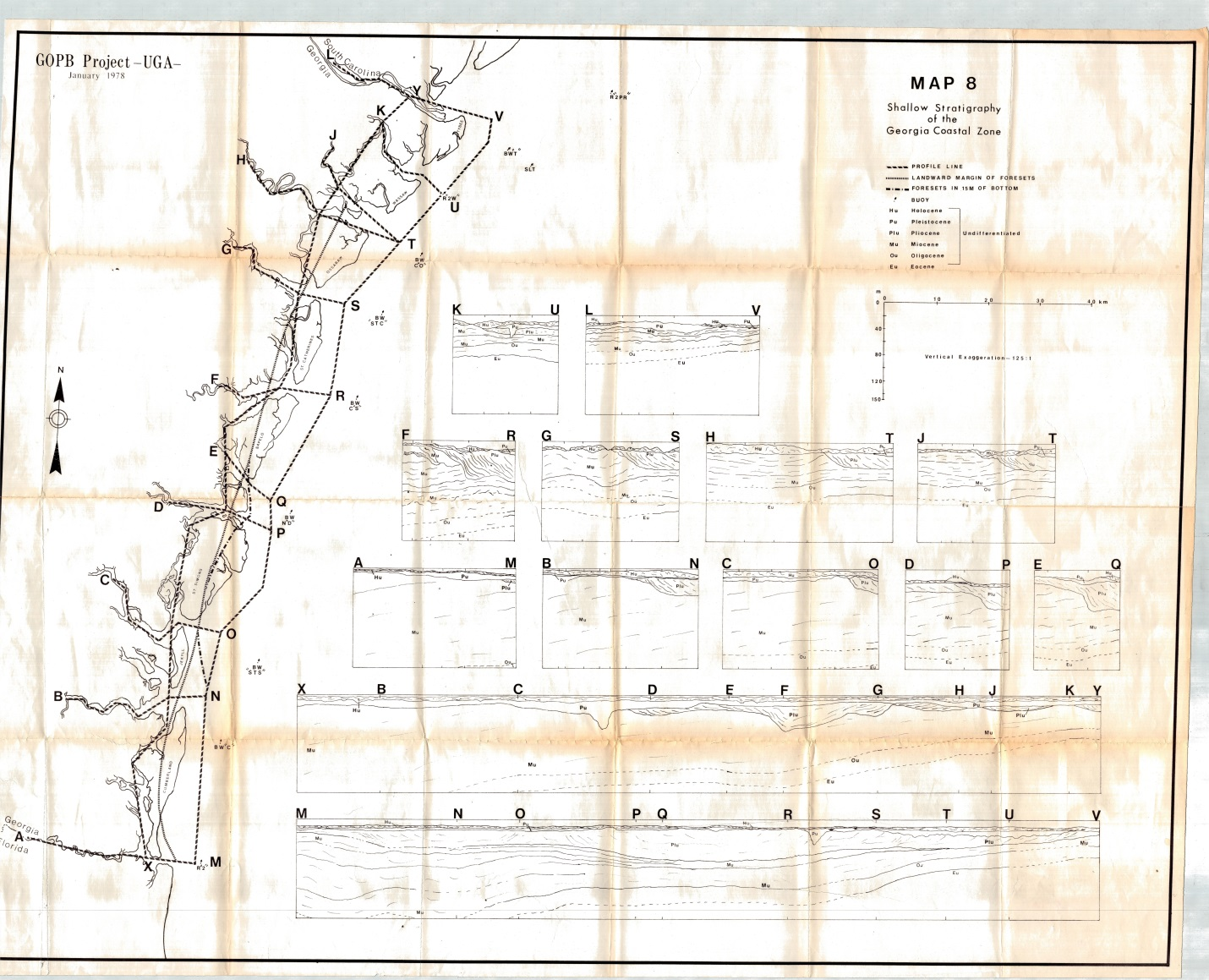

Figure 8. Shallow stratigraphy (and sediment facies) of the Georgia Coastal Zone (Henry, et al 1978).

References

American Oil & Gas Historical Society. 3204 18th Street, NW, No. 3. Washington, D.C.

Anderson, J. B. 2007. The Formation and Future of the Upper Texas Coast. Texas A&M University Press, College Station.

Barrell, J. 1917. Rhythms and the measurements of geologic time. Bulletin of the Geological Society of America 28(1):745-904.

Bicket, A., A. Firth, L. Tizzard and J. Benjamin. 2014. Heritage Management and Submerged Prehistory in the United Kingdom. In A. M. Evans, J.C. Flatman and N.C. Flemming, (Eds.). Prehistoric Archaeology on the Continental Shelf. Springer. New York. DOI 10.1007/978-1-4614-9635-9_9.

Blackwelder, E. 1909. The valuation of unconformities. The Journal of Geology 17(3):289-299.

Campana, S. and S. Piro, eds., 2008. Seeing the unseen. Geophysics and landscape archaeology. CRC Press. Boca Raton, FL.

Coastal Environments, Inc. 1977. Cultural Resources Evaluation of the Northern Gulf of Mexico Continental Shelf. Prepared for Interagency Archaeological Services, Office of Archaeology and Historic Preser- vation, National Park Service, United States Department of the Interior.

Coastal Environments, Inc. 1982. Sedimentary Studies of Prehistoric Archaeological Sites. Prepared for Division of State Plans and Grants, National Park Service, United States Department of the Interior.

Convention on the Law of the Sea. Dec. 10, 1982, 1833 U.N.T.S. 397. Entered into force Nov. 1, 1994. Article 55.
Cook Hale, J.W., and N.L. Hale and E.G., Garrison. 2019. What is past is prologue: excavations at the Econfina Channel site, Apalachee Bay, Florida, USA. Southeastern Archaeology 38(1):1-22.
Crombé, P. and J. Verhegge. 2015. In search of sealed Palaeolithic and Mesolithic sites using core sampling:the impact of grid size, meshes and auger diameter on discovery probability. Journal of Archeological Science 53:445–458.
Evans, A.M., 2012. Out of site but not out of mind: submerged prehistoric landscapes on the Northwestern Gulf of Mexico Outer Continental Shelf. Doctoral dissertation. Louisiana State University.

Evans, A.M., J.C. Flatman and N.C. Flemming, eds. 2014. Prehistoric Archaeology on the Continental Shelf. Springer. New York. DOI 10.1007/978-1-4614-9635-9_9.

Evans, A. M. and M.E. Keith. 2019. Submerged Prehistoric Archaeology: Confronting Issues of Scale and Context on the Gulf of Mexico Outer Continental Shelf. In Offshore Technology Conference. Offshore Technology Conference, Houston, Texas, USA, 6 – 9 May 2019.

Fitch, S., K. Thomson and V. Gaffney. 2005. Late Pleistocene and Holocene depositional systems
and the palaeogeography of the Dogger Bank, North Sea. Quaternary Research. 64 (2):185–196.

Faught, M.K. 2014. Remote Sensing, Target Identification and Testing for Submerged Prehistoric Sites in Florida: Process and CRM. In Evans, A.M., J.C. Flatman and N.C. Flemming, (eds.). Prehistoric Archaeology on the Continental Shelf. Springer. New York. DOI 10.1007/978-1-4614-9635-9_9.

Faught, M.K. and A.E. Gusick. 2011. Submerged Prehistory in the Americas. In Prehistoric Archaeology on the Continental Shelf . Springer. (1-12).

Faught, M.K. and S. Joy. 2019. The Potential for Offshore Industry to Enable Discovery of Paleo-Landscapes and Evidence for Early People: Past, Present and an Optimistic Future. In Offshore Technology Conference. Offshore Technology Conference, Houston, Texas, USA, 6 – 9 May 2019.

Gaffney, V., K. Thomson and S. Fitch., eds. 2007. Mapping Doggerland: The Mesolithic Landscapes of the Southern North Sea. Oxford, England: Archaeopress.
Gagliano, S. M., C. E. Pearson, R. A. Weinstein, D.E. Wiseman and C.M. McClendon. 1982. Sedimentary Studies of Prehistoric Archaeological Sites: Criteria for the Identification of Submerged Archaeological Sites of the Northern Gulf of Mexico Continental Shelf. National Park Service, Division of State Plans and Grants.

Garrison, E.G., J. Cook Hale, C.S. Cameron and E.A. Smith. 2016. The Archeology, Sedimentology and Paleontology of Gray's Reef National Marine Sanctuary and Nearby Hard Bottom Reefs along the Mid-Continental Shelf of the Georgia Bight. Journal of Archaeological Science: Reports 5:240-262.

Garrison, E.G. 2019. Submerged Archaeological Resources: Sound, Software and Three Inch Pipes - A Recipe for Finding Submerged Prehistoric Archaeological Sites? In Offshore Technology Conference. Offshore Technology Conference, Houston, Texas, USA, 6 – 9 May 2019.

Henry, V.J., R.T. Giles, and J.L. Harding. 1978. Geologic evaluation of potential pipeline
corridor sites along the Georgia coast: final report, phase I. Georgia Office of Planning and
Budget, Atlanta, GA. 101 p.

Johnson, L.L. and M.J. Stright, eds., 1991. Paleoshorelines and prehistory: an investigation of method. CRC Press.

Kuhn, T. S. 1962.The Structure of Scientific Revolutions. University of Chicago Press. Chicago, IL.

Madden, C., K. Goodin, B. Allee, M. Finkbeiner and D. Bamford. 2009. Coastal and marine ecological classification standard. NOAA and NatureServe, 107.

Masters, P.M., 1983. Detection and assessment of prehistoric artifact sites off the coast of southern California. In Quaternary coastlines and marine archaeology: Towards the prehistory of land bridges and continental shelves (Masters, P.M. and N.C. Flemming, Eds.): 189-213.

Masters, P.M. and N.C. Flemming, eds. 1983. Quaternary coastlines and marine archaeology: Towards the prehistory of land bridges and continental shelves. Academic Press.

Nelson, H. F. and E. E. Bray. 1970. Stratigraphy and History of Holocene Sediments in the Sabine-High Island Area, Gulf of Mexico. In, Deltaic Sedimentation, Modern and Ancient, J.P. Morgan (Ed.) Society of Economic Paleontologists and Mineralogists Special Publication 15:48–77.

Pedersen, M. W., A. Ruter, C. Schweger, H. Friebe, R.A. Staff, K.K. Kjeldsen, et al. 2016. Postglacial viability and colonization in North America's ice-free corridor. Nature, 537: 45.

Pearson, C. E., R. A. Weinstein, D. E. Wiseman and C. M McClendon. 1982. Sedimentary studies of prehistoric archaeological sites: Criteria for the identification of submerged archaeological sites of the northern Gulf of Mexico continental shelf. Coastal Environments, Inc. Baton Rouge, LA. 118 p.

Pearson, C.E., D.B. Kelley, R.A. Weinstein and S.M. Gagliano. 1986. Archaeological investigations on the Outer Continental Shelf: A study within the Sabine River Valley, offshore Louisiana and Texas. Coastal Environments, Inc. Prepared by Coastal Environments Inc. Published by Minerals Management Service, US Department of Interior, Reston, VA.

Pearson, C.E., R.A. Weinstein and D.B. Kelley. 2008. Prehistoric site discovery on the Outer Continental Shelf, United States of America. Paper presented at the 6th World Archaeological Conference, Dublin, Ireland, June 28–July 4.

Pearson, C.E. 2019. Prehistoric site discovery and paleolandscape modeling on the Outer Continental Shelf, Gulf of Mexico, United States of America. Geoscience Colloquium Series, Department of Geology, University of Georgia. March 22nd.

Powell, J. W. 1875. Exploration of the Colorado River and Its Tributaries, 153. U. S. Government Printing Office, Washington, D. C.

Ricklis, R.A. and M.D Blum. 1997. The geoarchaeological record of Holocene sea level change and human occupation of the Texas gulf coast. Geoarchaeology: An International Journal 12(4):287-314.

Ricklis, R. A. 2004 The Archeology of the Native American Occupation of Southeast Texas. In The Prehistory of Texas, Timothy K. Perttula (ed.), pp. 181–202, Texas A&M University Press, College Station.
Smith, O., G. Momber, R. Bates, P. Garwood, S. Fitch, M. Pallen, V. Gaffney and R.G. Allaby. 2015. Sedimentary DNA from a submerged site reveals wheat in the British Isles 8000 years ago. Science 47(6225):998-1001.

Sonnenburg, E.P., J.I. Boyce and E.G.Reinhardt. 2011. Quartz flakes in lakes: Microdebitage evidence for submerged Great Lakes prehistoric (Late Paleoindian–Early Archaic) tool-making sites. Geology 39(7):631-634.

Stanford, D., D. Lowery, M. Jodry, B.A. Bradley, M. Kay, T.W. Stafford and R.J. Speakman. 2014. New evidence for a possible Paleolithic occupation of the eastern North American continental shelf at the Last Glacial Maximum. In Prehistoric Archaeology on the Continental Shelf (pp. 73-93). Springer.

Stright, M. J. 1981. Federal Cultural Resources Management on the OCS: Problems and Potential. U.S. Department of the Interior, Bureau of Land Management, November, Washington, D.C.

Stright, M. J. 1982. The Future of Federal Cultural Resources Management on the OCS. In Underwater Archaeology: The Proceedings of the Eleventh Conference on Underwater Archaeology, Calvin R. Cummings, ed., Fathom Eight, San Marino, CA.

Stright, M.J. 1986a Human occupation of the Continental Shelf during the Late Pleistocene / Early Holocene: Methods for Site Location. Geoarchaeology 1:347–364.

Stright, M.J. 1986b Evaluation of Archaeological Site Potential on the Gulf of Mexico Continental Shelf Using High-resolution Seismic Data. Geophysics, 51(3): 605.

Stright, M. J. 1995. Archaeological Geology of the Archaic Period in North America. In Archaeological Geology of the Archaic Period in North America. E.A. Bettis III (ed.). Boulder, CO. Geological Society of America.. 131–148.

Stright, M.J., L.M. Eileen and J. F. Bennett. 1999 Spatial Data Analysis of Artifacts Redeposited by Coastal Erosion: A Case Study of McFaddin Beach, Texas. OCS Study MMS 99-0068. Minerals Management Service, Herndon, VA.
Vail, P.R., R. M. Mitchum, S. Thompson III. 1977. Seismic stratigraphy and global changes of sea level. In Payton, C.E.( ed.). Seismic stratigraphy: applications to hydrocarbon exploration 26: 1-516).
American Association of Petroleum Geologists. Tulsa, OK.

Walther, J. 1894.Einleitung in die Geologie als Historische Wissenschaft. Lithogenesis der Gegenwart, Bd. 3, Fischer Verlag: 535-1055

ABBREVIATIONS AND ACRONYMS

BLM Bureau of Land Management

BOEM Bureau of Ocean Energy Management

GOM Gulf of Mexico

LOSC Law of the Sea Convention

NEPA National Environmental Policy Act

NHPA National Historic Preservation Act

OCS Outer Continental Shelf

